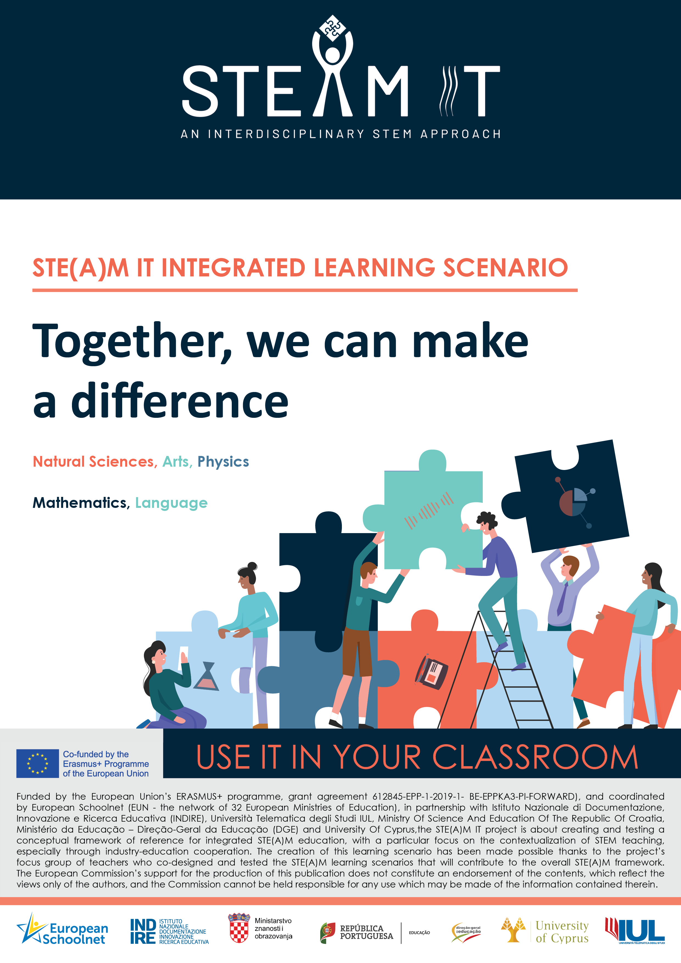
Ultrasonic Volume Measurement with Arduino Physical Programming

STE(A)M IT INTEGRATED LESSON PLAN
Introduction 3
Title 4
Authors 4
Summary 4
Licenses 4
Subject (s) 4
Real- life questions 5
Aims of the lesson 5
Connection to STEM careers 6
Age of students 6
Time 6
Teaching resources (material & online tools) 6
21st century skills 7
Lesson Plan 8
Assessment 18
Initial assessment 19
Formative evaluation 19
Final assessment 19
Student feedback 19
Teacher feedback 19
Annexes 20
Annex 1: Pedagogical Trends in Education 20
Annex 2: Worksheets Lesson 2 24
Annex 3: Formative Assessment Rubric 27

Introduction
In order to inspire students, see the added value of STEM subjects and careers, contributing the same way in tacking unfavourable perceptions and the overall lack of interest in Science, there is a need to reconsider the way STEM subjects are taught. For this purpose, there is a need for an integrated way of teaching. More specifically, there is a need to combine Science classes with other disciplines, ensuring that the integrated STE(A)M education will contextualize STEM teaching is such a way that it becomes more attractive for every student.
Right now, there is no integrated STE(A)M education framework in Europe that will further enhance coherence in STEM education. It is essential to bring together partners from different countries, already working in STE(A)M education, policy, pedagogical innovation and professional development of teachers, educators and school leaders, and engage them in discussions, planning, implementing and the review of new practices. This will ensure that the topic is given new and more intense attention within each country. Therefore, the STE(A)M IT project will lead the way in the creation and testing of the 1st Integrated STE(A)M framework, aiming to strengthen the coherence in STEM education by defining collectively with MoEs and STEM teachers the integrated STE(A)M education framework. The focus group teachers that will create interdisciplinary and innovative teaching and learning scenarios, will be used to test the proposed framework of reference for integrated STE(A)M education.
The creation and implementation of the aforementioned framework is particularly important for students who do not link STEM subjects and their use with their everyday life, but most importantly with their future career paths. The teaching of each STEM subject individually often prevents students from linking those subjects, consequently missing out on a cohesive educational opportunity that might largely affect their study path choice and eventually career.
It is additionally important for teachers of Primary and Secondary schools to work together and fully exploit the benefits of the in-between them collaboration, while contributing to the creation of innovative and cross-disciplinary approaches to STE(A)M teaching in education, each adding their own insight, expertise and knowledge. This collaboration and continuous feedback aim to provide an opportunity for reflection and support a steady and much necessary change in formal education but also career consultancy. This way, schools will assume the additional role of mentorship supporting their students collectively.
A STE(A)M IT Integrated lesson plan is a teacher's detailed description of the course of instruction or "learning trajectory" for a lesson, a guide and a document that will be continuously improved and updated. Each lesson needs to combine three subjects, two of the subjects must be STEM and the third subject can be either STEM or non-STEM. is about designing educational activities that facilitate deep learning to enhance 21st century skills such as critical thinking, collaboration, communication and creativity and divergent thinking. Designing a path based on methodologies such as Problem, Project and Challenged Based learning allow to incorporate problem-solving, inquiry and design based learning into the teaching activity taking care of real challenges in an authentic context, that of our world.
With this in mind, an integrated STEM approach will develop capable citizens who personally and professionally make informed decisions in their daily lives and have the power to follow STEM careers and guide innovation at any age.
Title
Ultrasonic Volume Measurement with Arduino Physical Programming
Authors
Mesut ULU
Summary
This Learning Scenario aims to measure the water level in a tank by using the ultrasonic measurement method with Arduino Uno. Level measurement is a measurement application frequently used in many different engineering fields. In this Learning Scenario, students will first make a literature review of the methods used in level measurement. Next, they will classify the methods into two groups: mechanical-based and electrical-based. To put their knowledge into practice, students will produce an ultrasonic level detection method, using an HC-SR04 Ultrasonic Sensor and Arduino Uno, a data acquisition and control card will also be used. The dimensions of the container will be coded with mBlock, which will enable some warning lamps that will light up when the liquid accumulated in the tank reaches a certain level. In such a way, a warning system will be activated. To do so, the trigger pin of the ultrasonic sensor will be connected to the 13th pin of the Arduino board and the Echo pin of the sensor will be connected to the 12th pin of the board. The energy required for the ultrasonic sensor (5 V DC) is provided from the USB port of the computer via the Arduino board. By testing the ultrasonic measurement method, students will come up with a solution to measure the water level in a small tank.
Licenses
Attribution CC BY. This license lets others distribute, remix, tweak, and build upon your work, even commercially, if they credit you for the original creation. This is the most accommodating of licenses offered. Recommended for maximum dissemination and use of licensed materials.

Subject (s)
STEM Subject 1 – Science: Students will work with electrical circuits, connecting circuit elements on a breadboard. They will also get acquainted with the particular nature of matter and fluids, as well as volume measurement.
STEM Subject 2 – Technology: Students will be introduced to physical programming with Arduino. They will also learn about the best materials to be used in volume measurement, and what is usefulness and cost in the product design process.
STEM Subject 2.1 – Information Technologies: Students will get acquainted with the mBlock program and how to code formulas for volume measurement.
STEM Subject 3 – Mathematics: Students will recognize geometric-shaped containers to be used in volume measurement, considering their criteria and limitations. Besides, they will make use of estimation, induction, description, generalization, and verification – among other mathematical processes – to reach and test the validity of their solution, considering different factors (logical reasoning). They will also learn formulas to measure the volume of cylinders and prisms, and their subsequent application in a coding program.
STEM Subject 4 – Engineering: students will get acquainted with the engineering design process by designing a volume measurement tool, they will go thorough different stages such as development, prototyping and testing.
Non-STEM Subject – Visual Arts: students will work on the design of their measurement device. They will also present it to the rest of the class by making use of creative tools, such as video-editing.
Real- life questions
Students will be faced with the following problem situation:
Archimedes and Newton are studying at school, and they are conducting an experiment aimed at measuring volume. Their teacher asks them to measure 630 ml of alcohol to use in the experiment. While measuring with a graduated cylinder, it suddenly slips from their hands and breaks. As they cannot find any other graduated cylinders in the laboratory, their experiments are left unfinished – something that really upsets them. In front of this situation, the teacher asks them to research whether there exist other materials suitable for measuring volume with exactitude, adapted to today’s technology. They can get help from the IT teacher to investigate this. Archimedes and Newton are expected to think like “scientists” and develop a material capable to measure volume with simple Arduino materials.
Students are asked to come up with a solution to the situation described above. That is, they are expected to design a volume measurement tool that is faster and more accurate than a graduated cylinder, in accordance with today's technology.
Aims of the lesson
In this Learning Scenario, after researching methods used in level measurement, students will aim to measure the water level in a tank by using an ultrasonic measurement method with Arduino Uno. In addition, students will aim to create a warning system in which when the liquid accumulated in the tank reaches certain levels, the led bulbs will be turned out to give a warming.
At the end of the implementation of this lesson plan, our students will:
- Comprehend the role of physical programming in intelligent designs.
- Understand the relationship between Arduino and physical programming and STEM.
- Gain awareness of the characteristics of innovative and entrepreneurial designs.
- Get to know why volume measurement is very important in daily life and design a unique volume measurement system.
- Understand that science and engineering are closely related. Students will know that electrical engineers use their creativity as well as their science and math knowledge to solve their problems.
- Be acquainted with the engineering design process and the steps that can be used to solve problems.
- Develop problem-solving, teamwork, communication, and creative thinking skills while working through engineering design challenges.
Connection to STEM careers
Level measurement is a measurement application frequently encountered in many different engineering fields. Students will learn, for example, how to digitally measure the amount of fuel in the tanks at the gas stations, how much grain can be stored in a silo, or how much water can fill in a water tank.
Age of students
11 to 14 years old.
Time
Preparation time: 4 hours.
Teaching time: 6 hours.
- Preparation: Procurement of materials for Arduino kits and volume measurement material design.
- STEM Subject 1 – Science: The importance of volume measurement in our daily life, volume measurement methods and areas of use.
- STEM Subject 2, 3 & 4 – Technology, Mathematics & Engineering: Arduino physical programming and volume measurement thanks to an ultrasonic distance sensor.
- Non-STEM Subject – Visual Arts: Determining the criteria and limitations in the material design process; schematizing, prototyping, testing, and developing the design by considering shape, size, and visuality.
Teaching resources (material & online tools)
Materials: HC-SR04 Ultrasonic distance sensor, jumper cables, led bulbs, resistor, laptop, infrared transceiver, IR receiver module wireless remote control, medium and large breadboard, 16x2 LCD display, cardboard, styrofoam, scissors, adhesive and double sided tapes, buzzer (the determined materials were given to 6 groups of students).

Online tools:
Online platforms:
- Google Classroom: https://edu.google.com/workspace-for-education/classroom/
- Microsoft Teams: https://www.microsoft.com/pt-pt/microsoft-365/microsoft-teams/download-app
- Zoom: https://zoom.us/
- YouTube: https://www.youtube.com/

Other online tools include:
- Board: http://board.net
- Padlet: http://padlet.com
- Classroomscreen: http://classroomscreen.com
- BitPaper: https://bitpaper.io
- Quizizz: https://quizizz.com/admin

Online video editing tools:
- Lumen5 (easy tool for automatic video creation based on text upload): https://lumen5.com/
- TextingStory (a simple tool to write your story and create video): http://textingstory.com
- ThingLink & Renderforest (an online tool to create your interactive images, videos and virtual tours):
https://www.thinglink.com
https://www.renderforest.com/en/templates
- Mysimpleshow (an online tool for creating explainer videos):
https://www.mysimpleshow.com
- LearningApps & Lumi Education (tool to build learning tools):
https://learningapps.org/
https://next.lumi.education/

21st century skills
This lesson plan will enhance among the students the following skills, defined as 21st-century skills:
- Mathematical Literacy.
- Science Literacy.
- Critical Thinking and Problem Solving.
- Communication and Collaboration.
- Creativity and Innovation.
- Initiative and Self-Direction.
- Social, Intercultural Skills, Leadership and Responsibility.
Lesson Plan
The implementation of integrated STEM teaching and learning is facilitated by the use of specific pedagogical approaches (PBL, IBL, etc.). In order to facilitate the research done by the teachers and the design of activities by teachers, a selection of such approaches is presented in Annex 1. Maintaining Annex 1 in the Learning Scenario and citing where necessary is mandatory.
The tools and materials will be provided by the teacher to each group of students. Students will collect their data to solve the problem. They will also construct hypotheses, design and perform experiments to test, collect, analyze and interpret data. During this process, the teachers will walk around the groups and motivate the students with their questions. The possible sub-problems and activities are detailed below:
Name of activity | Procedure | Time
1st Lesson
Brainstorming and discussion | Students will be faced with the following problem situation:  Archimedes and Newton are studying at school, and they are conducting an experiment aimed at measuring volume. Their teacher asks them to measure 630 ml of alcohol to use in the experiment. While measuring with a graduated cylinder, it suddenly slips from their hands and breaks. As they cannot find any other graduated cylinders in the laboratory, their experiments are left unfinished – something that really upsets them. In front of this situation, the teacher asks them to research whether there exist other materials suitable for measuring volume with exactitude, adapted to today’s technology. They can get help from the IT teacher to investigate this. Archimedes and Newton are expected to think like “scientists” and develop a material capable to measure volume with simple Arduino materials.  Students are asked to come up with a solution to the situation described above. That is, they are expected to design a volume measurement tool that is faster and more accurate than a graduated cylinder, in accordance with today's technology.  Students are asked to come to the next lesson by having scanned relevant literature in this field. | 2 hours
Discussion and preparation for the next lesson | Students' research on the subject is shared by each group. Afterward, the following literature review is distributed to the students.
2nd Lesson
STEM Subject 1 – Science | Research volume measurement methods and their importance | 2 hours
With the rapid changes in science and technology, education and training programs have also changed to respond to the demands of our times. New educational approaches have moved students to a
position where they take responsibility for their own learning, where knowledge has an active role and central position (MEB 2005, MEB 2013). This has led to the adoption of new technologies and the testing of different methods, such as different measurement tools.
Level measurement is a measurement application that is frequently
encountered in daily life. In general, the following applications can
be given as examples:
- The amount of fuel in vehicle tanks.
- The amount of fuel in the tanks at the gas stations.
- Product level in solid and liquid product tanks.
- Water fill level in dams.
Besides, level measurement is also a frequently encountered measurement application in the field of agriculture. The following applications can be given as examples:
- The amount of fuel in the tractor tanks.
- Grain amounts in silos.
- The amount of water in water tanks.
- The amount of fuel in fuel tanks.
- The amount of liquid in the sprayer.
- The amount of product in the warehouses of liquid agricultural products (milk, juice, vegetable oil, etc.).
Students will classify the different methods used in level measurement, based on a literature review. The methods will be divided into two groups: mechanical based and electric based (Doebelin, 1990; Hughes, 1995; Hambrice and Hopper, 2004; Kadlec, 2008; MEB, 2009; Ametek, 2014).

Mechanically based | Electric based
Float | Electrode (conductive) based
Combined container | Ultrasonic based
Bubble method | Radar-based
Pressure based | Laser-based
Magnetic method | TDR based
Vibrating fork | Capacitance based
Rotary pedal | Magnetic field based

Learning products | - Students will make a poster in Canva showing the circulation of water in nature.
3rd Lesson
STEM Subject 2, 3 & 4 – Technology, Mathematics & Engineering | Arduino physical programming and volume measurement thanks to the ultrasonic distance sensor | 3 hours
In the study, an experimental method was used. A program is created in the m Block software for distance measurement and level determination. The volume measurement is provided by transferring the program code used to Arduino. In the study, a cylindrical vessel with a radius of 4.54 cm and a height of 25.8 cm was used. As the liquid is added to this container, the volume of the liquid accumulating in it is ultrasonically measured and coding is used that gives both light and audible warnings at certain levels of the container.
The HC-SR04 Ultrasonic sensing sensor is placed on a small tank and water is gradually added to the tank. At certain water level values, a precise volume measurement is attempted with the HC-SR04 Ultrasonic sensor, which works in accordance with the coding of the water level determined by the sensor.
Below, you can find the steps on how to set the ultrasonic distance sensor, accompanied by images.
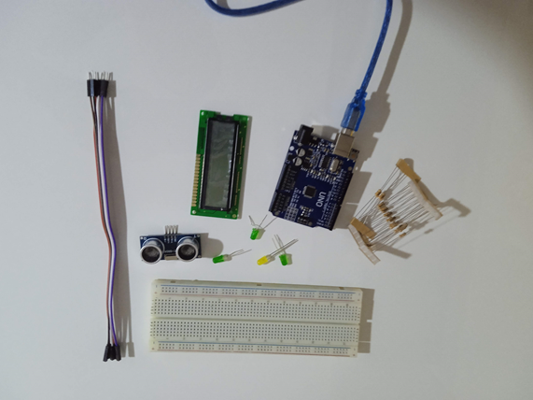
Picture provided by the author (Attribution CC-BY)

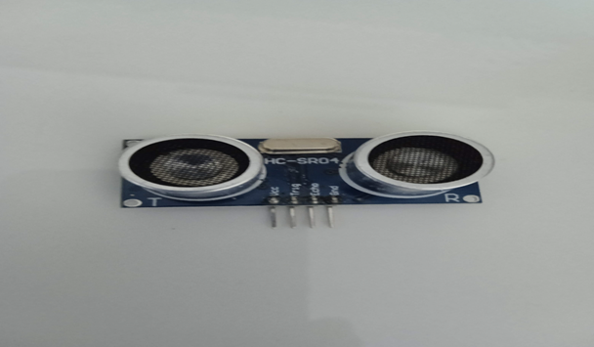
Our materials used in the development of the volume measurement tool Arduino Uno is a control card that enables other circuit elements to work according to the commands sent by the computer.
Picture provided by the author (Attribution CC-BY)

The HC-SR04 Ultrasonic Sensor is a source that calculates the distance to the opposite object using sonar communication. The system we call sonar helps us calculate the distance of the object using sound waves.

The HC-SR04 Ultrasonic Distance Sensor is a very popular sensor involved in almost all robotic projects.

There are 4 pins on the sensor: vcc, gnd, trig, echo pins. The principle of operation of the sensor is simple: when a signal is given from the TRIG pin, a sound wave with a frequency of 40 Khz is produced by the sensor, and when this sound wave hits an object and returns, the ECHO pin becomes active.
Vcc | 5V source
Gnd | Grounding
Trig | The part of the sensor that sends the sound wave
Echo | The part that receives the sent sound waves

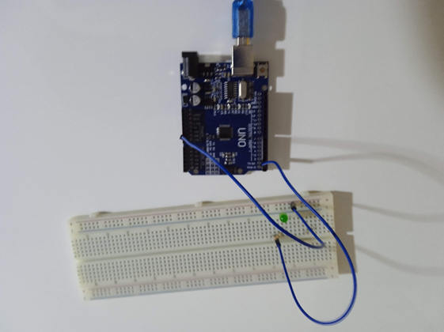
In our circuit, we connect the trig pin that provides the signal output to the digital pin 12 on the Arduino Uno, and the echo pin, which is the receiver, to the digital pin 13. We pay attention to the pin number while coding.
Picture provided by the author (Attribution CC-BY)

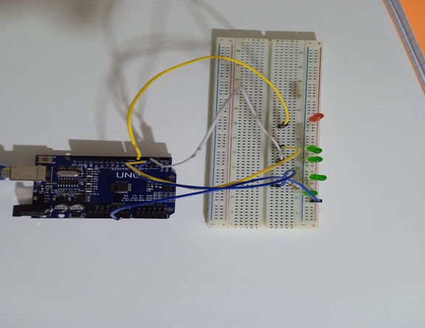
The breadboard is a breadboard on which we can connect a single circuit element. We connect both digital displays and gradually burning led bulbs for visual warning. We use five led bulbs for this. The long leg of the led bulbs is the positive pole, while the short leg is the negative pole. So we put the short leg of the bulbs to the negative pole on the breadboard and connect it to the GND pin of the Arduino Uno with the jumper cable. Since our bulbs are of a small voltage, the positive part is first connected to a resistor and then to a desired digital pin. We connect our first light bulb to digital pin 2 in our circuit.
Picture provided by the author (Attribution CC-BY)

We connect five light bulbs on the breadboard with the same method. We connect these bulbs to the digital pins 2, 3, 4, 5, 6 on the Arduino Uno, respectively. While creating our coding, we will create our coding for the led bulbs to burn gradually as the amount of liquid in the container increases.

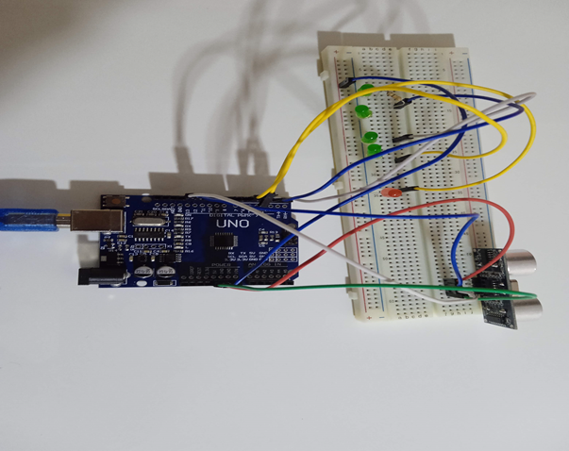
Picture provided by the author (Attribution CC-BY)

We connect the HC-SR04 Sensor and the led bulbs in the image above.
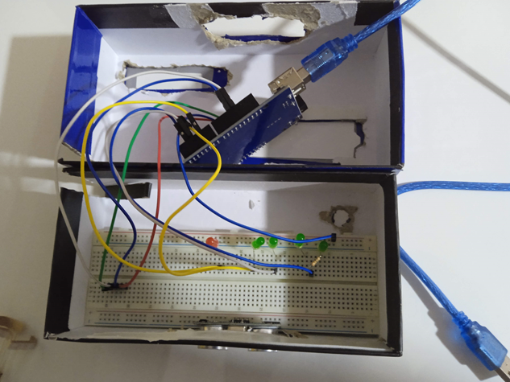
Picture provided by the author (Attribution CC-BY)

We place the circuit we have created into the designs we have prepared in a way that makes the measurement easy.

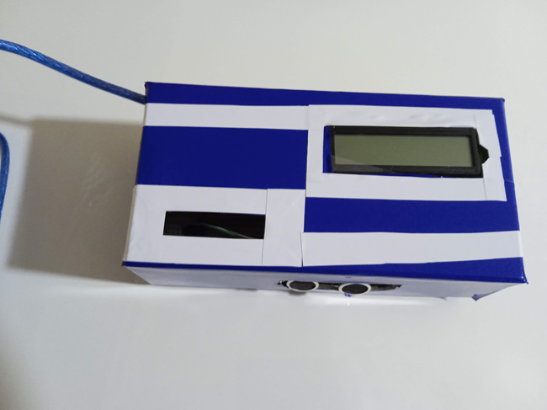
We complete our circuit by adding a digital display that shows the fill rate and volume value of the water in our container, and a buzzer that gives a sound warning. Our measuring tool is ready.

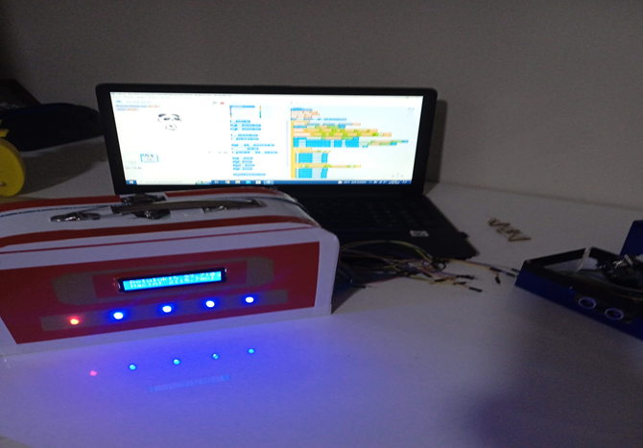
Picture provided by the author (Attribution CC-BY)

Our measurement tool prepared by another student group.
Learning products | See a video of the setting here (in Turkish) and some pictures for guidance in Annex 2 or this link.
4th Lesson
STEM Subject 2, 3 & 4 – Technology, Mathematics & Engineering | Coding, algorithm, and presentation of the designs | 2 hours
Develop solutions to the problem: create an algorithm.
At this stage, students are asked to produce solutions for the problem situation. In other words, to develop different solutions in line with the criteria and restrictions you have determined for the volume measurement material; To evaluate the solutions they developed according to the criteria they determined in the previous step and to choose the most suitable one:

- Testing and improving the solution.
- Test the solution by evaluating the process steps (algorithm) of the solution step by step and improve it if there are any deficiencies.

Generating and testing the code
The written code was tested with the physical components, and the determined steps were checked and the prototype was mounted on the volume measuring device model created with simple tools.
In line with the criteria and restrictions determined at this stage, Arduino components were mounted in the box made with simple tools such as design, cardboard and foam.

In the study, a cylindrical vessel with a radius of 4.54 cm and a height of 25.8 cm was used. The code has been created in the m Block program for distance measurement and level determination.

Where r is the radius of the bottom or ceiling circle of the cylinder and h is the height of the cylinder ($π=3,14 )$
Volume $=πr^{2}$h
The variable to be used in volume measurement is created on mBlock and the code is written.
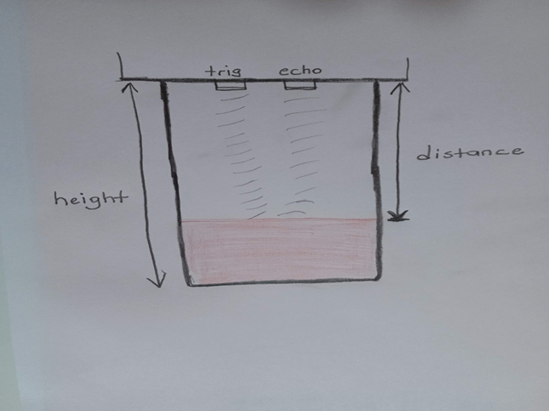
Picture provided by the author (Attribution CC-BY)

π=3.14
r=4.54
liquid height = container height-distance
volume = π x radius x (height of the container-distance)
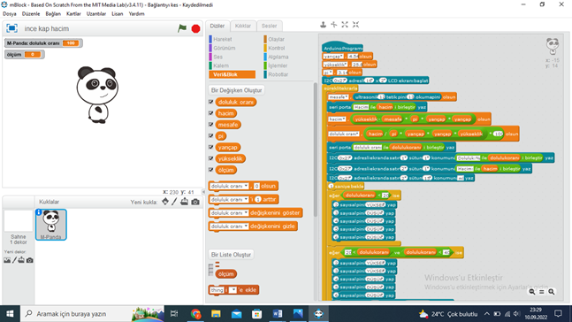
Picture provided by the author (Attribution CC-BY)

As can be seen in the image of the mBlock program, the volume has been mathematically formulated and coded. In addition, a coding has been created that will gradually light up according to the occupancy rate of the five LED bulbs connected to the container.

Between 0% and 20%, pin number two is entered as high and other pins as low. In this way, a single LED bulb is lit in this range.

2 led bulbs are on between 20%-40%.
3 led bulbs are lit between 40%-60%.
4 led bulbs are lit between 60%-80%.
5 led bulbs are lit between 80%-100%.

In addition, thanks to the buzzer used, it is possible to write a code that will give an audible warning when the container reaches a certain fullness.

Presentation of designs
The groups will present their work. See the section on “teaching resources” to gain ideas on online tools, including online video editing tools, that can be used to present the designs.
Learning products | See here a video of a students’ presentation (in Turkish). For more guidance, see pictures here or in Annex 2.
5th Lesson
non-STEM Subject – Visual Arts | Measurement with visual arts and designs | 1 hours
Students are asked to visually transform the Arduino uno and circuits they run as a result of coding into a stylish and useful design.
They are expected to test designs as a device to be sold as a marketer.

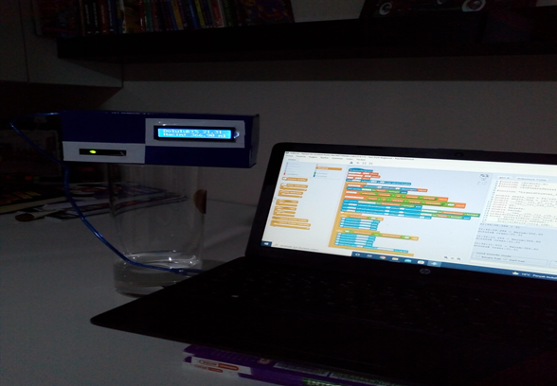
In practice, it has been seen that the volume of the liquid accumulating in the container can be measured precisely thanks to the HC-SR04 Ultrasonic sensor. It has been determined that the volume obtained by ultrasonic level measurement and the value measured in the graduated cylinder are 99% compatible.
Pictures provided by the author (Attribution CC-BY)
Learning products | New design.

Assessment
At this stage, the products of the student groups are evaluated in the discussion environment and in
line with the criteria of the problem. In this direction, the teacher can create a performance evaluation rubric (see Annex 3) and use it in the evaluation. The following questions can also be used:
- Do you think you have reached the most ideal design for the solution to the problem? Please elaborate on why the ideal design has been reached (or not).
- Briefly explain the engineering design process steps that you have followed in the second volumetric design.
- If you had enough time and the materials you wanted, what else would you do to improve your design? Please elaborate on your arguments.
Initial assessment
The initial assessment is comprised of the activity where students need to determine what materials are successful in measuring volume.
Formative evaluation
Student groups determine the positive and negative aspects of their own designs by observing and listening to the designs created by other groups.
Final assessment
All students rate the designs developed by their classmates. Students can also be assessed through a final quiz (see an example in Annex 3).
Student feedback
At the end of the activities, my students discovered that it is possible to measure volume by means of digital measurement other than mechanical measurement. This situation made them very happy and by enjoying the activities, all groups managed to create a material.
Teacher feedback
Student groups were very enthusiastic and successful in performing the literature review and proto-material design. They just had a hard time connecting the cables between the Arduino and the breadboard. In this aspect, they needed help from the ICT teacher.

Annexes

Annex 1: Pedagogical Trends in Education

PEDAGOGICAL TRENDS IN EDUCATION
Disclaimer: Information presented in this document has been previously partially published in the Scientix Newsletter “Pedagogical trends in education”, May 2019: http://files.eun.org/scientix/scx3/newsletter/Scientix-Newsletter-May-19.pdf

Inquiry-based science education
IBSE adopts John Dewey’s principle that education begins with curiosity (Savery, 2006), and makes students go through all the steps of scientific research: ask a question, develop a hypothesis, plan how to test this hypothesis, collect data, analyse the results and share it with peers (Pedaste et al. 2015). IBSE is ideal for science education, because it makes teaching more hands-on, and is perfect to learn how scientific research works. Students learn how to formulate questions answerable through experimentation. The teacher has both a facilitator role and an instructor role, making it an in-between method compared to full facilitation in problem-based, and instruction in project-based learning. However, the approach can be gradually made student-directed; students can start an IBSE project with a question provided by the teacher, and then can come up with their own questions to transfer what they learned for deeper learning.
IBSE does not only tap into creativity, problem-solving, and critical and analytical thinking. It also sets the stage for learning about how to collect and interpret data (become science and data-literate), and how to do this ethically and reliably. All these are skills of the 21st century, where data is abundantly available in every part of life.
As mentioned in the recent European Schoolnet publication, while inquiry-based science education (IBSE) has been already around in STEM education for decades, there is still much room for improvement in teachers’ development and continued dissemination of innovative pedagogical approaches. To highlight the impact of IBSE, its challenges, and the initiatives addressing these, we published the “Teacher Training and IBSE Practice in Europe, A European Schoolnet overview”.
Research shows that IBSE results in greater interest in Science, and motivation for STEM careers. Another important observation from the publication is that the benefits of IBSE are long-term and maintained, in contrast to the short-term acquisitions of traditional pedagogies that also come with less inclusion of both genders, and less interest in STEM.
One challenge is teacher support: teachers report that they receive little support in implementing IBSE in their classroom. Another challenge to IBSE is standard assessment: PISA tests, as well as end-of-secondary-education exams, are still more focused on recall and repeated-drill exercises, deterring the use of more diverse pedagogies. In order to better integrate inquiry-based methods in school curricula, standardized tests also need to evolve along with traditional pedagogies.

Problem, project and challenge-based learning
Problem-based learning (PBL) is a student-centred multi-disciplinary method that was initially adopted in medical education as a means to put multiple topics in context (Newman, 2003) PBL aims to make students good problem-solvers in the real world: for instance, to put knowledge from multiple disciplines into use, and be able to work with others productively. After all, real-world problems are hardly ever solvable by one single discipline and one single person.
A PBL activity consists of working on an open-ended, even ill-defined question, with no solution provided by the teacher. Students need to work collaboratively and devise a solution to the problem by themselves. The key component is that it is student-centred; students are more motivated when they are responsible for the solution to the problem, and when the whole process rests with them (Savery, 2006). Decades of research has established that although students who went through PBL do not necessarily score better on standardized exams, they are definitely better problem-solvers (Strobel & van Barneveld, 2009).
Project-based learning also involves collaborative learning and finding a solution to a problem. However, the process and the end product are more specified from the beginning. Students work on a project for an extended period of time, a project that will produce a solution to a complex question or solve a complicated problem. The role of the teacher is more active here because multiple obstacles are typically encountered in the production of something like a rocket, or a space habitat, and these obstacles mark the moments for the teacher to instruct specific topics.
Finally, with challenge-based learning (CBL) (Johnson et al. 2009), students are again asked to develop a solution to a problem. However, they are only provided with a “big idea”, a societal problem that they need to address with a challenge of their choosing (e.g. disinterest in mathematics, low upturn in elections). While the use of technology can be considered optional in other trends, technology needs to be incorporated in every step in CBL. Similar to project-based learning, there is an end product, although this product is determined in the process, not at the beginning. The focus is on the use of ICT in the collection of data and sharing the results.

Design thinking
If IBSE recreates scientific methodology in the classroom, design thinking (DT) does the same for design and prototype production. DT helps students develop the skill to identify problems and needs in the society, and entrepreneurship. DT can be implemented within problem or project-based learning; the difference is that the problem is identified by students, and the end product is a prototype to solve the problem. The product is tested and refined in multiple iterations. Students go through a cycle of steps: (1) empathize; (2) define; (3) ideate; (4) prototype; (5) test.

Blended-learning and the flipped classroom
In a classroom where all students are facing the instructor, each moment there will be students drifting from the topic, even if for thinking deeper about a specific point in the lecture. It is challenging to have the undivided attention of the whole classroom because each student has a different way of learning and a different pace. With online content, students can learn the material at home at their own pace. In turn, the teacher can use the classroom to engage students in debates, projects and group assignments. Blended-learning and flipped classroom are instructional strategies that help students learn in their own pace, and deepen their learning with making the most of classroom hours. Although these concepts are used interchangeably, they are slightly different: while blended learning complements online learning with class instruction and support, the flipped classroom requires students to learn the material before coming to class and do assignments and projects during class hours.

Content and Language Integrated Learning (CLIL)
Content and language integrated learning (CLIL) is a well-positioned pedagogical approach that emphasises on the integration of foreign language and thematic content within the context of all school subjects. CLIL is a pedagogical approach that allows to teachers and students use a foreign language as the medium of instruction in non-linguistic subjects, allowing this way the practice and improvement of both the second language and the immersion to subjects that may vary from science subjects to humanities. According to Cenoz et al. (2013) "the European Commission and the Council of Europe have funded many initiatives in support of CLIL because it responded to a need in Europe for enhancing second-language (L2) education and bilingualism that was well-received" and research further supports that CLIL is applied successfully in task-based pedagogies. In addition, when it comes specifically to the application of CLIL in the science classroom there are specific advantages including enabling learners to learn a school subject that exists in their curriculum using the respective second language they are learning, provide authentic learning settings while using the resources available at their school and support learners’ cognitive skills by equally supporting language practice and the teaching of science context.

References
- Bowers, C. (2002). Toward an eco-justice pedagogy. Environmental Education Research, 8 , 21–34.
- Cenoz, J., Genesee, F., Gorter,D., Critical Analysis of CLIL: Taking Stock and Looking Forward, Applied Linguistics, Volume 35, Issue 3, July 2014, Pages 243–262, https://doi.org/10.1093/applin/amt011
- Durando, M., Sjøberg, S., Gras-Velazquez, A., Leontaraki, I., Martin Santolaya, E. & Tasiopoulou, E. (2019). Teacher Training and IBSE Practice in Europe – A European Schoolnet overview. March 2019, European Schoolnet, Brussels.
- Gabillon, Z., Ailincai, R. (2013) CLIL: A Science Lesson with Breakthrough Level Young EFL Learners, Education, Vol. 3 No. 3, 2013, pp. 168-177. doi: 10.5923/j.edu.20130303.05. Hadjichambis, A. “Pedagogical Approaches on the Education for Environmental Citizenship”. 1st European Training School, Lisbon, Portugal, October 24-45, 2018.
- Johnson, L.F., Smith, R.S., Smythe, J.T. & Varon, R.K. (2009) Challenge-Based Learning: An Approach for Our Time. Austin, Texas: The New Media Consortium. Retrieved April 17, 2019 from https://www.learntechlib.org/p/182083/.
- Kemmis, S., McTaggart, R., Nixon, R. (2013) The action research planner: Doing critical participatory action research. Springer, London.
- Lorenzo, F., Casal, S., Moore, P., The Effects of Content and Language Integrated Learning in European Education: Key Findings from the Andalusian Bilingual Sections Evaluation Project, Applied Linguistics, Volume 31, Issue 3, July 2010, Pages 418–442, https://doi.org/10.1093/applin/amp041
- Newman, M. (2003) A pilot systematic review and meta-analysis on the effectiveness of problem-based learning. Retrieved December 12, 2005 from: http://www.ltsn-01.ac.uk/docs/pbl_report.pdf
- Nikula, T. (2015). Hands-on tasks in CLIL science classrooms as sites for subject-specific language use and learning. System, 54, 14-27.doi:10.1016/j.system.2015.04.003
- Pedaste, M., Mäeots, M., Siiman, L.A., de Jong, T., van Riesen, S. A. N., Kamp, E. T., Manoli, C. C., Zacharia Z. C. & Tsourlidaki, E. (2015) Phases of inquiry-based learning: Definitions and the inquiry cycle. Educational Research Review, 14, 47-61.
- Savery, J. R. (2006) Overview of problem-based learning: Definitions and distinctions. Interdisciplinary Journal of Problem-Based Learning, 1 (1).
- Schusler, T.M. & Kransy, M.E. (2015) Science and Democracy in Youth Environmental Action – Learning ―Good‖ Thinking. In M. P. Mueller and D. J. Tippins, EcoJustice, (Eds.), Citizen Science and Youth Activism Situated Tensions for Science Education (pp. 363–384). Cham, Switzerland: Springer.
- Strobel, J., & van Barneveld, A. (2009) When is PBL More Effective? A Meta-synthesis of Meta-analyses Comparing PBL to Conventional Classrooms. Interdisciplinary Journal of Problem-Based Learning, 3(1).
- Tidball, K.G. and M.E. Krasny. (2010) Urban environmental education from a social-ecological perspective: conceptual framework for civic ecology education. Cities and the Environment. 3(1): 11. http://escholarship.bc.edu/cate/vol3/iss1/11. 20 pp.
- Tippins D., Britton S.A. (2015) Ecojustice Pedagogy. In: Gunstone R. (eds) Encyclopedia of Science Education. Springer, Dordrecht

Annex 2: Pictures

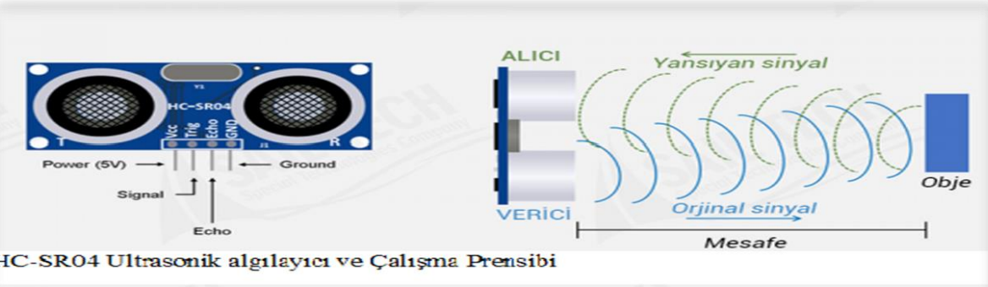

Source: https://www.sailteknoloji.com/blog/hc-sr04-ultrasonik-mesafe-olcum-sensoru-ozelliikleri-nedir-nasil-calisir-b35.html#:~:text=HC%2D%20SR04%20Ultrasonik%20Mesafe%20Sens%C3%B6r%C3%BC,ECHO%20pini%20aktif%20hale%20gelir.
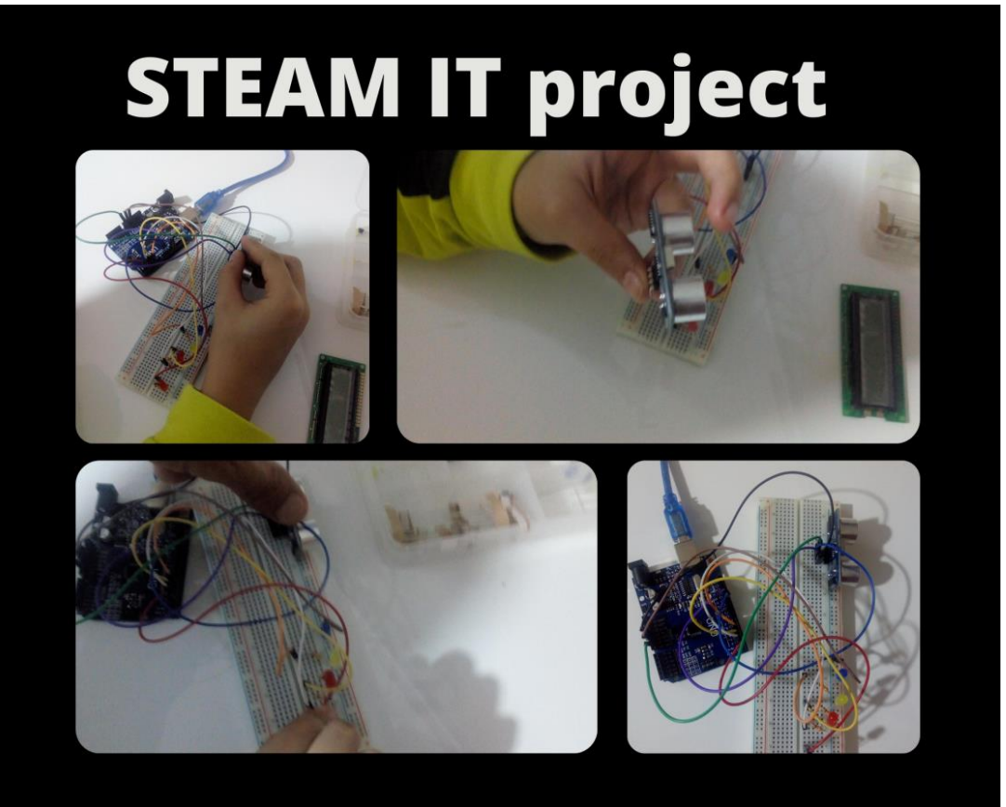

Picture provided by the author (Attribution CC-BY)
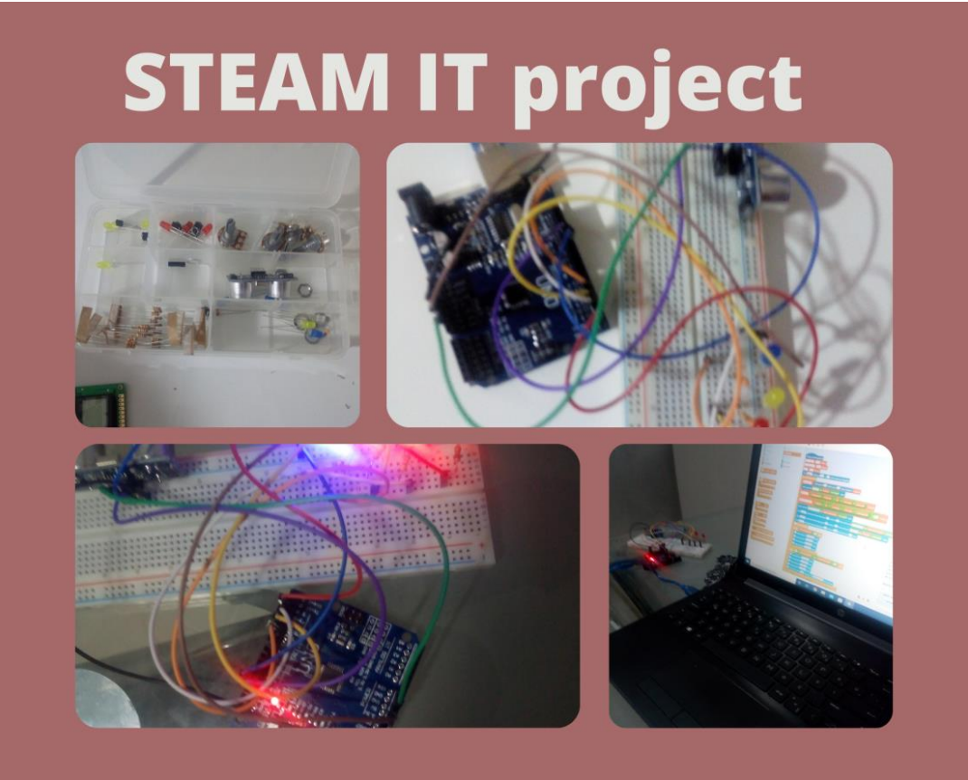

Picture provided by the author (Attribution CC-BY)

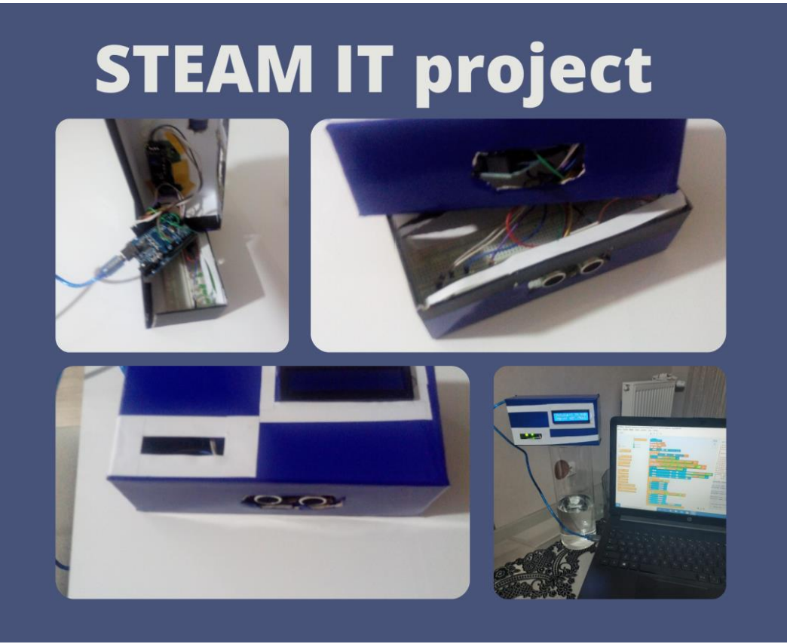

Picture provided by the author (Attribution CC-BY)
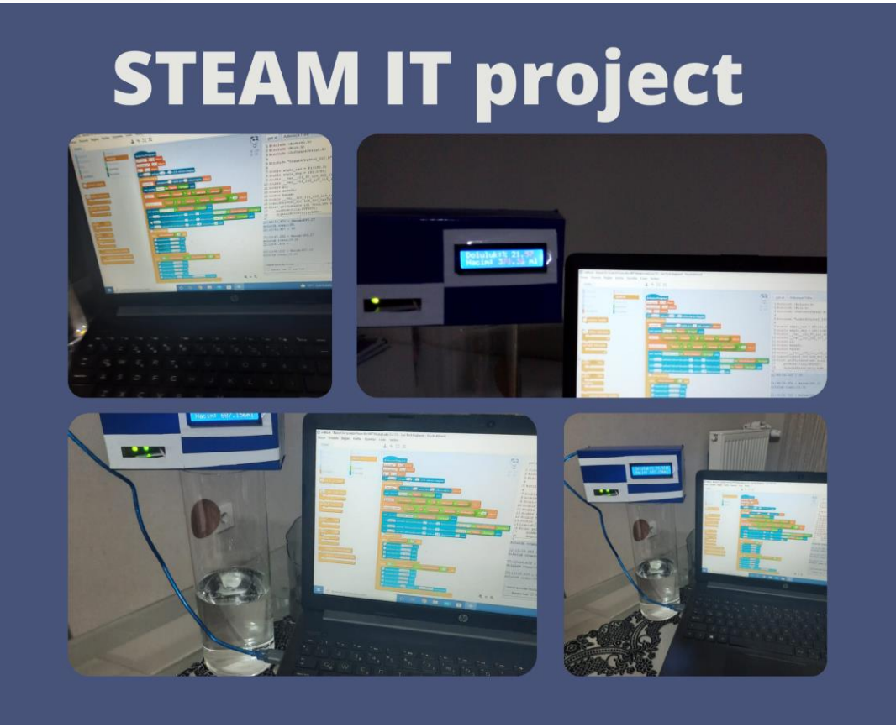

Picture provided by the author (Attribution CC-BY)

Annex 3: Performance Evaluation Rubric

Sequence No. | Group Name | Making a study plan in accordance with the problem situation (10) | Using the requested information (10) | Gathering and writing information from different sources (10) | Doing the homework according to the plan (10) | Making the study neat and clean (10) | Using the creativity ability (10) | Preparing the material in accordance with its purpose ( 30) | Deliver work on time (10) | NOTE
- 1
- 2
- 3
- 4
- 5

Annex 4: Final Quiz Example

1. Which of the following is your volume measurement method used in your project?
A) Electrode (conductive) based
B) Ultrasonic based
C) Radar based
D) Laser based

2. What is the unit of volume?
a) cm
B) cm2
C) cm3
D) mm

3) The piece of stone in the figure is placed into the graduated cylinder. What is the volume of this
piece of stone?
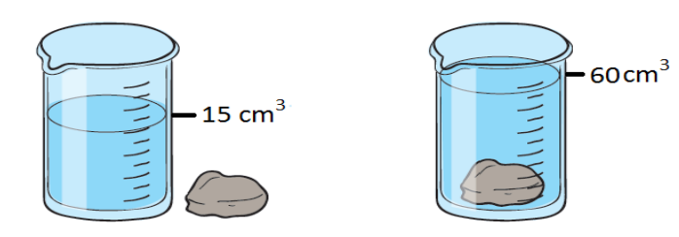
A) 60 cm3
B) 45 cm3
C) 30 cm3
D) 15 cm3

Source: https://yazili-sorulari.com/katilarin-hacmi-nasil-olculur/

