NATURE-BASED SOLUTIONS LEARNING SCENARIO
Nature-Based Solutions (NBS) for Climate Mitigation and Adaptation

Nature-Based Solutions (NBS) for Climate Mitigation and Adaptation
European Commission
Directorate-General for Research and Innovation
Healthy Planet – C3 - Climate and Planetary Boundaries
CDMA 03/154
Contact Josefina ENFEDAQUE
Email josefina.enfedaque@ec.europa.eu
RTD-PUBLICATIONS@ec.europa.eu
European Commission
B-1049 Brussels
Manuscript completed in October 2020.
1st edition.
This document has been prepared for the European Commission, however it reflects the views only of the authors, and the European Commission is not liable for any consequence stemming from the reuse of this publication.
More information on the European Union is available on the internet (http://europa.eu).
Luxembourg: Publications Office of the European Union, 2020
© European Union, 2020
The reuse policy of European Commission documents is implemented based on Commission Decision 2011/833/EU of 12 December 2011 on the reuse of Commission documents (OJ L 330, 14.12.2011, p. 39). Except otherwise noted, the reuse of this document is authorized under a Creative Commons Attribution 4.0 International (CC-BY 4.0) license (https://creativecommons.org/licenses/by/4.0/). This means that reuse is allowed provided appropriate credit is given and any changes are indicated.
For any use or reproduction of elements that are not owned by the European Union, permission may need to be sought directly from the respective right holders. The European Union does not own the copyright in relation to the following elements:
Cover page: © [Ping198 + 302210979]. Source: [stock.adobe.com]

EUROPEAN COMMISSION

NATURE-BASED SOLUTIONS LEARNING SCENARIO
Nature-Based Solutions (NBS) for Climate Mitigation and Adaptation

Juan Carlos Navarro García

Directorate-General for Research and Innovation
2020 EN

Table of Contents
Keywords 3
1. Introduction 3
2. Overview 3
3. Integration into the curriculum 5
4. Aim of the lesson. 5
5. Outcome of the lesson 5
6. Trends 5
7. 21st century skills 5
8. Activities 5
Annex 1: Review the parts of a tree 8
Annex 2: Eco-friendly schools’ map 11
Annex 3: POT BY POT... FLOWER POT! 12

- Abstract
Climate mitigation and adaptation are attempts to slow down the global climate-change process. This can be done in different ways:
- reducing the greenhouse gases that go into the atmosphere (1)
- absorbing existing CO2 from the air (2)
Plants and trees absorb and reduce = CO2 present in the air and are also viable NBS to fight the adverse impact of climate change and loss of biodiversity. Our learning scenario (LS) incorporates the following NBS focusing, on the one hand, on green vegetation for health and wellbeing and, on the other, on participatory planning and action:
- a school vegetable garden that will reduce greenhouse gases in the atmosphere and provide food and plants that improve students’ health and wellbeing.
- a green network of schools to foster student participation and action at a local level (see map of Eco-friendly schools joining after implementing this NBS Learning Scenario: https://padlet.com/eunacademy/vh0rymigpclqvrji).

Keywords
Climate change, environmental education, climate adaptation, NBS, reforestation, recycling, reduce greenhouse gases.

Introduction
“Nature-based solutions (NBS) are solutions that are inspired and supported by nature, which are cost-effective, simultaneously provide environmental, social and economic benefits and help build resilience. Such solutions bring more, and more diverse, nature and natural features and processes into cities, landscapes, and seascapes, through locally adapted, resource-efficient and systemic interventions. Nature-based solutions must therefore benefit biodiversity and support the delivery of a range of ecosystem services.” https://ec.europa.eu/info/research-and-innovation/research-area/environment/nature-based-solutions_en
To use this Learning Scenario more effectively, teachers are encouraged to:
- Check out the list of recent EU publications on Nature-Based solutions
- Read about Nature-based solutions: Transforming cities, enhancing well-being (also available as a PDF)
- Contact local NBS practitioners or scientists working in their area (they can be found through Oppla).
- Use the “Ask Oppla” service to request help in case of any technical/scientific question on NBS.

Overview
Table of summary
Subject | English, Computer Assisted Language Learning, Environmental Studies
NBS topic | Climate mitigation and adaptation
Recommended age of students | 8–9-year-old students
Preparation time | Activity 1: Review the parts of a tree: 45’.  Activity 2. Create a vegetable garden: 150’.  Activity 3. Create a vertical vegetable garden 150’.  Activity 4. Join the network of eco-friendly schools 15’.
Teaching time | Activity 1: Review the parts of a tree: 30’.  Activity 2. Create a vegetable garden: 50’.  Activity 3. Create a vertical vegetable garden 50’.  Activity 4. Join the network of eco-friendly schools 15’.
Online teaching material | Web from allotment CEIP José Ortega y Gasset: https://huertoescolarceuta.wixsite.com/ortegaygasset  Scholar Allotments (vegetable gardens): https://huertoescolarceuta.blogspot.com.es  Vertical gardens (recycling water bottles): www.youtube.com/watch?v=GxVujAVm3nQ  To identify plants with QR codes : https://es.qr-code-generator.com  App to create on-line presentation/introduction: http://www.duckduckmoose.com/educational-iphone-itouch-apps-for-kids/chatterpix/  Webpage from Ecoembes related to environmental education: https://www.naturalizaeducacion.org/  Video Lil Dicky: https://www.youtube.com/watch?v=S2SMvfGe72U  Videos related to sustainability (Spanish):  - Tips on sustainability: http://video.lab.rtve.es/resources/TE_NGVA/mp4/2018/huella-ecologica/tips.mp4  - Tips on sustainability and water: http://video.lab.rtve.es/resources/TE_NGVA/mp4/2018/huella-ecologica/tipsHidrica.mp4  - Tips on sustainability and carbon: http://video.lab.rtve.es/resources/TE_NGVA/mp4/2018/huella-ecologica/tipsCarbono.mp4  - Tips on sustainability and soil: http://video.lab.rtve.es/resources/TE_NGVA/mp4/2018/huella-ecologica/tipsSuelo.mp4  - Tips on Sustainability and materials: http://video.lab.rtve.es/resources/TE_NGVA/mp4/2018/huella-ecologica/tipsMateriales.mp4  Additional resources (in English or without any audio):  - http://www.youtube.com/watch?v=GxVujAVm3nQ – Vertical gardens (recycling water bottles)  - https://www.youtube.com/watch?v=pvuN_WvF1to (Lil Dicky - Earth Official Music Video)  - https://youtu.be/0e2zK0v2XPA (Lemon short film)  - https://youtu.be/r60R8kKXt5U (NGO Project: Plastic Tears)  - https://youtu.be/rTXudHZM39Q (The Forest)
Offline teaching material | Plastic water bottles used as containers or flowerpots to build the vertical garden, soil, plants or seeds, cutter.
NBS resources used | - Informative guide on NBS and relevant pedagogical approaches: NBS for Climate Change Mitigation and Adaptation https://www.ecologic.eu/sites/files/publication/2014/eco_bfn_nature-based-solutions_sept2014_en.pdf  - Webpage from related to environmental education: https://www.naturalizaeducacion.org/  - Edible City Solutions (EdiCitNet) for a Better World  - EdiCitNet Handbook and EdiCitNet Toolbox  - Urban Green Up on Green Space Management  - Grow Green Cities: Vertical Gardens and reused water for irrigation  - European Commission – Definition of NBS

Integration into the curriculum
NBS can be included in English as a foreign language due to the fact that students already deal with contents such as: parts of a tree, parts of a plant, numbers or measures, weather, seasons of the year, animals (such as bees and insects to pollinate). The part of the LS that deals with gardening can be incorporated into natural sciences classes, while the activities relating to the school network can be incorporated into social science classes (in addition to extra-curricular activities). The learning scenario, therefore, fits well into the Spanish national curriculum. Furthermore, this LS can be interdisciplinary and implemented by more than one teacher as a collaborative implementation.

Aim of the lesson.
The aim is to make students aware of how NBS can help tackle climate change and loss of biodiversity and promote a positive attitude towards environmental actions and change-making in the students. This scenario also allows students to create gardens (vegetable allotment and vertical) and teaches them how to take care of their local environment.

Outcome of the lesson
The outcome of the lesson will be tangible because students will end up building a vertical vegetable garden and planting in the created allotments. Moreover, students will be part of a network of eco-friendly schools, sharing activities or experiences with other students.

Trends
Informal Learning: learning happens in communities and Personal Learning Networks rather than in formal settings like a school.
Outdoor Education: learning outside of the school building in the “real” environment.
Civic awareness and eco-justice pedagogy

21st century skills
This learning scenario corresponds to 21st century skills because students are going to use ICT to produce some of the open source tools, they are going to deal with webpages or apps. They will be working in teams, thus improving their collaborative skills. Furthermore, they will develop their:
- environmental competence/conscience, climate change awareness
- creativity
- digital competences
- communication skills, transversal skills, and talents

Activities
Activity | Procedure | Time
Activity 1: Review the parts of a tree
Step 1 | With the help of the worksheet provided in Annex 1, review the parts of a tree or a plant, and discuss the seasons and the leaves’ lifecycle. In this activity students will draw a tree and match the words on the right-hand side with the parts of the tree they draw. They will then draw a second tree, and fill in the questionnaire about the size, colours, feels, and smells of their trees and its components. Finally, students will match the statements in the last activity to the different trees and complete the trees’ images according to the season. | 45’
Activity 2: Create a mini-vegetable garden
Step 0 | There are two possible options depending on how much space is available:  - buying a wooden vegetable garden from a shop, or  - building it using recycled material such as a wooden pallet. If we choose the second option, a person in charge would be responsible for doing this part of the activity because of security reasons due to the fact that a jigsaw will be needed to cut the pallet in four parts and then join the parts with screws. | 45’
Step 1 | Once the wooden vegetable garden is ready, students will be introduced to the process of preparing allotments and then, they will have to find an appropriate location before starting with the rest of the activities. After figuring out the right spot, students will prepare it with soil. Students will be divided into groups, some of them will put the soil in the wooden garden, some of them will move and air the soil with tools; some of them will put the seeds in the soil and the last group will water the seeds. At this point it would be advisable to introduce students to the theoretical concept of NBS and give them a definition. Because of their young age, the teacher will need to break down the definition for them and explain it thoroughly using the activity they just did as an example. | 50’
Step 2 | Every two or three days, a group of students will be assigned to look after the growth of the seeds planted, only watering the allotment if needed. They will learn on how plants grow, and they will be able to collect the resulting produce. They will be encouraged to take photos and check how the process is going on. The students will use QR codes to produce identification cards for the plants. | 50’
Activity 3: Create a vertical vegetable garden
Step 0 | Students will be shown a YouTube tutorial on how to create a vertical garden with plastic water bottles. Students will be encouraged to save water bottles at home, which will be then used for the vertical garden. The video will last 5 minutes. | 5’
Step 1 | Once the person in charge prepares the bottles, students will bring soil to the class and put soil in different bottles. | 25’ – 30’
Step 2 | The students will plant the seeds or seedling of the vegetables selected beforehand. | 15’
Step 3 | In another session, students will produce a QR code to identify seeds and plants in the vegetable garden, so they will have to investigate and search for information related to the plants planted in the vertical garden and then they will have to produce QR codes using free open source websites.  If this activity is not possible due to online learning or unavailability of materials, another option is to create a common vegetable garden with play dough or clay as seen in this link: https://www.slideshare.net/josedurangarcia3/make-your-own-plasticine-garden-for-kids-steps-34 | 50’
Activity 4: Join the network of eco-friendly schools
Step 0 | Schools carrying out this task, will share the location of their activities through https://padlet.com/eunacademy/vh0rymigpclqvrji These schools should:  - have used Nature Based Solutions for climate mitigation and adaptation as far as possible.  - know about Nature Based Solutions and develop actions and activities to reduce greenhouse effects and climate change.  - developed activities to foster awareness about environmental education.  - foster and encourage team work to develop sustainable actions to take care of the environment.  - know the biodiversity of landscapes, flora, and wildlife of our environment.  Any school that works on NBS, following this Learning Scenario, is welcome to add their information in the map (name of school, address, contact information of the teacher and NBS action taken. Check Annex 2 for an example from the school of the author of this learning scenario. | 50’

Annex 1: Review the parts of a tree
Name & surnames: _____________________________________
Date: ______________________________________________
What is the weather like today? It’s ________________________
Parts of a tree
Draw a tree and match the words to the picture

TRUNK

BARK

FRUIT

LEAVES

ROOTS

FLOWER

BRANCH

My First Tree
Draw your tree

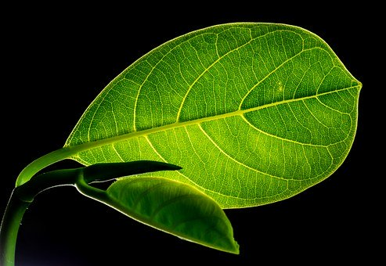 | Leaves: | Size:
 | Yes | Big |  | Small
 | No
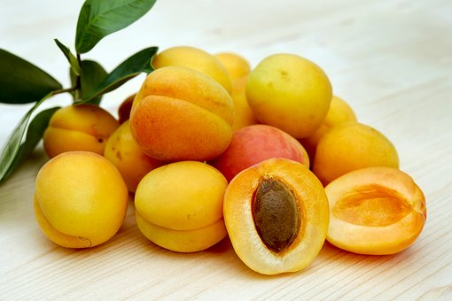 | Fruit: | Colours:
 | Yes | ___________________________________________________________________________________________________________________________________________________
 | No
 | Flowers: | Touch it | Smell it | 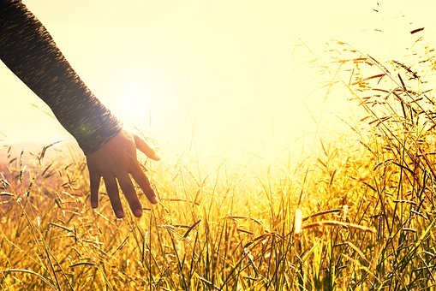
 | Yes | It’s yucky
 | No | It’s nice

Note: All the pictures are CC-0, taken from pixabay.com
Seasons
Complete the trees. Leaves’ lifecycle
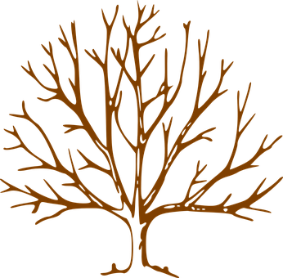  A In Spring... | B In Summer...
C In Autumn... | D In Winter...
When? …
It’s my birthday I go to the beach
Flowers and leaves grow School finishes
It’s cold It snows
School begins It’s hot
There are no leaves on the tree All the leaves fall from the tree
Note: All the pictures are CC-0, taken from pixabay.com

Annex 2: Eco-friendly schools’ map

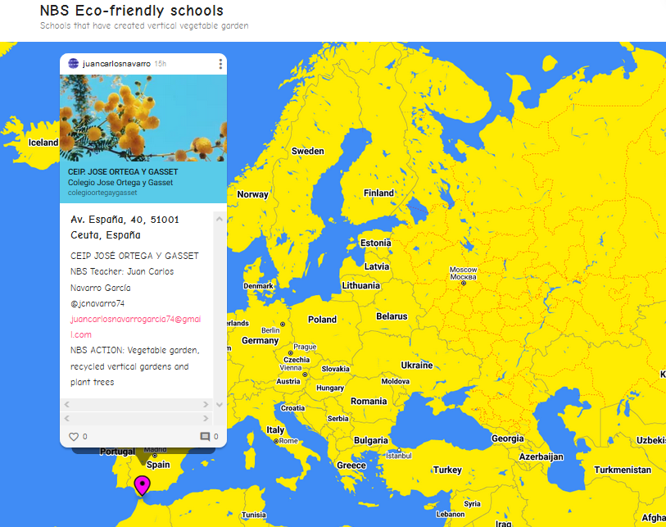

Annex 3: POT BY POT... FLOWER POT!
DESCRIPTION: students are asked to design their own flower/plant pots using recycled plastic containers from daily life activities. They should take used small plastic containers. Decorate them, make holes in the bottom so that the seeds can breathe and grow slowly. They should fill the container with soil, water the soil and plant the seeds. As an extra they can identify the plants using QR codes.
PREPARATION TIME: 45'approx.
TEACHING TIME: 10' approx.
GROUPING: individual, pair work, group work, teamwork, family work.
MATERIAL: plastic container, water, soil, seeds, cutter and light
EVIDENCE: students can share their flowerpots uploading their creations to a Padlet and their school can be part of the NBS network educational centres.
AGE: 8 – 9, but according to their ages, it can be flexible and adaptable, making the activity easier or more complicated.
OBJECTIVES: Climate mitigation and adaptation are connected to attempts to slow down the process of global climate change. This can be done in different ways:
- reducing the greenhouse gases that go into the atmosphere.
- absorbing existing CO2 from the air
21st CENTURY SKILLS:
- environmental competence/conscience
- creativity
- climate change awareness
- digital competences
OUTCOMES: The outcome of the lesson will be tangible because students will be able to create a flower/plant pot. Moreover, students would be able to create a network of eco-friendly schools sharing activities or experiences with other students using digital tools like Padlet.
AIMS:
- To make students aware about importance/impact of climate change and start creating a positive attitude towards environmental actions.
- To teach them take care of plants.
- To identify plants using QR codes.

Getting in touch with the EU
IN PERSON
All over the European Union there are hundreds of Europe Direct information centres.
You can find the address of the centre nearest you at: https://europa.eu/european-union/contact_en

ON THE PHONE OR BY EMAIL
Europe Direct is a service that answers your questions about the European Union.
You can contact this service:
– by freephone: 00 800 6 7 8 9 10 11 (certain operators may charge for these calls),
– at the following standard number: +32 22999696, or
– by email via: https://europa.eu/european-union/contact_en
Finding information about the EU
ONLINE
Information about the European Union in all the official languages of the EU is available on the Europa website at: https://europa.eu/european-union/index_en

EU PUBLICATIONS
You can download or order free and priced EU publications from:
https://op.europa.eu/en/publications. Multiple copies of free publications may be obtained by contacting Europe Direct or your local information centre (see https://europa.eu/european-union/contact_en)

EU LAW AND RELATED DOCUMENTS
For access to legal information from the EU, including all EU law since 1952 in all the official language versions, go to EUR-Lex at: http://eur-lex.europa.eu

OPEN DATA FROM THE EU
The EU Open Data Portal (http://data.europa.eu/euodp/en) provides access to datasets from the EU. Data can be downloaded and reused for free, for both commercial and non-commercial purposes.

About the NBS project

The NBS project is initiated and funded by the European Commission Directorate-General for Research and Innovation and coordinated by PPMI, in collaboration with European Schoolnet (EUN). PPMI (www.ppmi.lt/en) is a leading European research and policy analysis centre, aiming to help public sector and civil society leaders from around the world, presenting evidence in a way that is simple, clear and ready to use. European Schoolnet (www.eun.org) is the network of 34 European Ministries of Education, based in Brussels. EUN aims to bring innovation in teaching and learning to its key stakeholders: Ministries of Education, schools, teachers, researchers, and industry partners. Find out more about nature-based solutions: https://ec.europa.eu/research/environment/index.cfm?pg=nbs and all the NBS Learning Scenarios created in this project as well as the overall reports can be found at http://www.scientix.eu/pilots/nbs-project

The NBS project pilot has also been supported by the STE(A)M Partnerships programme of Scientix, funded from the European Union’s H2020 research and innovation programme – project Scientix 4 (Grant Agreement N. 101000063), coordinated by European Schoolnet (EUN). The content of the document is the sole responsibility of the organizer and it does not represent the opinion of the European Commission (EC), and the EC is not responsible for any use that might be made of information contained.
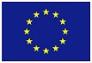

[Catalogue number]

Climate mitigation and adaptation are attempts to slow down the global climate-change process. This can be done in different ways:
- reducing the greenhouse gases that go into the atmosphere (1)
- absorbing existing CO2 from the air (2)
Plants and trees absorb and reduce = CO2 present in the air and are also viable NBS to fight the adverse impact of climate change and loss of biodiversity. Our learning scenario (LS) incorporates the following NBS focusing, on the one hand, on green vegetation for health and wellbeing and, on the other, on participatory planning and action:
- a school vegetable garden that will reduce greenhouse gases in the atmosphere and provide food and plants that improve students’ health and wellbeing.
- a green network of schools to foster student participation and action at a local level (see map of Eco-friendly schools joining after implementing this NBS Learning Scenario: https://padlet.com/eunacademy/vh0rymigpclqvrji).

Studies and reports

Personal Learning Networks consist of the people a learner interacts with and derives knowledge from outside formal education.
If either option is not possible, teachers/students may consider planting the mini-vegetable garden with reused materials found in their homes. A suggestion for this activity can be found in Annex 3.

