The BLOOM School Box

Future Classroom Scenario
Growing plastic & new life for plastic
This scenario is part of the BLOOM School Box, which consists of a set of five Future Classroom Scenarios combining bioeconomy into science, technology, engineering and mathematics (STEM) subjects. These resources were developed and tested in classrooms by 20 BLOOM expert teachers from 10 different countries.
This Future Classroom Scenario has been developed as part of the BLOOM project, using the methodology of the Future Classroom Toolkit (http://fcl.eun.org/toolkit).
This work is licensed under Attribution-ShareAlike 4.0 International (CC BY-SA 4.0) license.

Authors:
Costantina Cossu, Nele Deckx, Seppe Hermans, Caterina Mura

Table of contents
Area / Subject 2
Relevant Trends 2
Learning Objectives and Assessment 2
Learner’s Role 3
Tools and Resources 3
Learning Space 4
Future Classroom Scenario Narrative 4
Learning Activities 7
Annexes 8

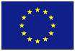
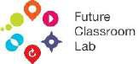
BLOOM has received funding from the European Union’s Horizon 2020 research and innovation programme under grant agreement No. 773983. Neither the European Commission nor any person acting on behalf of the Commission is responsible for how the following information is used. The views expressed in this publication are the sole responsibility of the authors and do not necessarily reflect the views of the European Commission.

Area / Subject
In which subject(s) or area of expertise can the scenario be used?

Subjects: Biology, Technology, Engineering, Environmental Education, Chemistry, Statistics

There are two subjects within which it is possible to implement this scenario:
- Science: including chemistry lab (Lesson 3)
- Engineering: including computer lab & 3D printer (Lesson 4) It is possible to have an interdisciplinary lesson or just one of the two. Curriculum: national secondary school 1st and 2nd level
Age of students: 11 to 18 years old

Relevant Trends
Relevant trend(s) the Scenario is intended to respond to. E.g. at http://www.allourideas.org/trendiez/results

Project-based learning: students get fact-based tasks, problems to solve and they work in groups. This kind of learning usually transcends traditional subjects.
STEM learning: increased focus on Science, Technology, Engineering and Mathematics.
Edutainment: playful learning. Learning while having fun.
Flipped Classroom: students master basic concepts of the topic at home. Time spent in classroom is used to reflect, discuss and develop the topic.
Collaborative learning: a strong focus on group work.
Lifelong learning: learning does not stop when leaving school.
Mobile learning: students get access to knowledge through smartphones and tablets. It is learning anytime, anywhere.
BYOD (Bring your own device): Students bring their own mobile devices to the classroom. Additional educational trends:
- Investigate
- Know-how
- Give new life to materials

Learning Objectives and Assessment
What are the main objectives? What skills will the learner develop and demonstrate within the scenario? (e.g. 21st Century Skills). How will the progress in achievement be assessed, ensuring the learner has access to information on their progress so they can improve?

Students will develop the following skills:
Collaboration: During group work, students have to collaborate.
Communication: During the discussions, students have to share ideas and learn to communicate.
Science & engineering: Students work in the science lab to “make plastic” and they have to draw
a keychain for the 3D printer.
Civic competence: Students are encouraged to understand the problem of plastic pollution.
Entrepreneurship: Students create something new out of plastic.
Digital competence: Students analyse plastic and micro-plastic with a microscope and smartphone. They use an online software to design a keychain.

Assessment:
- Analyse and discuss in group
- Environmental activities at the beach: collect, classify and weigh the plastic
- Experimental laboratory:
  - Identify 7 types of plastics
  - Identify micro-plastics in cosmetics and make the statistical calculation by unit and by local population
- Create bio-plastics from potatoes and plant residues
- Recycle and give new life to plastic
- Print in 3D
- Assessment methods at the end of lesson or experiment: quiz, questionnaire, experimental log

Learner’s Role
What sort of activities will the learner be involved in?

Investigate: Students are doing research on the topic Collaborate: Students are involved in group work Design: Students design their own keychain
Present: Students should present the outcome of their work
Discuss: Groups should discuss about the outcome of their investigations

Tools and Resources
What resources, particularly technologies, will be required?

Tools:
Internet: students should have Internet access to do research and to use Tinkercad to design their keychain.
- Smartphone: students will need a smartphone to analyse the plastics.
- Materials for the lab (lesson 4).
- Google Drive or another online application to share documents

Resources:
- Video “Bioeconomy start here”: https://www.youtube.com/watch?v=2xvXkOMRTs4 [in English]
- “Plastic pollution and marine debris”: www.marlisco.eu and http://malia.airicerca.org/ [in English]
- Micro-plastics: https://www.scienceinschool.org/content/microplastics-small-deadly [in Polish, English and Italian]
- Different kinds of biopolymers: https://polymerinnovationblog.com/biobased-or- biodegradable-polymers-whats-the-difference/ [in English]
- Bioplastics: https://www.european-bioplastics.org and https://www.youtube.com/watch?v=Dt8V0UShxPE [in English]

What resources, particularly technologies, will be required?

- Laboratory activity: http://www.rsc.org/Education/Teachers/Resources/Inspirational/resources/3.1.7.pdf [in English]
- What is 3D printing and how does it work?: https://www.youtube.com/watch?v=Vx0Z6LplaMU [in English]
- To make a 3D Design in Tinkercad, follow instructions in the “Tinkercad Keychain”
document in the Annexes.

Learning Space
Where will the learning take place e.g. school classroom, local library, museum, outdoors, in an online space?

- The research and discussions can be carried out in the classroom.
- For “making” plastic, the Chemistry lab is needed.
- For creating the keychain, a computer lab is needed.

Future Classroom Scenario Narrative
The detailed description of the activity
- The scenario enhances the following topics: pollution, organic solutions, biopolymers, making bioplastic, product design and 3D printing.
- Each part is a lesson of 45 minutes, except the part “Making bioplastic”, which will take
approximately 1 hour.
- The teacher may choose to implement both practical lessons to bring new life in plastic, or just one of them.
- The scenario can be done in class with students from age 11 until 18.

Breakdown of lessons:
- Lesson 1: Introduce students to the topic of plastic pollution.
- Lesson 2: Investigate and discuss about different kinds of plastic.
- Lesson 3: Practical Science: including carrying out experiments in the Chemistry lab.
- Lesson 4: Practical Engineering: including working in the computer lab and with the 3D printer.

Lesson 1: Plastic pollution (45 minutes)
- The teacher introduces the topic of plastic pollution. Take inspiration from the following article: http://coastalcare.org/2009/11/plastic-pollution/ [in English] or http://theconversation.com/we-are-guinea-pigs-in-a-worldwide-experiment-on- microplastics-97514 [in English]
- After the introduction, the teacher explains that the main idea is to know plastics well, catalogue them, and recycle them. It is possible to create creative objects from the plastic we collect.
- The class analyses the pictures and articles about the topic of plastic pollution and marine debris, recycling and bioeconomy. Take inspiration from [both in English]: www.marlisco.eu and http://malia.airicerca.org/
- The class discusses the topic in groups. Then, still in groups, students classify the type of plastic pollution at hand: micro-plastic, macro-plastic, etc.

The detailed description of the activity
- For the next activity, use the document “Identify 6 types of plastic” in the Annex 1
- After this, the class discusses possible reasons for plastic pollution in our seas. Students should formulate different hypotheses.
- Read this article [in English] again and find out why there is so much plastic in the sea. The class should check if their hypothesis is correct.

Lesson 2: Real labs (1 hour + exchanging results in the laboratory)
- Aim of the lesson: Investigate and discuss about different kinds of plastic and micro- plastics in the water.
- Students have one hour to experiment in three different groups. Each group receives a different resource (see below).
- After the 1 hour, they exchange their results.
- Resources (find all in the Annexes):
  - What’s hidden in our sand? [Annex 2]
  - What’s hidden in our laundry water? [Annex 3]
  - What’s hidden in the water when you use cosmetics? Microbeads in cosmetics [Annex 4]
  - Resource to give to each group: “How to identify different types of plastic” [Annex 5]
  - To identify the collected marine litter, you can use with your students, this resource [in Portuguese] called “Marine Litter – Collected Litter”: https://ambienteeuropeo.org/wp-content/uploads/2018/08/AAE-TARJETA-DE- DATOS_ESP.pdf

Lesson 3 : Organic solution - Bioplastics (45 minutes)
- During this lesson, students explore the possibilities of bioplastics and familiarize themselves with different terminologies. The world of bioplastic is very diverse.
- Read this article and watch this video (https://www.european-bioplastics.org and https://www.youtube.com/watch?v=Dt8V0UShxPE, both in English) to become familiar with bioplastics.
- Discuss in groups:
  - Why use bioplastics?
  - What is the difference between biodegradable and bio-based?
  - Which one would you use and why?
  - What are the consequences? (pros and cons)
  - Recycling
  - Bioeconomy
- Worksheet to use can be found in the Annex 6

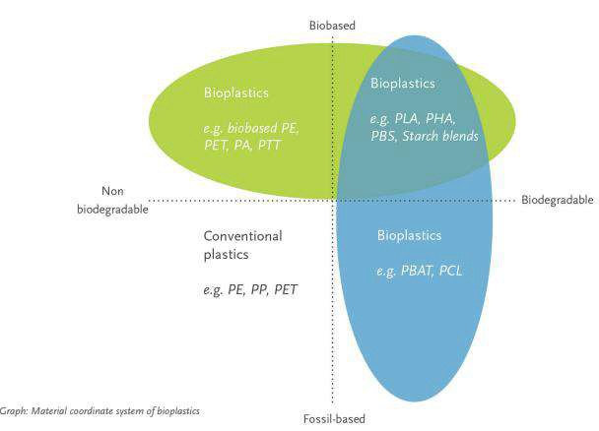

Figure 1: Source: FACT SHEET European Bioplastics / www.european-bioplastics.org

Lesson 4: Making bioplastic (1 hour)
- Investigation at home has to be done before doing the experiment:
  - 1st group: What is bioplastic?
  - 2nd group: What are the properties of bioplastic?
- Collect all the information in a document you can share (e.g.: google drive)
- The whole class then carries out the laboratory activity for 45 minutes, using the following resource: http://www.rsc.org/Education/Teachers/Resources/Inspirational/resources/3.1.7.pdf
- In this activity, students make a plastic from potato starch and other foods. They are divided into 3 different groups:
  - Group 1: make bioplastic from food residues that have starch.
  - Group 2: make bioplastic from potatoes
  - Group 3: make bioplastic from starch.
- Then students investigate the effect that adding a ‘plasticiser’ has on the properties of the polymer that they make.
- Finally, the class discusses recycling and bioeconomy together.

Lesson 5: Product design and 3D Printing (45 minutes)
- The class watches the following video to become familiar with 3D printing: https://www.youtube.com/watch?v=Vx0Z6LplaMU [in English]
- The class discusses their thoughts on 3D printing. For the discussion you can use following worksheet about 3D printing from the Annex 7.
  - The teacher divides students into groups of 4 or 5 students.
  - Every group should have some sticky notes, so they can write down their opinions.
  - Students present their opinions to the class after the discussion.
- The class makes a 3D design for a keychain in Tinkercad, following instructions in Annex 8.

The detailed description of the activity

- If the schools has a 3D printer, it is possible to print the final product in class. If not, the teacher can maybe liaise with a fablab or with a company in the neighbourhood to print it.

Learning Activities
Link to the Learning Activities created with Learning Designer (http://learningdesigner.org)

https://v.gd/RcWp4L (Full text available in Annex 9)

Annexes

Annex 1: Identify 6 types of plastic
- Experimental Protocols
- How to identify 6 different types of plastic
- Target Audience
- Curricular Areas: Natural Sciences, Chemistry, Physic and Biology
- Age group: 11-18

Name of group: date: Name of students

Background information: Types of plastic
The following table illustrates the most common types of plastics used and the symbol which is often used to identify them on forms of plastic packaging- European directive 94/62/CE.

Table 1. Plastic materials, symbols and acronyms.
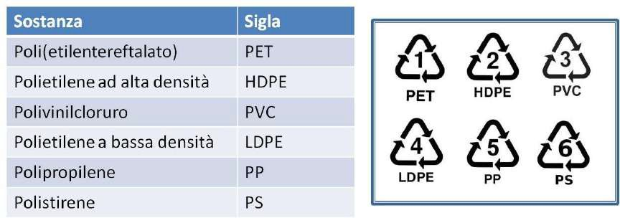
The identification of the plastics allows separate collection and therefore the possibility of recycling them. Polymer recycling is part of the policy of saving energy resources and protecting the environment.

It is not easy to recognize the various types of plastic, even if the beverage containers are usually made of PET, the LDPE bags and the PVC pipes. Plastic is a polymeric material. The different molecular structure of the polymers involves different physical and chemical properties and for this reason it is possible to develop protocols for the recognition of these substances.

This laboratory activity is based on the recognition of 6 different types of polymers through the evaluation of their different density and through a flame test.

The purpose of the following experience is:
- building a density scale of the six polymers (Activity 1);
- identify a polymer using the flame test (Activity 2).

ACTIVITY 1: Which plastic floats and which sinks
The activity is based on the application of the Archimedes principle: "in the presence of a gravitational field, a body immersed in a fluid receives a thrust from the bottom upwards equal to the weight of the displaced fluid volume".
The result of the principle of Archimedes is that if we immerse a body in a fluid, the body sinks if its density is higher than that of the fluid, it floats if its density is lower, it is in indifferent equilibrium, that is, it does not sink and does not float , if its density is identical to that of the fluid.

Materials (required for each group)
- Graduated cylinder;
- Glass rod;
- Pasteur pipette;
- Solution of ethanol and water (60 parts of alcohol, 40 parts of water) density about 0.90 g / mL (The 96% ethyl alcohol has a density of about 0.80 g / mL, pure water has density 1 g / mL);
- Saturated solution of NaCl (the common kitchen salt), density about 1.2 g / mL;
- 6 types of plastic (PET, PVC, PS, PP, HDPE, LDPE).

The density of polymers and solutions are shown in Table 2.

Table 2. The density of polymers and solutions
Substance in italian | Substance in English | Symbol /n |  | Density g/mL
Poli(etilentereftalato) | Poly(ethylene terephthalate) | PET | 1 | 1.38-1.39
Polivinilcloruro | Polyvinyl cloride | PVC | 3 | 1.16-1.35
Polistirene | Polystyrene | PS | 6 | 1.05-1.07
Polietilene alta densità | High density polyethylene | HDPE | 2 | 0.95-0.96
Polietilene a bassa densità | Low density polyethylene | LDPE | 4 | 0.92-0.94
Poliprolene | Polypropylene | PP | 5 | 0.90-0.91
Acqua | Water |  |  | 1.0
Etanolo in acqua | Ethanol:water (60:40) |  |  | ca. 0.9
Soluzione satura di NaCl | Saturated NaCl solution |  |  | ca. 1.2

Method
In a 100 mL graduated cylinder, 70 mL of pure water are added and six pieces of plastic are introduced; three float (HDPE, LDPE and PP) and three sink (PET, PVC, PS).

The three samples that float in water recover, dry and insert into a 100 mL graduated cylinder containing 70 mL of ethanol / water solution. LDPE and HDPE sink, while the PP floats. By adding still pure water (half a millilitre at a time) the density of the solution is increased, until the LDPE floats. The HDPE remains on the bottom.

The three samples that sink into water, recover, dry and insert into another 100 mL graduated cylinder containing 70 mL of saturated NaCl solution.

The PS floats, the other two sink. The two remaining polymers (PVC and PET) are subjected to the flame test (because their density, due to the addition of additives and plasticizers, is very similar).

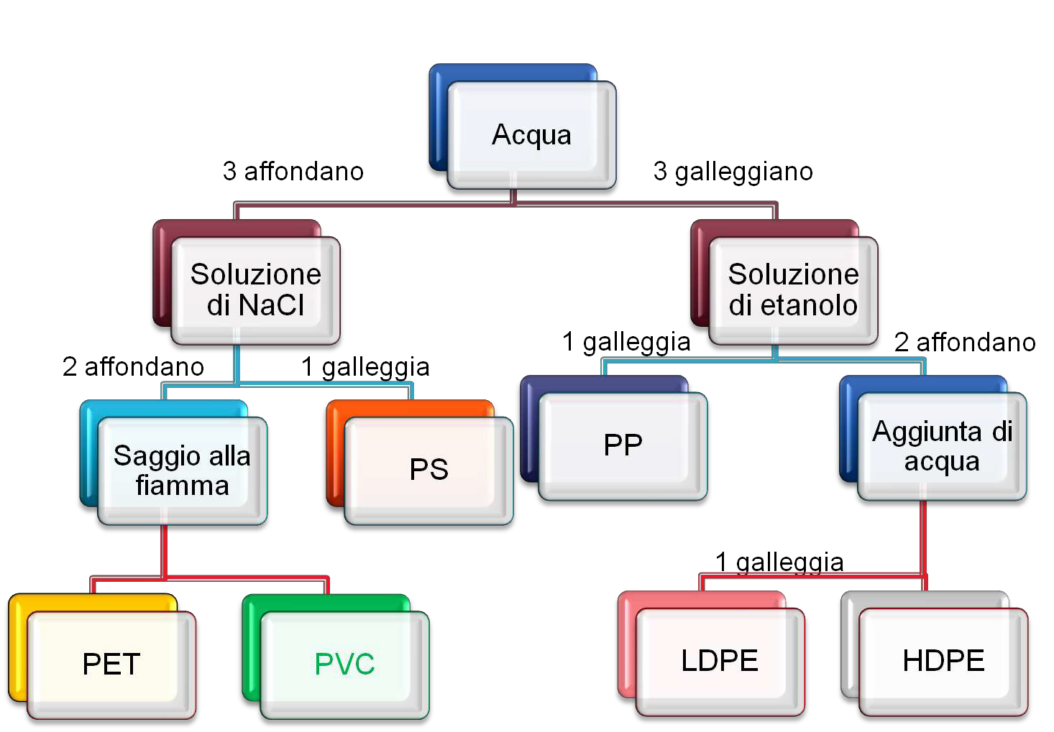

ACTIVITY 2: Flame test
The flame test is based on the recognition of certain substances (metallic salts) based on the colour the flame takes when it is put in contact with the test compound. In fact, through thermal energy, the electrons of the metal are excited and reach a higher energy atomic orbital. However, they tend to return to the lower energy level, starting, the more stable energy, resulting in the emission of radiation. These are characteristics for each cation and are perceived as coloured light.

In the specific case, the recognition concerns the formation of CuCl2. When a copper wire is put in contact with the polyvinylchloride (PVC) and then placed in the flame, the latter takes on the characteristic green colour, typical of Cu2 +.

Materials (required for each group)
- Copper wire;
- PVC and PET;
- Bunsen burner;
- Wooden clothespin.

Method
You take the copper wire and heat up on the flame. Next, the copper wire is placed on the unknown plastic material which melts and deposits on the copper wire itself. At this point, the copper wire is exposed to the flame again. This is coloured green if the plastic material is PVC, remains unchanged in the other case (PET).
Fiamma verde
CuCl₂

Annex 2: Experimental protocol: What's Hidden In Our Sand?
- Target Audience
- Curricular Areas: Natural Sciences and Biology
- Age group: 11-18

Name of group: date: Name of students

Background information
The multiple activities carried out daily in the coastal zones can lead to the presence of several pollutants in our sea.
Plastics account for 60-80% of marine litter and are currently considered one of the main pollutants responsible for marine pollution, together with petroleum hydrocarbons, ballast water and nutrients which, when at high levels, cause for instance eutrophication. Plastic can be carried by surface currents to sites far from the original ones having detrimental effects on both oceanic species and coastal ecosystems (US-EPA, 2002). Indeed, plastics pose a major threat to marine organisms such as fish, birds, turtles, mammals and zooplankton, mainly because of the risk of ingestion. About 400 marine species fromaround the world have already been found "stuck" to tons of plastic scattered across the ocean like plastic bags and fishing nets.
Microplastics are small particles (<5mm), that vary in composition (synthetic polymer), shape and colour. They are manufactured (primary microplastics) to fulfil certain functions, such as industrial abrasives, exfoliant micro-beads in personal care products or cosmetics, and pre- production plastic beads or pellets. They can also result from degradation or fragmentation of larger plastic particles (secondary microplastics) through mechanical, UV and microbial action which can result from larger plastic particles that have been degraded or from small dimensions purpose-built plastics. Since they have the capacity to absorb contaminants, namely Persistent Organic Pollutants (POPs), when ingested by marine species, they represent a route of entry of POPs to reach the marine food chain.

Aims
This activity aims to present microplastics, their origin and the consequences of their presence in the marine environment. This activity aims to raise awareness of the need to reduce the production and consumption of plastics. This activity is related with The Ocean Literacy Principles, namely Principle 6 –The Ocean and Humans are inextricably interconnected1.

Material
- 1 Water bottle with a capacity of 5L or more
- 1 Bottle of 1,5L
- 0,5L Funnel
- Sieve
- 1 Kg of cooking salt

- Beach sand (1 bottle of 1,5L)
- Filtration glassware (i.e. Büchner flask, filtration glass, clamping device...)
- Vacuum pump with hose
- 2 filters ca. 0,2 µm porosity (1 for each 0,5L bottle)
- Stereomicroscope
- e Petri dishes
- Tweezers

Procedure
- Collect sand from the high tide line, on the shallow side, up to about 5-10cm depth and sieve it to a 1.5L bottle. Discard large debris, or plastics, found into adequate recycling bins; Suggestion: students may be asked to collect and bring to the class sands from beaches under differing levels of human pressure and compare them
- In the lab, prepare a ultra-concentrated saline solution with a concentration of approximately 360 g / L. To do this, in a 5 L capacity bottle, add 3 L of water and 1 kg of cooking salt. if there is no material for measuring 3L of water, a 1.5L bottle filled twice can be used;
- Shake in 3 sets of 1 minute each;
- Place the collected sand (free of large debris / debris), which is in the 1.5 L bottle, into the 5 L water bottle;
- Close it and shake vigorously in 5 sets of about 30 seconds each;
- Allow the mixture to stand for about 15 minutes;
- Pass the water with the suspended particles to the 0.5 L bottle;
- Prepare the filtration system and (vacuum pump + filtration glassware) and place the membrane filter in place;
- Decant 250 ml of the salted with the sand into the filtration cup and connect the pump
- At the end of the filtration, transfer the filter to a Petri dish with the tweezer and observe at with the with the stereomicroscope (repeat step 8 with the water in other 0.5L bottle);
- Proceed to the research and identification of microplastics. If desired, they may also be separated into a petri dish to facilitate their counting.

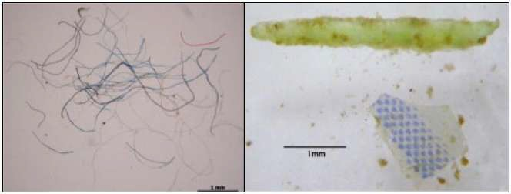
a)
b)
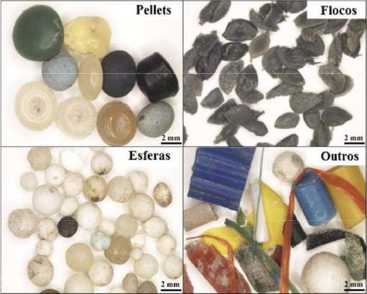
c)

Figure 1: Examples of nylon fibres (a), rigid plastic (b1)2 and of different types of plastics (c2).

What's hidden in our sand?
Experimental log:
- Indicates the hypothesis to be tested in this experiment.
- What is the purpose of the NaCl used for in the experiment?
- During the filtration of the sample where are the microplastics retained?
- Is the sample analysed contaminated with microplastics? If yes, what kind of microplastics did you find (shape, colour, etc.)?
- What measures should be taken in our daily life to avoid contamination of waters with microplastics?

1 Possatto, F.E.; Barletta, M.; Costa, M.F.; Ivar do Sul, J.; Dantas D.V. 2011. Plastic debris ingestion by marine catfish: an unexpected fisheries impact. Mar Poll Bull 62: 1098–1102
2 Lechner, A.; Keckeis, H.; Lamesberger-Loisl, F.; Zens, B.; Krusch, R.; Tritthart, M.; Glas, M.; Schludermann,
E. 2014. The Danube so colourful: A potpourii of plastic litter outnumbers fish larvae in Europe’s second largest
river. Environmental Pollution 188: 177-

Annex 3: Experimental Protocol - What’s Hidden In Our Laundry Water?

Background information
Multiple daily human activities carried on inland and in coastal zones directly and indirectly affect the marine ecosystem. According to the United Nations, about 80% of all litter at sea comes from land, with plastic waste as the most representative fraction (60-95%). Besides the 8 million tons of plastic thrown into the ocean every year, more and more personal hygiene products have microplastics (a facial cleanser can have about 330 thousand of microplastics) and many pieces of clothing have polyester fibres in their composition. It has been estimated that about 1,900 plastic microfibers are released from a single synthetic cloth every time it is washed in a laundry machine. Due to its small size, microfibers are not retained in the washing machine filter and end up in the marine environment. It has also been estimated that there are about 4 billion plastic microfibers per km2 of ocean floor.
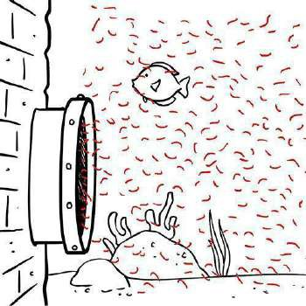
Figure 1: Polyester fibers (plastic) being release in the marine environment.
Source: http://storyofstuff.org/blog/microfibers-are-microplastics-1/

Target Audience
- Curricular Areas: Natural Sciences and Biology
- Age group: 11-18

Aims
The purpose of this activity is to raise awareness to the problem of microplastics, in particular polyester fibres, and the consequences they have to the marine environment. This activity aims to raise awareness of the need to reduce the production and consumption of plastics, as well as to warn about the need to change our daily activities that negatively affect the marine environment. This activity is related with The Ocean Literacy Principles3, namely Principle 6: The Ocean and Humans are inextricably interconnected1.

Material
- 1.5L bottle
- Large bucket

3 http://oceanliteracy.wp2.coexploration.org/ocean-literacy-framework/ [in English]

- Funnel
- 100% polyester clothing
- Filtration glassware (i.e. Büchner flask, filtration glass, clamping device...) Vacuum pump with hose
- Six ca. 1.2µm membrane
- Filters Stereomicroscope
- Petri dishes
- Tweezers
- Dissection
- Needle
- Lighter
- Light microscope

Procedure
- To perform this experiment it will be necessary to collect the water from the first wash of a washing machine;

- Make sure the water outlet hose of the washing machine is in a visible and safe place (for example, inside a bucket);

- Select 100 % polyester clothes (confirm on the label of each piece of clothing). Give preference to clothes with vibrant colours to facilitate the observation of microfibers with the magnifying glass;

- Wash the polyester clothes the washing machine using the “economical” program. Do not use
any type of detergent or soap;

- Pay attention to the water outlet of the washing machine and, using a funnel, connect the hose to the mouth of the plastic bottle (do this in a bucket). After collecting 1.5L of water, the hose can be returned to the usual location;

- Do not store water collected for many days (try to do the laundry the day before the experiment);

- Before starting the filtration, close the bottle and shake it vigorously 3 times for about 3 seconds (repeat the process when necessary, the microfibers can stick to the wall of the plastic bottle);

- Prepare the filtration system (vacuum pump + filtration glassware + clamping device) and fit the filter (for a more economical, and easy to find, option you can use round-cut coffee paper filters that fit the filter cup);

- Turn on the vacuum pump and gradually pour the water from the bottle. Change filters whenever you feel you need;

- At the end of each filtration, transfer the filter to a Petri dish with the tweezers and observe with the stereomicroscope;

- The microfibers present in the filter may also be separated into categories (colours, sizes, texture) in order to facilitate their counting and logging;

- Try to distinguish synthetic from cotton microfibers with the help of the light microscope. Polyester fibres are smooth tubes, usually translucent in their interior, with very well defined walls. Cotton fibres are flat, usually twisted, their interior may contain pigmentation and the walls have many imperfections and folds (Fig. 2 and 3);

- To confirm you are observing a synthetic microfiber you may also do the “hot needle test”, with the help of the stereomicroscope and of an adult to manipulate the lighter or another heat source. Heat the tip of a dissection needle with a lighter (or other heat source) and place the hot needle near the fibre under analysis. If the fibre quickly curls or melts on the needle, showing the behaviour of a burning plastic, it can be considered to be a plastic rather than a cotton microfiber.

Suggestion: The same procedure can also be carried out with 100% cotton clothing thus allowing making comparisons between microfibers of natural fabrics and synthetic.

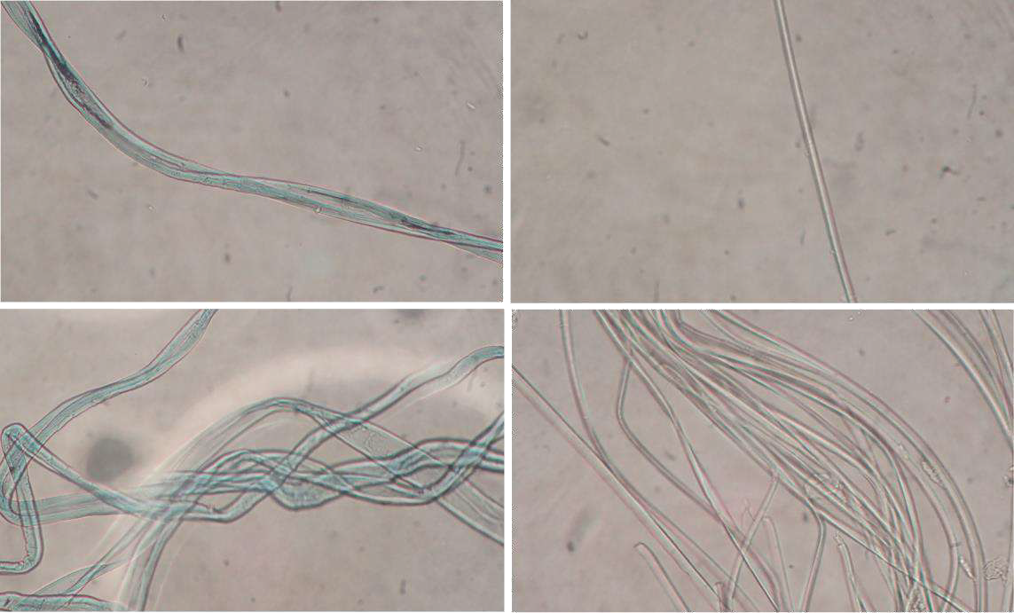
Figure 2: Cotton (left) and polyester (right) microfibers observed under the light microscope

What’s hidden in our laundry water?

Experimental log

- Indicate the hypothesis to be tested in this experiment.

- What are microplastics?

- Name three sources of the microplastics found in the environment

- Where were the microfibers retained during the filtration of the sample?

  - Is the analysed sample contaminated with microfibers? If so, how many fibres were found in 1.5L of water.
  - Write down in the table the number of microfibers counted per colour and material (polyester or cotton) in the water sample. Write the table caption.

Table 1:

 | Number of Microfibers
 | Polyester | Cotton
Colour 1:
Colour 2:
Colour 3:
Colour 4:
Colour 5:
Colour 6:
Colour 7:
Colour 8:
Total (in %)

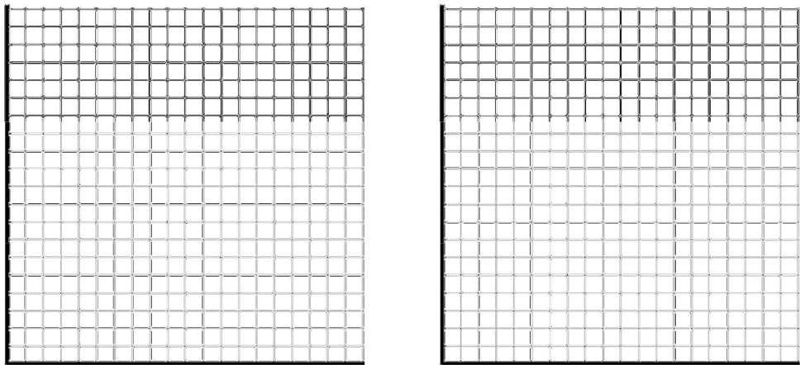
- In the axes system below draw graphs for the number of polyester microfibers of each colour counted in the water sample (Figure 1) and for the total relative frequency (in %) of polyester and cotton microfibers found (Figure 2). Write the captions for the Xand Yaxes and the graphs you have drawn.

Figure 1. Figure 2.

- What is the difference between a polyester and a cotton microfiber?

- What type of clothing releases more fibres per litter of water?

- Choose five classmates and write down on the table the material with which each T-shirt is made of (example: polyester, cotton, nylon ...). Write down the table caption.

Table2:
Class Colleague | T-shirt Material
Colleague 1
Colleague 2
Colleague 3
Colleague 4
Colleague 5

- What conclusions can you draw from Table 2 regarding the use of plastic in our clothing?
- Right now, are you wearing any clothes or have any school supplies that do not contain plastic? If yes, indicate which.
- What measures would you propose to be taken to prevent water contamination with polyester microfibers?
- What can you do to reduce the use of plastic in your daily life? Give two examples.

Annex 4: Experimental Protocol - Microbeads from cosmetics

  - Target Audience
  - Curricular Areas: Natural Sciences and Biology

Age group: 11-18

Name of group: date: name students

Background information
Microbeads are another source of microplastics. These tiny plastic beads are used in cosmetics and personal care products (e.g. exfoliating and hand-washing creams, toothpastes). In this activity, students (aged 11–16) isolate and examine microbeads from such products, and consider their impact on the environment.
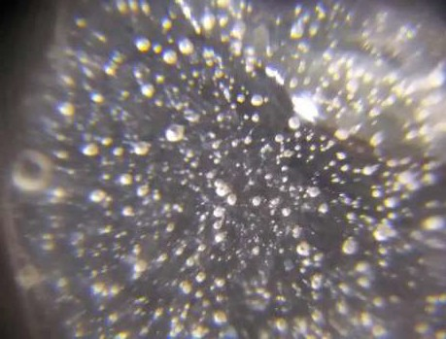
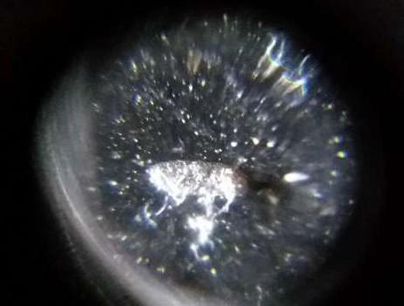
Picture n 1 : Microplastic in scrub cosmetics Picture n2: Microplastic in toothpaste

Materials
  - Some cosmetics and personal care products containing microbeads. Check the composition: if polyethylene is listed, the product contains microbeads.
  - Clear acetate sheets
  - Magnifying glasses or a microscope for smartphone
  - Transparent plastic cups
  - Tap water
  - Dishwashing detergent
  - Salt
  - Spoons

Procedure
Using the materials above, ask the students to:
- Read the composition of the product to confirm that it contains microbeads.
- Examine the product by spreading it on an acetate sheet and looking at it with the magnifying lens (or a microscope), and also by touching it.

- Test the microbeads for buoyancy in three different liquids, using the transparent cups:
  - Tap water
  - Water plus detergent (1/2 spoonful per cup)
  - Water plus salt (1 spoonful per cup).
- Based on the students’ results, predict whether in the natural environment, microbeads will float or sink in freshwater (e.g. in a lake) and in saltwater (e.g. in the sea).

How many microbeads are we dumping in the sea?
This extension to the previous activity asks students aged 11–16 to make a rough estimate of how many microbeads are being dumped each year by people in their town, and to investigate and debate the environmental issues involved.

Materials
As for the previous activity, plus:
  - Measuring spoons with a volume of 5 ml (like those used for cough syrups, etc.)
  - Coffee filters

Procedure
Ask the students to:
- Measure 5 ml ofa product containing microbeads and dissolve it in a cup half-filled with tap water plus 5 ml of dishwashing detergent.
- Stir the mixture for one minute, then filter the mixture with a coffee filter.
- Transfer the microbeads from the filter paper to an acetate sheet. Now count the microbeads.
- Using this result and the volume of the product’s original container, calculate how many
microbeads are contained in a whole tube or bottle.
- Estimate how many containers of this product are used by a person in one year, and how many people in their town are likely to use this product.
- Multiply these numbers together to calculate how many microbeads their town is dumping into the sewage system (and then into the sea) per year from this one product.
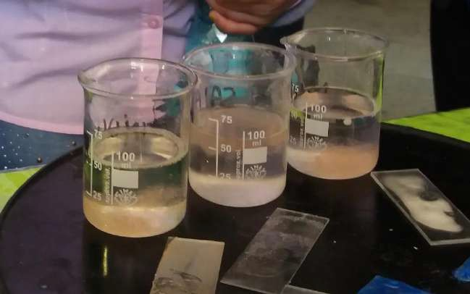
Picture n 3 Cosmetics in water, salad water, water with detergent

Finally, ask the students to research information about the problem of microbeads in the environment, and on current debates and actions limiting or banning their use in productsw4.

Acknowledgements
The activities described in this article were developed jointly by the author, Giuliana Candussio, Marinella Manià and Serenella Palamin. All four are members of Scienza under 18 Isontinaw2, an association that aims to inspire school students and teachers and to share good practice.
The “Exploring plastics” activity was adapted from materials developed as part of progetto APQUA, the Italian version of the Lawrence Hall of Science, University of California at Berkeley’s Science Education for Public Understanding Program (SEPUP). The progetto APQUA materials were kindly provided by Federchimica-Assoplast, the association of Italian plastic manufacturers.

Annex 5: How to identify different types of plastic

Types of plastic
The following table illustrates the most common types of plastics used, their applications and the symbol which is often used to identify them on forms of plastic packaging.

Polymer Types | Examples of applications | Symbol
Polyethylene Terephthalate | Fizzy drink and water bottles. Salad trays. | 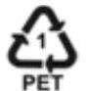
High Density Polyethylene | Milk bottles, bleach, cleaners and most shampoo bottles. | 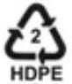
Polyvinyl Chloride | Pipes, fittings, window and door frames (rigid PVC). Thermal insulation (PVC foam) and automotive parts. | 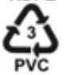
Low Density Polyethylene | Carrier bags, bin liners and packaging films. | 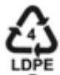
Polypropylene | Margarine tubs, microwaveable meal trays, also produced as fibres and filaments for carpets, wall coverings and vehicle upholstery. | 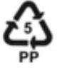
Polystyrene | Yoghurt pots, foam hamburger boxes and egg cartons, plastic cutlery, protective packaging for electronic goods and toys. Insulating material in the building and construction industry. | 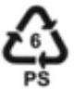

Polymer Types | Examples of applications | Symbol
Unallocated References | Any other plastics that do not fall into any of the above categories - for example polycarbonate which is often used in glazing for the aircraft industry | 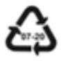

Materials

Density tests
  - 5 beakers: Water (Density=1.0 g/mL)
  - water, salt: Salt Water -1200g salt per 1 L of water – (D= 1.2 g/mL)
  - corn syrup: Corn Syrup (D= 1.36 g/mL)
  - isopropyl alcohol: Isopropyl Alcohol (D=0.94 g/mL)
  - vegetable oil: Vegetable Oil (D=0.90 g/mL)

Several different samples of Plastics (6). Try to provide a density range value for Plastics.

Name Observations Worksheet
Plastics Type | Observations

  - Have them try different variations of the density tests to find out if each 6 sample produces the same results. For example, did each 6 sample float in water? Sink?
  - What about in the isopropyl alcohol?
  - Follow the flow chart, performing each test as numbered in order. Please note that you will not use all 6 plastic samples for each test. After completing each test, determine which plastics (of the ones used for that particular test) sink and which float.
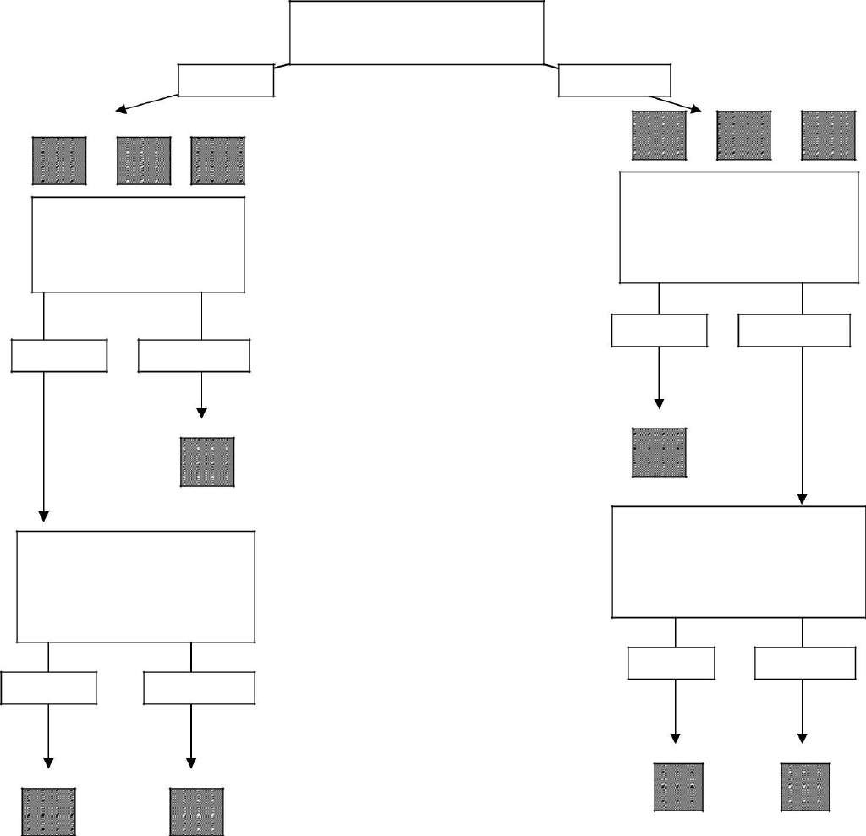
Water test
Sinks
Floats
Salt Water Test
Isopropyl Alcohol Test
SINKS
FLOATS
SINKS
FLOATS
Corn Syrup Test
Vegetable Oil Test
SINKS
FLOATS
SINKS
FLOATS

Questions
- A lifeguard sees a young child fall into the neighbourhood pool. There are 6 plastic life preservers labelled 1, 2, 3, 4, 5, and 6. If the labels identify the type of plastic each is made of, which three would be the best to grab to save the child? Why?
- A ship carrying empty milk jugs down the Mediterranean Sea has a spill, and the jugs go overboard. What will happen to the jugs when they hit the water?
- What do you think would happen to the jugs when they reach the salt waters of the Mediterranean Sea? Explain your answer.
- A local water park has a new ride. The slime used in the ride has a density of 1.15 g/mL. What type(s) of plastic would be best to use for making the floats for the ride?

Characteristics Of Plastics Information Sheet

Plastics Type | Name | Properties | Density | Common
 | Polyethylene Terephthalate | Tough, rigid, shatter-resistant, softens if heated | 1.38-1.39 g/mL | Soda, water,  juice, and  cooking oil bottles
 | High Density Polyethylene | Semi-rigid, tough, flexible | 0.95-0.97 g/mL | Milk and water jugs, bleach bottles
 | Polyvinyl Chloride | Strong, semi- rigid, glossy | 1.16-1.35 g/mL | Detergent bottles, shampoo bottles, shrink wrap, pipes
 | Low Density Polyethylene | Flexible, not crinkly,  moisture-proof | 0.92-0.94g/mL | Garbage bags, sandwich bags, 6-pack rings
 | Polypropylene | Non-glossy, semi-rigid | 0.90-0.91 g/mL | Yogurt cups, margarine tubs, screw-on lids/caps
 | Polystyrene | Often brittle, sometimes glossy, often has strong chemical reactions | 1.05-1.07 g/mL | Styrofoam, egg cartons, packing pellets, take-out containers

Annex 6: Worksheet: Bioplastic

Biobased
Made from fuel such as coal, oil, or natural gas formed in the earth from plant or animal remains over millions of years.

Biodegradable

Materials or products (partly) derived from biomass (plants). e.g.
corn, sugarcane, or cellulose.

Fossil-based
A chemical process during which microorganisms that are available in the environment convert materials into natural substances such as water, carbon dioxide, and compost.

Renewable
Materials or products that can be used repeatedly and replaced
naturally.

Are all bioplastics bio-based? ⃞ Yes ⃞ No Are all bioplastics biodegradable? ⃞ Yes ⃞ No

Look up these different types of plastics
Name | Made from: | Bio-based? | Biodegradable?
PLA  (polylactic acid) |  | ⃞ Yes ⃞ No | ⃞ Yes ⃞ No
PHA  (Polyhydroxyalkanoates) |  | ⃞ Yes ⃞ No | ⃞ Yes ⃞ No
PBS  (Polybutylene succinate) |  | ⃞ Yes ⃞ No | ⃞ Yes ⃞ No
PBAT  (Polybutylene adipate terephthalate) |  | ⃞ Yes ⃞ No | ⃞ Yes ⃞ No
PCL  (Polycaprolactone) |  | ⃞ Yes ⃞ No | ⃞ Yes ⃞ No
PE  (Polyethylene) |  | ⃞ Yes ⃞ No | ⃞ Yes ⃞ No
PET  (Polyethylene terephthalate) |  | ⃞ Yes ⃞ No | ⃞ Yes ⃞ No
PA  (polyamide ) |  | ⃞ Yes ⃞ No | ⃞ Yes ⃞ No
PTT  (Polytrimethylene terephthalate) |  | ⃞ Yes ⃞ No | ⃞ Yes ⃞ No

Knowing this, why do you think people still make Fossil-based plastics?

Which products would you replace with bioplastic?

Do they already exist? Look them up.

What would the benefit of replacing them with bioplastic be?

LEGO aims to make all its bricks from sustainable materials by 2030. Why would they do that?
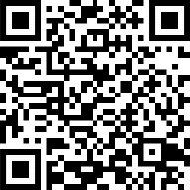
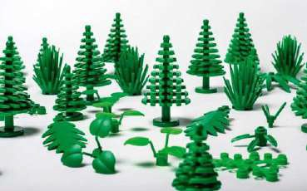
http://legoexternal.23video.com/video/22467724/lego-plants-made-from-plants

Annex 7: Worksheet - What is 3D printing
PLA is used to produce plastic films, bottles, and biodegradable medical devices,..
It melts under heat so this makes it suitable for some interesting applications in 3D printing. The PLA material is melted in the head of the printer and hardens again when it’s touching the colder plate.
But how does 3D printing works and what can we print?

Watch following YouTube video:

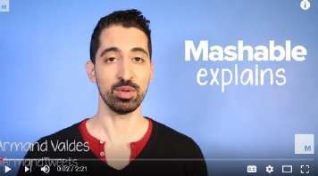
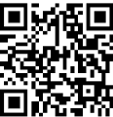
https://www.youtube.com/watch?v=Vx0Z6LplaMU

Discuss following topics in your group and write some opinions on the sticky notes

  - What’s your opinion about 3D-printing in general?
  - Should students learn how to draw and use 3D-printing in school?
  - Printing small plastic stuff is common use, but what do you think about printing parts of houses?
  - 3D printing is still in the beginning stage, what do you think about the printing of bodyparts, organs,..
  - What do you think the future can bring with 3D printing?
  - Be creative : what will you like to print yourself if everything is possible?

Annex 8: Tinkercad tutorial - Tinkercad keychain

Login
  - Go to www.tinkercad.com
  - Click “sign up” in the above right corner
  - Select your country and fill in your Birthday, click NEXT
  - Create account:
    - Fill in your Email address
    - Choose a password
    - Check on “I agree-box”
    - Click on “create account”

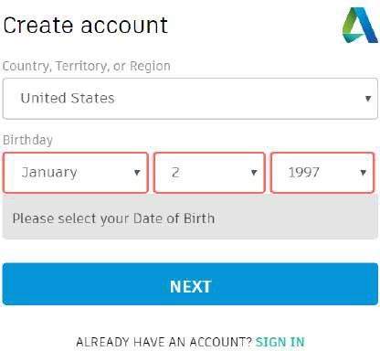
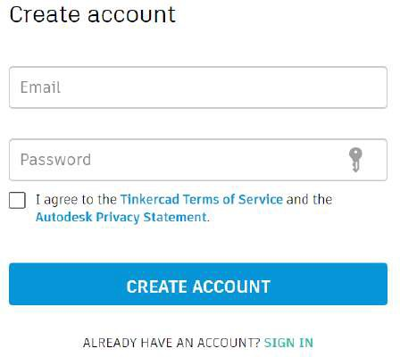

Making the keychain

Open a new project
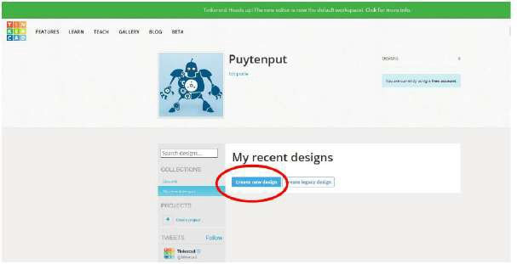

Rename your project

Click on the name above and type over your own project name

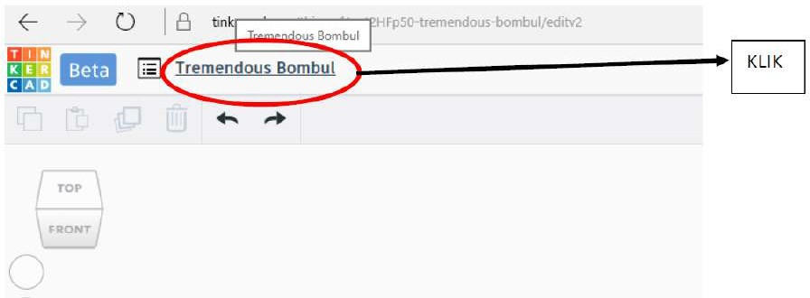

First, we make a square for our keychain.
Drag and drop a red cube to the middle of the workspace.
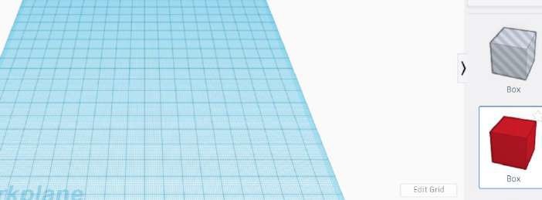

The standard size of a cube is 20mm X 20mm X 20mm
We are going to adjust the width and height to 25mm X 25mm
  - Click on a corner
  - Adjust the size by dragging OR by filling 25 in the white box
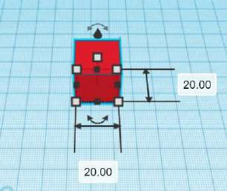

Adjust the height of the cube
The height of the keychain should be 3mm. So, we are going to adjust this one.
  - Click on the white box in the middle of the square.
  - Adjust the size by dragging or by filling “3” in the white box
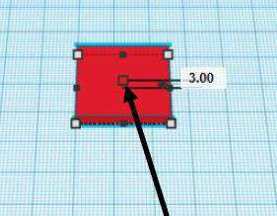

Select a letter for the keychain
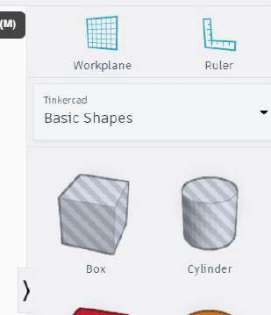
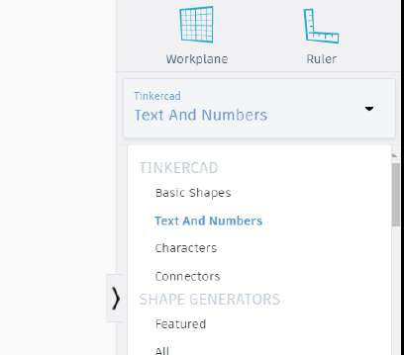
In the menu at the right side you click on “basic shapes” and choose “Text and numbers”

Drag the letter to the workspace above the square.
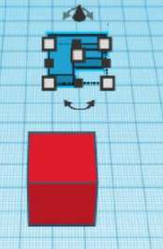
We drag this above the square, so we can adjust the size of the letter.

Adjust the size of the letter:
Click on a corner and change size to: 20mm X 20mm
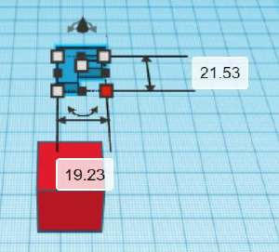
- Click on the corner
- Click on size
- Type the correct size

Adjusting the height of the letter:
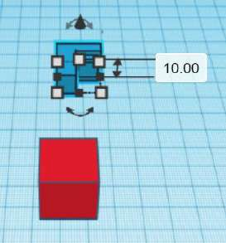
Click on the square in the middle of the letter and change height to 10 mm

Put the letter on the square
  - Click on the letter and drag over the square
  - Tip: if you want to turn the workspace: click on the right mouse button
  - Zoom in - zoom out: scroll with your mouse wheel
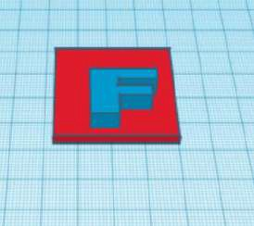
  - Check that the letter is in the middle of the square

Lowering down the letter in the square by changing the height
Click on the back cone above the letter and drag this down until the letter goes through the square.
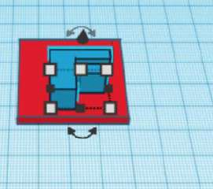

Change the letter in a “hole”.
Click on the letter to select it, click afterwards on “hole”
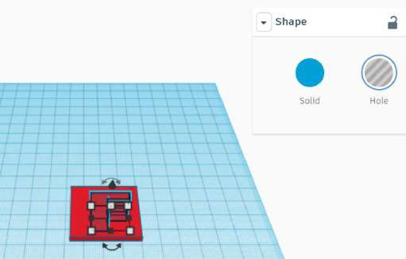
- Click on the letter
- Click on HOLE

We have to make from the 2 different figures, one peace
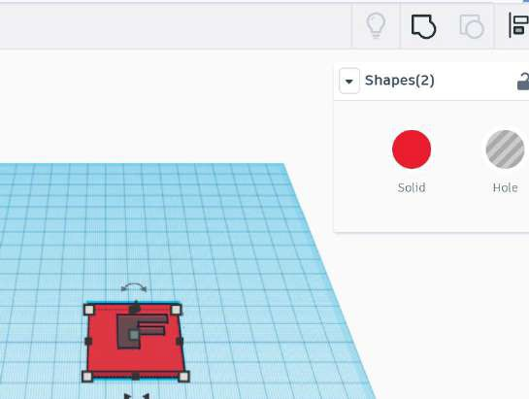

- Select the complete figure.
- Click on the icon “MAKE GROUP”

If everything is correct, your figure looks like this:
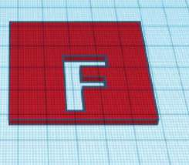

To finish, you have to make a hole for the key.

In which corner you have to make is, depends of your letter. Place it where you have some space left.
  - Choose in the menu on the right “BASIC CHAPES”
  - Drag a cylinder on the workspace

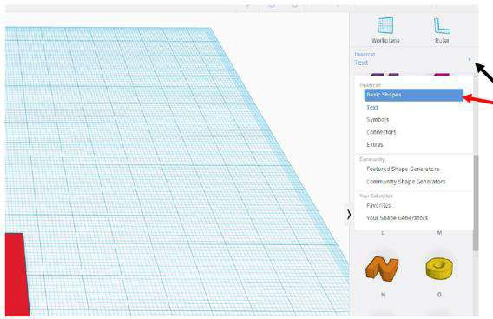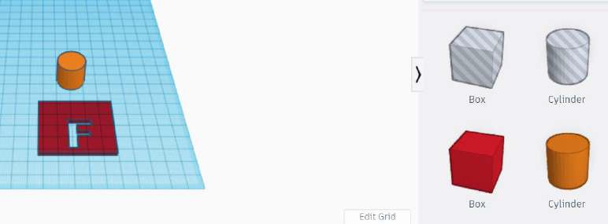

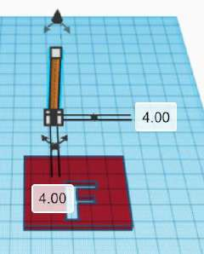
Adjust the diameter to 4mm

- Drag the cylinder in the keychain, be careful that there is enough space left in the corner, else it will break while printing.
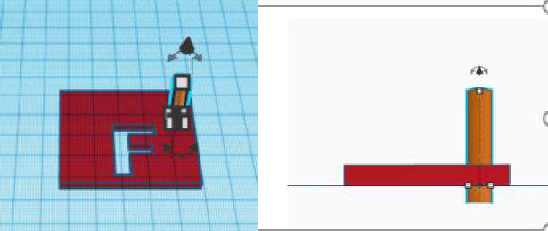
Lower the cylinder until it’s complete through the keychain.

Make from the cylinder a “hole”
For this click on “hole”

- 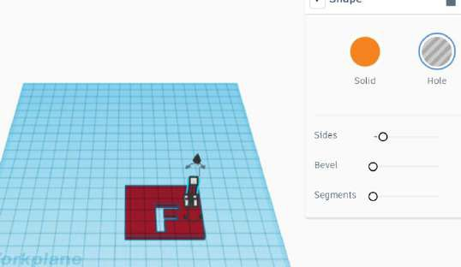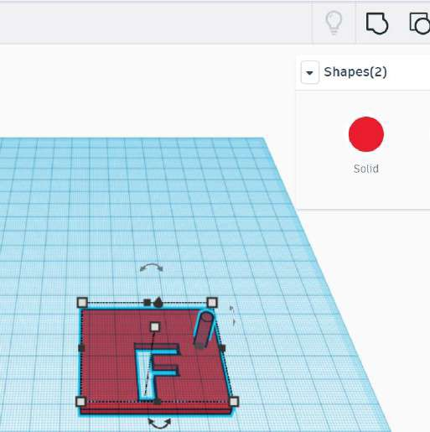Group your figure again to make it one.
For this, select your whole figure
and click on “GROUP”

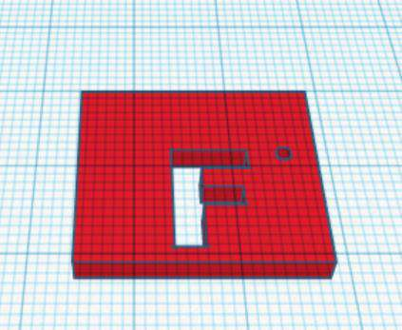

GREAT JOB! Your keychain is now ready for printing!!
The next page is only necessary when you are going to print it with the 3D printer!

Click on EXPORT right above in the corner to export your keychain to print
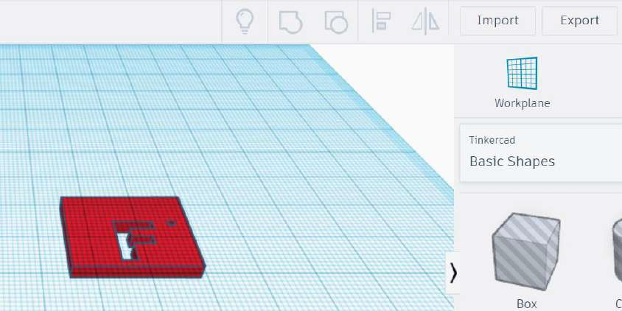

Choose for format “stl” for downloading

(the format depends on your printer!! Check which format you need!)
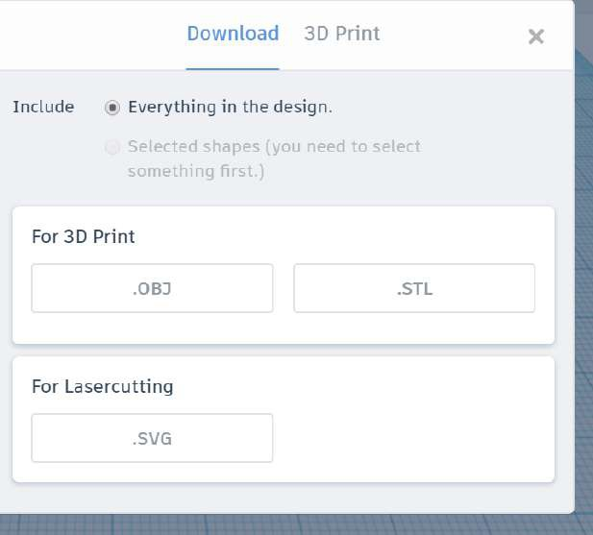

Annex 9: Learning Design

Description
Context | Topic: Bioeconomy  Total learning time: 220 minutes  Number of students: 15-25  The world population is living, working, vacationing, along the coasts, and standing on the front row of the greatest, most unprecedented, plastic waste tide ever faced. Plastic is versatile, lightweight, flexible, moisture resistant, strong, and relatively inexpensive.  Those are the attractive qualities that lead us, around the world, to such a voracious appetite and over-consumption of plastic goods. Our tremendous attraction to plastic, coupled with an undeniable behavioural propensity of increasingly over-consuming, discarding, littering and thus polluting, has become a combination of lethal nature.  The future for the world is bioeconomy, recycle and use biodegradable material
Aims | Collaboration Communication Science & engineering civic  competence entrepreneurship digital competence
Teaching-Learning activities
Plastic pollution | Investigate 30 minutes 20 students Tutor is available  Analyse this pictures about "Plastic pollution and marine debris"  http://www.marlisco.eu/
Practice 50 minutes 20 students Tutor is available
You work in group and make a table and classify the type of plastic
pollution.
Discuss30 minutes 20 students Tutor is available
Why are there so many plastic pollution in the sea/beach ? To
formulate different hypotheses.
Read Watch Listen 50 minutes 20 students Tutor is available
Read the document and find why there is so much plastic in the sea.
Is it ok with your hypotheses?
Organic solution - Biopolymers | Read Watch Listen 10 minutes Tutor is available  "Know your plastics" Different kinds of biopolymers and their  resources
Discuss25 minutes students Tutor is available
Why use bioplastics? Is this a good option? What are the
consequences? (pros and cons)
Investigate 25 minutes Tutor is available
Investigate different bioplastics and their properties.
Practice 15 minutes Tutor is available
Exercise on biopolymers
Read Watch Listen 20 minutes 20 students Tutor is available
To search the internet at home.

Bioplastic-Making Bioplastic 3 lessons | First group: What is bioplastic?  Second group: What are the properties of bioplastic? To communicate using drive docs.
Produce 30 minutes 20 students Tutor is available
First group: Make Bioplastic from food residues that have starch.
Second group: Make bioplastic from potatoes
Third group: Make bioplastic from starch
Investigate 30 minutes 20 students Tutor is available
Class practice: In this activity, students investigate the effect that
adding a ‘plasticiser’ has on the properties ofthe polymer they make.
Product design/3D Printing | Read Watch Listen 15 minutes Tutor is available  YouTube movie: What is 3D printing and how does it work?
Discuss20 minutes 20 students Tutor is available
What do you think of 3D printing?
Printing toys, parts of houses, or even ears, organs... PLA is bioplastic, what do you think of that?
Produce 45 minutes 1 students Tutor is available
3D Design in Thinkercad, following instructions
If you have a 3D printer in class, you can print it in class. Else you can maybe let it print in a fablab or in a company in the neighbourhood.

