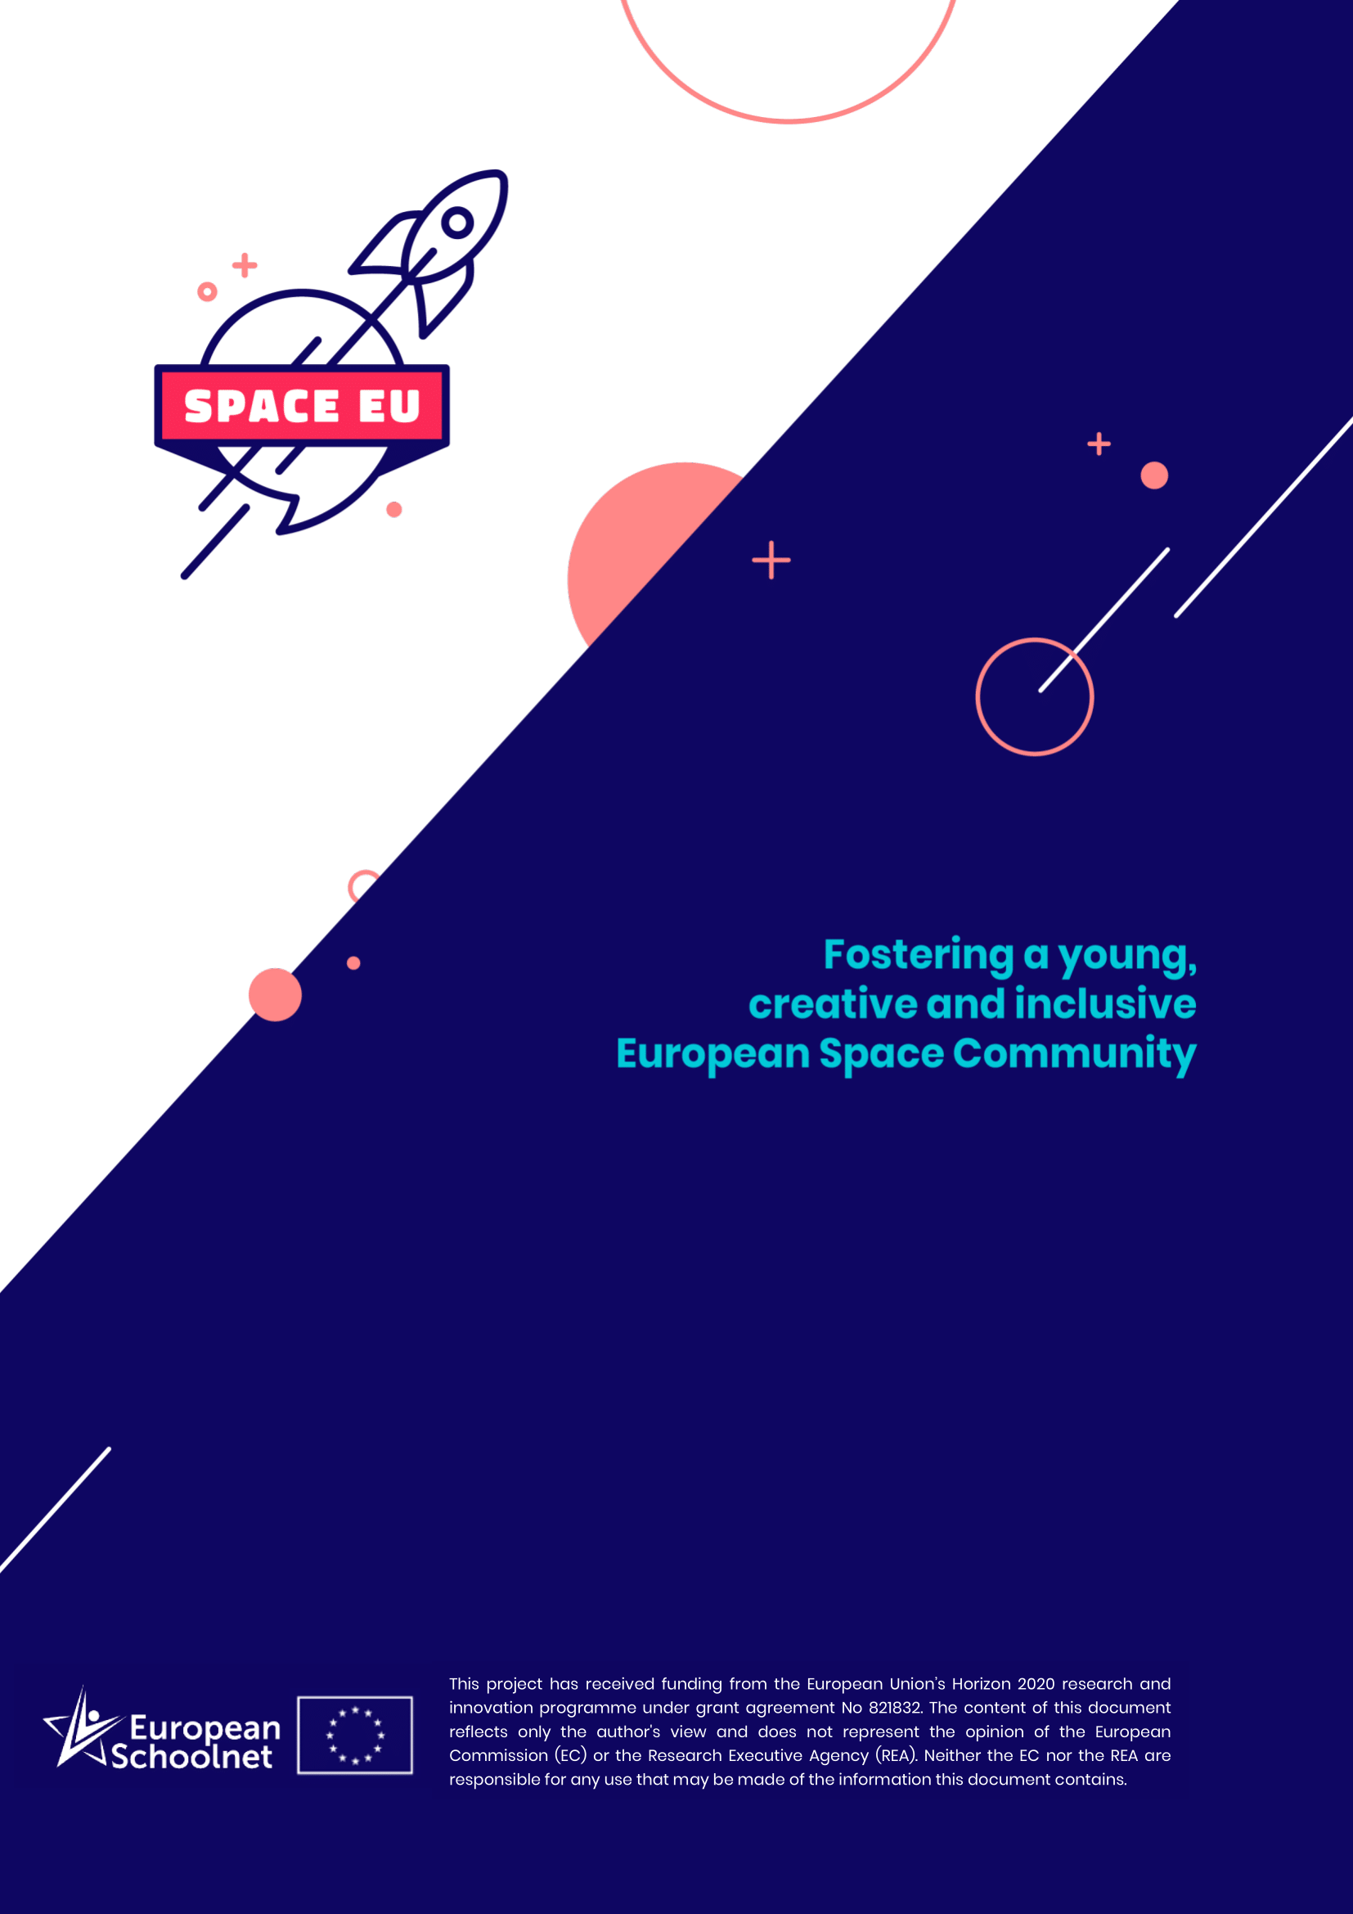

SpaceEU Teacher Training Programmes

“S.C.S. Cinema Club SpaceFlix”
Country: | Greece
Organization: | GFOSS (Open Technologies Alliance)
Target audience: | In-service secondary school teachers
Place: | Online
Period of implementation: | 30 September - 19 November 2019

Course description

Introduction
This training programme has been developed in the framework of the spaceEU project. The course aims at analysing science issues that are displayed in science-fiction (Sci-Fi) space movies. The course was organised as a distance learning asynchronous 8-week course. There were six weeks dedicated to educational materials and activities and two weeks of peer-to-peer review of the final produced project plans following the European Schoolnet Academy template for e-learning courses.

Main Course description
In this course, there are six Sci-Fi movies concerning space that demonstrate the starting point of every module. In each module, the science topics addressed in the respective movie are analysed. In addition, careers related to these topics are presented and put in context via contacts in the local community if possible (local places, clubs, exhibitions and persons that could be involved in any way).

Week 1 | Week 2 | Week 3 | Week 4 | Week 5 | Week 6 | Week 7 | Week 8
Introduction
2001 A Space Odyssey | Apollo 13 | The Martian | Gravity | Interstellar | Star Wars | Peer2peer review | Peer2peer review
Local Interviews | Local Interviews | Local Interviews | Local Interviews | Local Interviews | Local Interviews
EUN links | EUN links | EUN links | EUN links | EUN links | EUN links

Placement / practicum / assignment
There are no space lessons in Greek secondary education curriculum to use them as entry points for the upcoming course. Possible in-service elements guide the course towards two existing peripheral activities. The first are annual courses about career guidance that take place in all grades of secondary education. The second are biannual secondary courses called “Projects” which have the freedom of curriculum and are accomplished in both periods (Winter-Spring).

Follow-up
Results of both (annual and biannual) projects should be submitted to the course with assignments as also with project outcomes form.

Training materials

Schedule and structure
- Introduction to the spaceEU project (module 1: ca. 4 workhours)
- Introduction to this training (module 1: ca. 2 workhours)
- Demonstration of the repository of resources (modules 1-4: ca. 2 workhours each)
- Participants work on online asynchronous training task which is to connect Sci-Fi movies with repositories (ca. 3 workhours each module);
- Reflection in groups during forum conversations; Final assignment on the question “How can we use Sci-Fi movies in primary/secondary school to integrate space subjects?” (ca. 3 workhours)

Each week, with exception to the first and the two last weeks, follows the same structure.
In the very first module, the course will be introduced to the participants. Questions that can be addressed could be:
- How is science perceived in everyday life?
- Why is science important in everyday life?
- How can we use space and space topics as a medium to motivate and excite students for (space) science?

The instructor then gives an outline over the weeks to come and what will be expected from the participants.
After the introduction part of the first module as well as in each of the following modules, the content of Sci-Fi movies will be discussed. A selection of space-related Sci-Fi movies could be:
- 2001 A Space Odyssey
- Apollo 13
- The Martian
- Gravity
- Interstellar
- Star Wars

Guiding questions for the analysis and discussion of the content, depending on each movie, could be:
- What kind of science and technology is displayed in the movie?
- How is this science and technology used and portrayed? How realistic is it?
- Can this be used to spark students’ interest in science? If so, how?
- How can we use Sci-Fi movies in primary/secondary school to integrate space subjects?

Following the discussion and analysis, possibly related careers will be presented to the participants. Please find the links to career paths in the section on links and materials.

Resources and materials description
The following links direct to a) webinars dedicated to particular careers and b) career sheets and descriptions.

Webinars
- http://www.space-awareness.org/el/careers/webinar/webinar-3-space-careers-classroom/
- http://www.space-awareness.org/el/careers/webinar/webinar-4-path-space-careers/
- http://www.space-awareness.org/el/careers/webinar/webinar-5-discover-space-awareness-activities-your-classroom/
- http://www.space-awareness.org/el/careers/webinar/webinar-10-earth20-future-humankind-space/

Career sheets and descriptions
- http://www.space-awareness.org/el/careers/career/ti-einai-o-astrobiologos/
- http://www.space-awareness.org/el/careers/career/ti-einai-o-astroxhmikos/
- http://www.space-awareness.org/el/careers/career/who-astronauts-costumes-designer/
- http://www.esa.int/Our_Activities/Human_Spaceflight/Couture_in_orbit/Space_textiles_space_patterns
- http://www.esa.int/Our_Activities/Human_Spaceflight/Couture_in_Orbit_from_spacewalk_to_catwalk
- https://blog.sciencemuseum.org.uk/to-boldly-go-where-no-fashionista-has-gone-before/
- http://www.space-awareness.org/el/careers/career/who-astronomer/
- https://www.youtube.com/watch?v=MduaF0wPI_M
- https://en.wikipedia.org/wiki/List_of_astronomical_observatories
- http://www.space-awareness.org/el/careers/career/who-archaeoastronomer/
- http://www.space-awareness.org/el/careers/career/who-science-historian/
- http://www.space-awareness.org/el/careers/career/who-materials-engineer/
- http://www.space-awareness.org/el/careers/career/who-space-educator/
- http://www.space-awareness.org/el/careers/interview/students-and-their-dreams-space/
- http://www.space-awareness.org/el/careers/interview/dr-karen-olsson-francis/
- http://www.space-awareness.org/el/careers/interview/dr-susanne-schwenzer/
- http://www.space-awareness.org/el/careers/interview/dr-jorge-vago/

As this online course has been implemented in Greece, this is specific information targeted at educators working in this country.
This is an estimation of participants’ workload in the online course. The workload for face-to-classes may differ.

