Career Sheet: Electrician
My name is Duran, and I was born in 1985. I studied electrical engineering for 2 years. I’ve been working in an electricity distribution company for the past 10 years. I love my job!

Duran Sezer (Technician, Electricity Distribution Company)
OVERVIEW OF THE JOB

I work as an electrician. Physics, mathematics, and physical competencies are required to study and work in this field. It’s a profession that requires interdisciplinary work.
WHAT INSPIRED YOU

I've always enjoyed experimenting with electrical circuits. My Physics teacher inspired me to choose this field.
Electrical wires, poles, and transformers, which fail a lot on stormy winter days, intensify the work. Sometimes we have to climb high voltage lines that seem very dangerous. But if we don’t work, electricity cannot reach homes and other places.
TYPICAL WORKING DAY

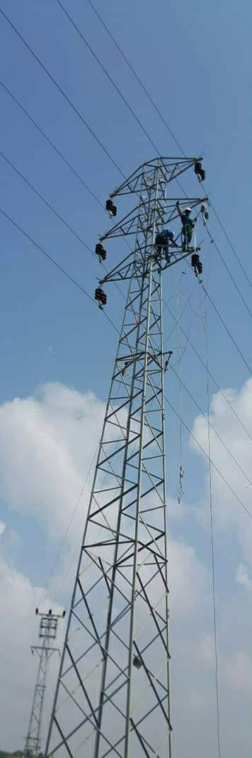
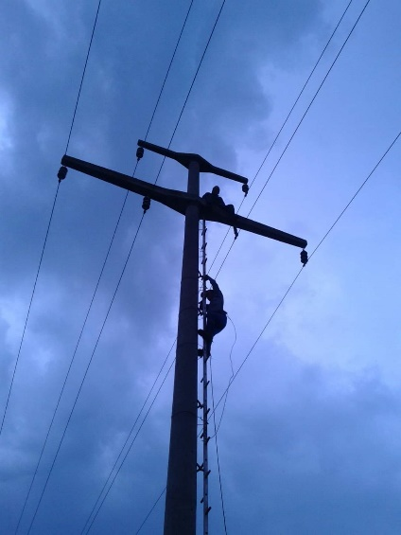

I studied for 2 years after high school. I did an internship for one year and then, I started to work. It’s very nice to be useful to people. If I go back to my youth again, I’d like to work harder and become an electrical engineer.
Pictures provided by the author (Attribution CC-By)

STUDY & CAREER PATH

KEY SKILLS
Problem-solving skills are used to understand the location of the fault and come up with alternative solutions.
Teamwork and motivation are also necessary.
System analysis, referring to ensuring that all elements needed to distribute electricity perform as intended, is also very important.
CAREER PROSPECT
I always give importance to my personal development, and I stay updated on the latest technologies in my field. I follow the occupational safety rules, so I can work anywhere in the industry.
CHALLENGES
One of the main challenges for electricians is safety concerns because they are exposed to several electrical hazards. That’s why it’s important to be careful and avoid making mistakes, as even the smallest ones can cause big problems! Therefore, guarding against falling items and electric shock is among the main challenges of our job.
YOUR ADVICE TO STUDENTS
All professions related to energy will be very important in the future. STEM can help students solve real-world problems, such as meeting the energy demands of our world with clean energy sources. For this reason, I recommend students to engage with STEM subjects and professions.
YOUR ADVICE TO TEACHERS AND PARENTS
It’s necessary to support the work of children in the field they love. It’s the duty of our teachers and parents to guide students according to their abilities and interests.
Attribution CC BY. This license lets others distribute, remix, tweak, and build upon your work, even commercially, as long as they credit you for the original creation. This is the most accommodating of licenses offered. Recommended for maximum dissemination and use of licensed materials.
This career sheet was submitted by Selda Topal and is among the winners of the STEM Alliance & STE(A)M IT - Professionals Go Back to Schools Competition 2022.

