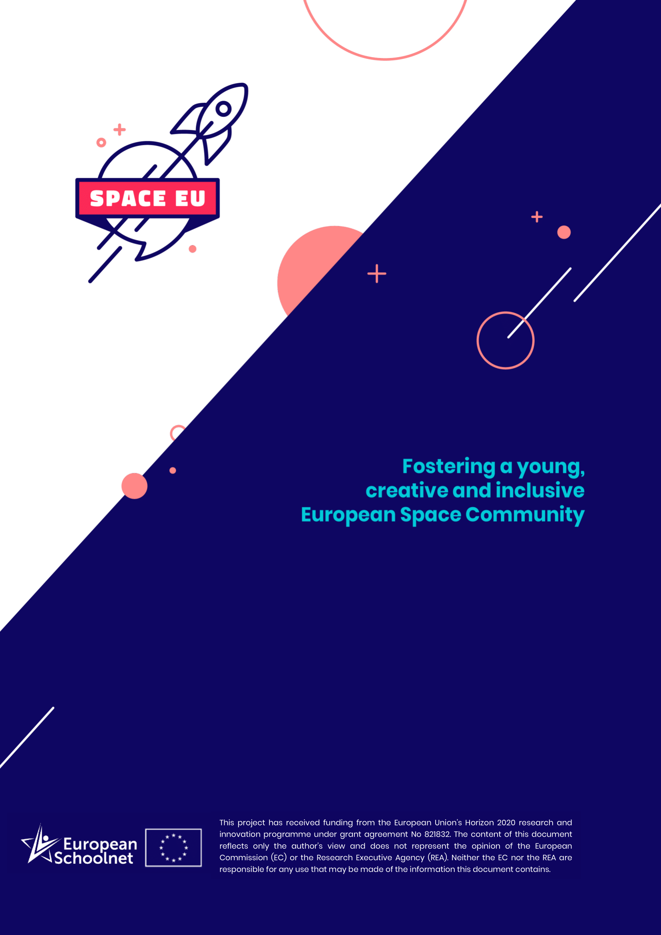

SpaceEU Teacher Training Programmes

STEM Careers and Skills of the Future

Organization: | European Schoolnet
Target audience: | In-service teachers in secondary schools
Place: | Face-to-face, online

Course description

Training aim and objectives
This training programme has been developed in the framework of the spaceEU project. Many teachers around Europe are also asked to fulfil the role of career counsellor as part of their function. To do so, they need to be aware of the STEM jobs currently and soon to become available in various sectors, especially in industry. The aim of this workshop is to get participants acquainted with a variety of STEM and space-related jobs with a focus on jobs of the future that current students – future professionals will be able to enter in the years and decades to come.

Workshop schedule (structure & duration)
- Intro – rationale of the workshop and misconseptions in STEM and space (~3 min)
- Overview of the projects/parties contributing to this workshop (~3-5 min)
- Workshop structure explained (~2 min)
- Group work (~35 min):
  - Step 1: Participants split in groups of 4-5 (~2 min)
  - Step 2: Participants will select a resource (or several resources) from the 3 recommended sources of information to look for a career path which fits subject(s) they teach (~8 min)
  - Step 3: Participants will consider the types of skills needed to be successful in the chosen career and fill them in the worksheet (~10 min)
  - Step 4: Participants will discuss in their groups what they can do/can improve to help pupils develop these skills in their classes? (~13 min)
  - (Optional) Step 5: Participants will share with other groups what they found the most interesting in chosen career profile(s) - if there is extra time
- Wrap up (~2 min)

Guided practice
(Activities delivered by the workshop instructor)
- Short introduction in the topic of STEM careers and misconceptions related to these jobs
- Facilitation of group work.

Independent practice
(Activities participants are invited to perform independently)
- Participants will be invited to select the career sheets from the material available in the following projects: spaceEU, Space Awareness, TIWI, and STEM Alliance.

Group practice
(Activities participants are invited to perform in groups)
Participants will work in groups to select from the offered material the most interesting and, in their opinion, appealing to their students career information (career profiles) and share within their group what they learnt and how pupils’ skills can be developed in the direction of chosen profiles.

Resources
- STEM Alliance: webinars with STEM professionals from industry http://www.stemalliance.eu/webinars and career sheets related to the career profiles of the presenters.
- SpaceEU/Space Awareness: Career Hub http://www.space-awareness.org/en/careers/
- TIWI: Career sheets and role models from ICT http://tiwi.eun.org/category/career-materials/

Other Related Projects / Resources:
- STEM Careers toolkit (STEM Learning UK)
- Hypatia toolkit for schools (Hypatia project)
- Career profiles (Siemens)

