Issue 19
- 25/05/2011 -
Astronomy / space, Biology, Chemistry, Physics

Building a space habitat in the classroom
Erin Tranfield

What does it take to live on the Moon or even Mars? Erin Tranfield suggests an interdisciplinary teaching activity to get your students thinking about this – and learning a lot of science along the way.
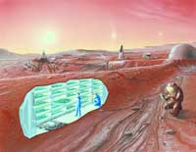
Artist’s concept of possible colonies on future Mars missions.Click to enlarge image
Image courtesy of NASA

Planet Earth is able to meet the basic living requirements for trillions of organisms, including humans. The oxygen we need is in the air around us, the atmosphere protects us from radiation, drinking water can be found in rivers and lakes, and food can be readily found in most places.
On Earth, cycles exist where one species’ waste products are used by another species, so that the waste products do not build up to high levels: an example of this is the complex carbon cycle^{w1} in which oxygen and carbon dioxide are alternately produced and used by plant species and animal species.
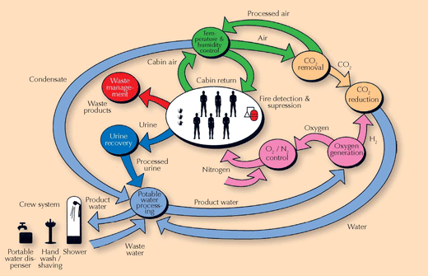
The flow of recyclable resources on board the ISS
Image courtesy of NASA

However, in space, none of these requirements for human survival are met. Therefore, to live and work in space, we have to take with us everything we need, and we need to devise ways to recycle or dispose of the waste we produce. We must do this while limiting the weight of material taken to space and building in backup safety equipment (redundancy).
Weight must be minimised as transport into space is extremely expensive. It currently costs about 17 000 USD to lift 1 kg to the International Space Station (ISS) (based on an average launch cost of 450 million USD and shuttles carrying an average of 26 000 kg of cargo plus astronauts). It will cost much more to take 1 kg to the Moon or to Mars.

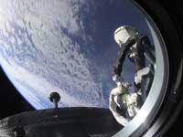
A photo of the Earth taken by ESA astronaut André Kuipers out of the window of the Soyuz capsule
Image courtesy of ESA

At such a great expense and with the inherent difficulty of each mission to space, every kilogram needs to be justified. Furthermore, backup equipment is required for every life-support system in space. Currently, on the ISS, there are three levels of this redundancy, just in case the primary system fails and a backup system is needed.
Getting your students thinking about habitat design on the Moon or Mars can be a good way to consider the challenges of living and working in space as well as illustrating the critical role that the cycles on Earth play in the survival of all organisms. It is an activity suitable for students of all ages (see the suggestions for different age groups, below).
The introduction to the activity will take about 2 hours, with at least a further 2 hours to design the habitat, depending on its complexity. To build the habitat could take 5-15 hours, depending on how many students are involved and how complex a habitat they are building. If the students are really enthusiastic about the idea, they might want to invest even more time.
When you have finished, send a photo of your completed space habitat toeditor@scienceinschool.org and we will publish a selection of the photos on the Science in School website.
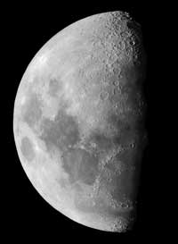
Image courtesy of Luc Viatour; image source: Wikimedia Commons

Designing a space habitat
Begin by asking your students to consider what humans need to stay alive and work efficiently on Earth. How could we meet these needs in space? And how can we build space facilities with the highest efficiency, lightest weight and longest durability? See the box below for many ideas, together with links to more resources, including many from the European Space Agency^{w2}. Further background information can be downloaded as a PDF or Word® document^{w3}.
Now the students can begin to design and even build their own space habitat. First, they will need to decide whether to build their habitat on Mars or the Moon, because the design requirements will differ^{w4}.
They should bear in mind that the Moon has greater temperature changes and no atmosphere for protection but is closer to Earth. Mars has more moderate temperature changes and an atmosphere, but it is much further away from Earth, thus a Mars habitat will need to be much more independent.
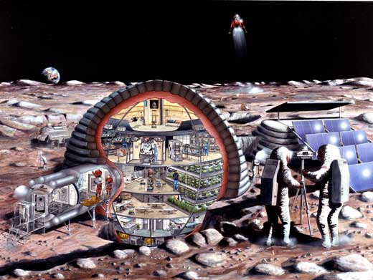
An inflatable habitat such as the one depicted here, 16 m in diameter, could accommodate the needs of a dozen astronauts living and working on the surface of the Moon. Depicted are astronauts exercising, a base operations centre, a pressurised lunar rover, a small clean room, a fully equipped life sciences lab, a lunar lander, selenological (lunar geology) work, hydroponic gardens, a wardroom, private crew quarters, dust-removing devices for lunar surface work and an airlock
Image courtesy of NASA

Activity for students aged 7-10
- Begin by discussing what humans need to survive on Earth and then extrapolate the list to what humans need in space. What is essential for survival in space and what can be removed to save weight and money?
- Discuss how the requirements are important during the design and construction process. Pick two of the requirements that a habitat needs to provide (listed in the boxbelow) and include them in the design of a planetary habitat for at least two people.
- Build a model habitat out of cardboard and strong sticky tape. The habitat can be room-sized or tabletop-sized. You may find the Worldflower Garden Dome^{w5} and Geo-Dome^{w6} websites helpful for your design. Decorate the habitat to make it a liveable place, for example by adding colour or windows.
- Discuss with the group what each student would take with them if they could only choose one personal item (e.g. a family photo, music recording or book).
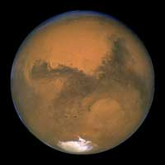
Image courtesy of NASA/JPL-Caltech

Activity for students aged 10-14
- As for the previous group, but pick four to six of the requirements of a space habitat (seebox) and include them in a design for at least four people.
- Give more consideration to the weight of the habitat and the associated costs.
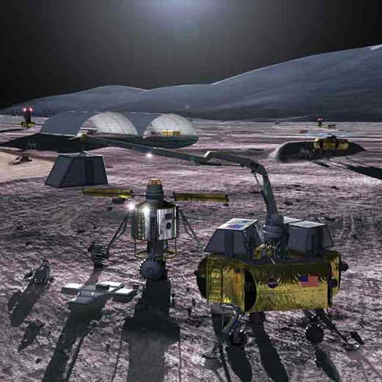
An outpost on the Moon could produce lunar oxygen, conduct long-term surface operations, and reveal issues before humans begin the journey to explore Mars. The Moon’s proximity, only several days from Earth, allows the testing of systems that will enable months-long round trips to Mars
Image courtesy of Pat Rawlings and Faisal Ali / SAI
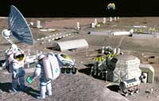

Artist’s impression of a lunar mining facility harvesting oxygen from the resource-rich volcanic soil of the eastern Mare Serenitatis (Sea of Serenity) on the Moon. Click to enlarge image
Image courtesy of NASA /Pat Rawlings (SAIC)

Activity for students aged 14-19
- As for the first group, but instead of building a cardboard model, small groups of students should use computer modelling software^{w7} to create their vision of a habitat. Take into consideration at least eight of the requirements for a space habitat (see boxbelow) for four people.
- Include a description of the different technologies needed for the habitat, e.g. an electrolyser to produce oxygen from water, or a Sabatier reactor to split carbon dioxide into methane and water^{w8}, technology that is being tested on the ISS^{w9}.
- In the design, incorporate features to support a sense of well-being such as windows, paint colour or leisure areas.
- Compare what the teams did and see if everyone likes the designs. There will probably be differences in what individuals consider appealing. Discuss how to design one habitat for many cultures.

Considerations for designing a space habitat

Earth requirements
What do we expect for our everyday life on Earth?
- Shelter from weather – a home and clothing
- Clean drinking water and a sanitary living environment
- Breathable air
- Nutritious food
- Medical care
- Adequate sleep and leisure time
- Physical well-being

Requirements for a planetary space habitat
Many of our requirements in a space habitat would be similar to those on Earth, but some would be specific to the new environment.
- Shelter from radiation, micro-meteorites, dust, the surrounding vacuum and the extreme temperature environments
- Significant reduction in standard water use, increased water recovery and recycling^{w10}. This includes hygiene facilities that use very little water – for the astronauts to wash their clothes and bodies, and a toilet
- Breathable air – a way to either recycle old air (oxygen provision, carbon dioxide and contaminant removal) or supply new air^{w11}
- Nutritious food – to be either brought and stored or produced in the habitat
- Medical facilities for minor problems such as cuts, rashes, infections, toothache and motion sickness, and for more serious problems such as broken bones, kidney stones and heart attacks
- Sleeping quarters
- Exercise facilities addressing cardiovascular, muscle and skeleton maintenance
- Temperature regulation systems to compensate for the temperature extremes. Surface temperatures on the Moon can be as low as -270 °C in permanently shadowed craters at the poles, and higher than 121 °C in the full sun at the lunar equator^{w12}
- Communication systems (contact with mission control as well as family and friends on Earth)
- Recycling or disposal of liquid waste (urine) and solid waste (general garbage, faeces)^{w10, w11, w13}. This needs to be done under the guidelines of planetary protection^{w14}
- Monitoring systems for the life-support systems (air- and water-quality monitoring, radiation dose measurements)
- A food preparation and eating area
- Work areas for exploration experiments (geology, biology, chemistry, etc.). This is a requirement to justify long-duration space exploration.
Many of these considerations were also important in the design of the ISS. For more details, see Hartevelt-Velani & Walker (2008).

Possible extension: psychology
Any crew on a long mission, for example to Mars, will be isolated from their loved ones and confined in a small space with other crew members. Training in conflict management is crucial, as is enhancing our understanding of how humans respond under stress, in a confined space over long durations^{w15}.
The mental state of each individual is extremely important, as it will affect the group mental state and ultimately even the overall mission success. It is therefore important to ensure good mental support for the crew.
On Earth, humans need a sense of mental well-being including interactions between people to be happy and productive. To achieve this, in addition to the points listed above, a space habitat needs to provide:
- Privacy for each crew member, even if the space is small
- A common area for interaction and leisure
- Colour in the habitat, selected by each crew prior to launch
- Living things, e.g. plants or fish. Might there be ethical issues?
- Windows. Being able to look outside is a very important psychological factor. From Mars, this will be harder than from the Moon, since Earth will look like just another small star in the sky.
To learn about life on board the ISS, for which these considerations are important, see also Hartevelt-Velani et al. (2008).

Design constraints
When a space habitat is designed, it is important that it should be:
- Safe – this is the most important consideration
- Robust – strong, reliable, durable, requiring minimal maintenance
- Lightweight – the average fridge weighs 100 kg and is clearly not an option in a space habitat
- Launchable – the different elements have to fit an available rocket in terms of weight, shape and power requirements
- Effective – it must do what it was designed to do
- Affordable – space exploration is expensive, so all steps to reduce costs without compromising performance and safety must be taken.

Designing an effective habitat
How can we meet the requirements of a space habitat under the constraints that are imposed? This is done by:
- Using a modular construction system, beginning with the essential features and adding ‘rooms’ as needed for particular purposes (e.g. research or space for more crew)
- Developing technology to utilise the resources on the Moon or Mars, e.g. making lunar bricks or lunar cement, or using the underground caves on Mars for habitats
- Recycling (air, water, waste, parts of the landing spacecraft for construction, the oxygen and hydrogen in extra rocket fuel for water production)
- Miniaturising as many things as possible, standardising all tools, power connections, etc.
- Making areas multipurpose, e.g. a dining table that folds away so that the space can also be used for other purposes.

Acknowledgement
The author would like to thank Scott Hovland from the European Space Agency for valuable comments and advice.

References
- Hartevelt-Velani S, Walker C (2008) The International Space Station: a foothold in space. Science in School 9: 62-65.www.scienceinschool.org/2008/issue9/iss
- Hartevelt-Velani S, Walker C, Elmann-Larsen B (2008) The International Space Station: life in space. Science in School 10: 76-81.www.scienceinschool.org/2008/issue10/iss

Web references
- w1 – Learn more about the carbon cycle on the Windows to the Universe website:www.windows2universe.org/earth/Water/co2_cycle.html
- w2 – The European Space Agency (ESA) is Europe’s gateway to space. It is a member of EIROforum, the publisher of Science in School. For more information, see: www.esa.int
- w3 – Background information to support teachers in this activity can be downloaded here as a PDF or Word® document.
- w4 –For detailed information about our Solar System, see: http://solarsystem.nasa.gov
- w5 – The Worldflower Garden Domes website offers instructions for building a paper dome based on a buckyball. See:www.gardendome.com/GD1.htm
- w6 – Further instructions for building a geodesic dome are available on the Geo-Dome website: www.geo-dome.co.uk/article.asp?uname=modelbuild
- w7 – For a list of free computer-aided design (CAD) software, see : www.freebyte.com/cad/cad.htm
- w8 – To learn more about the Sabatier reaction for use on Mars missions, see:
  - Richardson JT (2000) Improved Sabatier reactors for in situ resource utilization on Mars. In Institute for Space Systems Operations - 1999-2000 Annual Report. Pp 84-86. Houston, Texas, USA: University of Houston.www.isso.uh.edu/publications/A9900/mini-richardson.htm
- w9 – In 2010, a Sabatier system was delivered to the ISS for testing. See the NASA press release onwww.nasaspaceflight.com or use the direct link: http://tinyurl.com/3su8p26
- w10 – For an interactive online model of the water recycling circuit on board the ISS, see:http://esamultimedia.esa.int/docs/issedukit/en/html/t030505t1.html
- w11 – To find out more about the flow of recyclable resources on board the ISS, especially air, see:http://science.nasa.gov/science-news/science-at-nasa/2000/ast13nov_1
- w12 – For fact sheets on the planets and their satellites, see: http://nssdc.gsfc.nasa.gov/planetary/planetfact.html
- w13 – For more information on ESA’s life support and recycling systems for space, including French educational materials on the MELISSA project, see: http://ecls.esa.int/ecls
- w14 – For more information on how NASA, the US National Aeronautics and Space Administration, reduces the risk of biological cross-contamination, see: http://planetaryprotection.nasa.gov
- w15 – For information about Mars500, a study done to understand key physiology and psychology effects of long duration isolation and crew dynamics, see: www.esa.int/esaMI/Mars500
- w16 – The report Luna Gaia – a closed loop habitat for the moon can be downloaded from www.isunet.edu^{w17} or using the direct link: http://tinyurl.com/69bjugb
- w17 – To find out more about the International Space University, see: www.isunet.edu

Resources
- NASA has developed a problem-based learning module on space habitats. Starting from a ‘sealed room’ introductory activity, four content areas are offered, on ‘life in a sealed container’, ‘healthy choices’, ‘air and water’, and ‘trash or treasure’, exploring ecosystems, human nutrition and fitness, recycling of air and water, and waste removal. See: www.nasa.gov/audience/foreducators/son/habitat
- The EU-funded CoReflect project has developed a teaching unit on designing a Moon habitat for 10- to 12-year-olds, available in English and Dutch. See: www.coreflect.org/nqcontent.cfm?a_id=15089
- To learn more about a potential manned mission to Mars, see: http://nssdc.gsfc.nasa.gov/planetary/mars/mars_crew.html
- ESA’s ISS education kits are freely available for primary- or lower-secondary-school students (ages 8-10 and 12-15) in all ESA member state languages. They offer teaching activities, background notes for teachers and students, and much more.
  - The primary-school ISS education kit includes activities such as building a model of the ISS from recycled household materials, planning the amount of water and weight of other materials to be taken onto a space mission, or creating an astronaut menu. See: www.esa.int/SPECIALS/Education/SEMN3A5KXMF_0.html
  - The lower-secondary-school ISS education kit offers videos, background reading and interactive online materials about building the ISS, life and work on board, as well as classroom activities such as investigating and filtering your local fresh water, designing a space station bathroom, studying how the environment affects materials, or designing and constructing a glove box like the one used for experiments on board the ISS. See: www.esa.int/SPECIALS/Education/SEMTBS4KXMF_0.html
- Educational DVDs about the ISS for students aged 12-18, explaining basic concepts such as the effects of weightlessness on the human body with simple demonstrations, were produced with the help of European astronauts during their missions on board the ISS. The free materials can be downloaded online or ordered on DVD. See: www.esa.int/esaHS/SEMZTFYO4HD_education_0.html
- ESA’s teaching materials on the ISS also include the 3D teaching tool ‘Spaceflight challenge I’ for secondary-school students, which can be used either as a role-playing adventure game or as a set of interactive exercises. It features science topics from across the European curricula, with scientific explanations and background information. To download the software or order your free copy, see:www.esa.int/esaHS/SEM3TFYO4HD_education_0.html
- ESA’s ‘lessons online’ for primary- and secondary-school students and their teachers include text, short videos and graphics. Topics covered include ‘life in space’, ‘radiation’, ‘gravitation and weightlessness’ and ‘bugs in space’. See:www.esa.int/SPECIALS/Lessons_online
- Simulate flying over the surface of Mars with Google Mars: www.google.com/mars
- Here is a selection of space-related articles previously published in Science in School
  - Warmbein B (2007) Down to Earth: interview with Thomas Reiter. Science in School 5: 19-23.www.scienceinschool.org/2007/issue5/thomasreiter
  - Wegener A-L (2008) Laboratory in space: interview with Bernardo Patti. Science in School 8: 8-12.www.scienceinschool.org/2008/issue8/bernardopatti
  - Williams A (2008) The Automated Transfer Vehicle – supporting Europe in space. Science in School 8: 14-20.www.scienceinschool.org/2008/issue8/atv

Author
Erin Tranfield completed her PhD in May 2007 in the Department of Pathology and Laboratory Medicine at the University of British Columbia, in Vancouver, Canada. She then spent two years at NASA Ames Research Center in Moffett Field, California, USA, investigating the effects of lunar dust on human physiology and pathology. Erin is currently at the European Molecular Biology Laboratory in Heidelberg, Germany, working on the three-dimensional reconstruction of the mitotic spindle using high-resolution electron tomography.
Erin was an author of Luna Gaia – a closed loop habitat for the moon^{w16}, a student research report of the International Space University (ISU)^{w17} in 2006. She is now adjunct faculty at the ISU and will be the chair of the space life science department at the ISU two-month space studies programme in summer 2011 in Graz, Austria.

License information
CC-BY-NC-SA

