LET’S MAKE A FAKE BRINICLE!
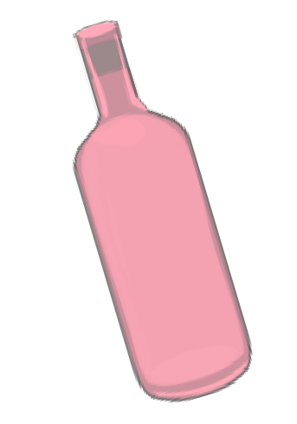
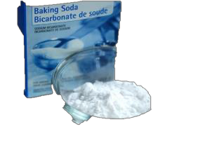
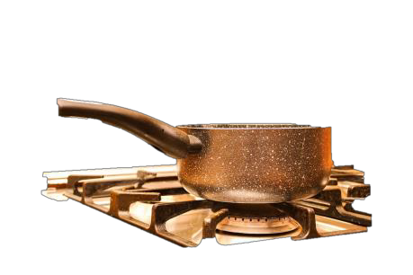

What you need:

- 3 cups of vinegar
- 2 cups of baking soda
- Pan, bowl (for water bath), spoon
  - water
- drinking glass

What you do:

Mix vinegar and soda, put the mixture to boil. Evaporate the solution until there’s only powder left. Get rid of all the ‘lumps’. Heat the powder in water bath (put it into the bowl, place the bowl on the pan with boiling water; do not let the bowl touch the water.

Add put warm powder into a drinking glass and add a little water. Touch the solution with your finger and observe how ‘hot ice’ forms!

Explanation:

Here is the reaction between the baking soda (Na⁺[HCO3]– ) and vinegar (CH3–COOH ) to produce the sodium acetate (CH3–COO– Na⁺) :

Na⁺[HCO3]– + CH3–COOH → CH3–COO– Na⁺ + H2O + CO2

When we boil the solution to concentrate the sodium acetate. Once we touch it, the crystallization (with
heat release) process is initiated.
