How society uses and misuses Animals
3RS LEARNING SCENARIO
Author(s)
Ismail Ali Gago & Jonathan González Viñas
Summary
In this learning scenario students will become aware of the different ways in which animals are "used and misused" in our societies. Examples include the use of animals to produce food and clothing, for religion and cultural traditions, in entertainment, pet-therapy, etc. The aim of this course if for students to enrich their knowledge and exercise different learning skills.
Key elements
Key elements | Suggestions
Subject | Biology, Math, Scientific culture, Ethics, Environmental Science
Topic | Animal welfare – Animals in society
Age of students | 15-17 years
Preparation time | The estimated time allocated for the preparation of teachers by the creators of this Learning Scenario is 2 weeks.
Teaching time | The estimated time for the use of this Learning Scenario in the classroom is five periods of 55 minutes each. This Leaning Scenario can be implemented using the Project-Based Learning method, and instructors can dedicate
Online teaching material | - Google Documents (https://www.google.com/docs/about/),  - Virtual classrooms  - Moodle based (https://moodle.org),  - Virtual clouds (Google drive, OneDrive, Owncloud),  - Padlet,  - Spreadsheets,  - Word processors,  - Authoring tools (eXelearning: https://exelearning.net),  - Presentation tools
Offline teaching material | Laptop, mobile phone, tablets, projectors
Resources used | An essential part of this lesson is for students to be introduced in survey methods. For this reason, the use of online tools and forms providing the questions teachers can use in order to conduct a survey about uses of animals. Examples of such tools include:  - Google Forms: https://www.google.com/forms/about/  - EU Survey: https://ec.europa.eu/eusurvey/home/welcome  - Survey Monkey: https://www.surveymonkey.com/  In order to conduct the survey, teachers can use the questions found in Annex 1.  Other resources:  European Food Safety Authority  https://www.efsa.europa.eu/en/microstrategy/foodex2-level-2  EU consumer habits regarding fishery and aquaculture products  https://ec.europa.eu/commfrontoffice/publicopinion/index.cfm/ResultDoc/download/DocumentKy/76537 (online pdf)  Food Safety in the EU  https://www.efsa.europa.eu/sites/default/files/corporate_publications/files/Eurobarometer2019_Food-safety-in-the-EU_Full-report.pdf (online pdf)  Students' Attitudes to Animal Welfare and Rights in Europe and Asia  https://www.researchgate.net/publication/235720214_Students'_Attitudes_to_Animal_Welfare_and_Rights_in_Europe_and_Asia  Attitudes of EU citizens towards Animal Welfare  https://ec.europa.eu/commfrontoffice/publicopinion/archives/ebs/ebs_270_en.pdf  Attitudes of Europeans towards Animal Welfare  http://eurogrourb.cluster020.hosting.ovh.net/wp-content/uploads/Eurobarometer-2016-Animal-Welfare.pdf  The Pet Report 2015  http://petreport.petsathome.com/  Sustainable Hunting and Natura 2020  https://ec.europa.eu/environment/nature/info/pubs/docs/factsheets/hunting.pdf  Creative Value Rubric (please see the Google Drive link)  https://drive.google.com/drive/folders/1wDyWpnBQZJLykKxLSMUAyCTM6491YYGw

Licenses
© European Union, 2020
Attribution CC BY 4.0
The Commission’s reuse policy is implemented by Commission Decision 2011/833/EU of 12 December 2011 on the reuse of Commission documents (OJ L 330, 14.12.2011, p. 39 – https://eur-lex.europa.eu/eli/dec/2011/833/oj).
Unless otherwise noted, the reuse of this document is authorised under the Creative Commons Attribution 4.0 International (CC BY 4.0) licence (https://creativecommons.org/licenses/by/4.0/). This means that reuse is allowed, provided appropriate credit is given and any changes are indicated.
For any use or reproduction of elements that are not owned by the EU, permission may need to be sought directly from the respective right holders.
Aim of the lesson
- Identify common uses of animals in our society.
- Collect different opinions among students.
- Develop critical thinking on this topic.
Trends
- Project-Based Learning
- Collaborative Learning
- Flipped Classroom
- STEM Learning
- Outdoor Education
- Mobile Learning
- Open Source Learning
- BYOD
- Social Media Learning
- Learning Materials
- Peer Learning
21st century skills
- Creativity and Innovation
- Critical Thinking and Problem Solving
- Communication
- Collaboration
- ICT (Information, Communications, and Technology) Literacy
- Social and Cross-Cultural Skills
Lesson Plan
Name of activity | Procedure | Time
Survey | Teachers present and explain the aim of the survey.  They might opt to use the questions found in Annex 1 and either create a survey using EU Survey, Google Forms or any other tool, or print and distribute the survey.  Teachers may copy the questions found in this form (also found in Annex 1) https://docs.google.com/document/d/17y1FAadLanaANRcS0j7KTcKPnnXNJkKGYS_IQ4GkB_U/edit. | 55’
Results and grouping | After the implementation of the surveys, teachers present the results and explain the different roles and grouping of the students in the different key areas in the activities that will follow. The topics that will be discussed are the use of animals like pets, in entertainment, for food, the use of animals in the process of finding environmental solutions, and the use of animals in religion and cultural traditions. (15´)  The students will be divided in groups of four or five people (it depends on the total number of students) and each one of them will have a different role.  The different roles are:  - Keeping a learning diary: the assigned student is responsible for taking notes, pictures or videos and for registering the activity (in Google Docs, text editor or blogs); they will also be the representative of the group. In the last five-ten minutes of the lesson, he/she should ask these questions to his classmates:  - What did you do?  - Which tools have you used?  - Problems faced?  - How much time did you spent?  - Presenter: the assigned student is responsible for the group’s final presentation. All the students of the group need to contribute, and the presenter will collect all the materials and make the final presentation of the group.  - Investigator: The assigned student is responsible for the information sources, licenses and copyright.  - Map Locator: The assigned student will use a map (either a digital map or not, as long as it has labels or the option to pin a location) and place on it the spots where the information was found, linking the map to the resources used during the lesson. The students decide what role each one will have, and then they will distribute the investigation work (10´)  When they finish, students will start with the investigation (85´) | 110’
Group task | Once students finish the investigation about the assigned topic, the preparation of the learning diary (15´) and discussion about it (15´) they focus on the preparation of the presentation and the map that will be shared with the main group. (25´) | 55’
Main group | The different groups present to each other their presentations and conclusions. (15´)  A debate follows about the different topics in the main group and students draw the conclusions to be published. (20´)  The different people assigned for different tasks and responsibilities are grouped in order to make a common learning diary, presentation, map locator and ensure that the sources and copyrights are respected (10´).  The students will undertake again the survey and compare the results with the fist survey (10´). | 55’
Assessment
Here we include as an example the image of a rubric teachers can use in order to assess their students:
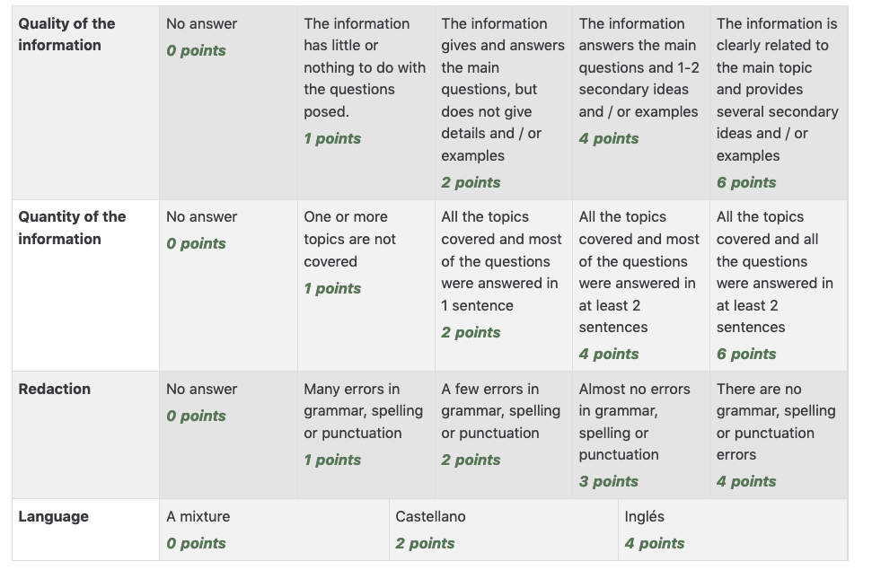
Students’ and teachers’ feedback after the implementation of the Learning Scenario during the Pilot phase of the project
Student feedback
- This Learning Scenario has been more challenging for students aged below 14, and less difficult for students in Secondary and High School but still challenging.
- It is preferable to introduce students in the reasoning of having a survey in class. Following, proceed with the creation of a survey.
Teacher’s remarks
- Given the variety of discussion topics and activities in the Learning Scenario, but also the possibility to implement the scenario using the Project-Based Learning method, teachers can choose between spending hours during consequent days in one week, or allocate specific time for each activity during the semester. For example, the first session could be dedicated to the survey, its uses and testing different tools. Following, teachers can introduce their students in the various topics (animals in society, culture, entertainment) and improvise by adapting the content and activities (for example focus on ethics and following assign an activity about the ethics of hunting and the recent regulation).
- Please take into consideration that the materials of the Learning Scenario might be strong. Teachers are advised to adapt according to the age and previous knowledge of their students.
- In addition, kindly consider that the topics of this Learning Scenario might generate interesting but intense debate in class. Allocate specific time for each activity, including the debate so the implementation is complete and meaningful.
- This Learning Scenario can be implemented in an interdisciplinary way in the context of subjects like biology, anatomy, ethics, philosophy and environmental science.
- Teachers are strongly advised to prepare questions for all the topics discussed (materials found in Annex 2).
- Teachers can be proactive in finding and introducing more resources about the topic (e.g. The UNESCO Declaration of Animal Rights: http://www.esdaw.eu/unesco.html)
About 3Rs project
This Learning Scenario has been created in the framework of the 3Rs project. The 3Rs project is building learning activities for secondary schools to introduce the principles of the 3Rs - the Replacement, Reduction and Refinement of animal use in science. Students will develop their critical thinking and science literacy skills by exploring topics such as ethics in science, how the European Union is protecting the welfare of laboratory animals, and what high-tech non-animal tools are available as alternatives. The learning activities are available for teachers in a Massive Open Online Course (MOOC), organized by the European Schoolnet Academy.
The 3Rs project has been funded by the European Commission's Joint Research Centre under a European Parliament Pilot Project. This document has been prepared by European Schoolnet (a network of 34 European Ministries of Education which aims to bring innovation in teaching and learning), in collaboration with ECORYS (international company providing research, consultancy and management services) and SYRCLE (Systematic Review Center for Laboratory Animal Experimentation).

Annex 1
Survey about different topics regarding the use and misuse of animals in society

General information
*Write here your name and surname, please
………………………………………………………………………………………………………………………………………………………………………………………………………………………………………………………………………………………………………………………………

*Write here your age, please
……………………………………………………………………………………………………………………………………………………………………………………………………………………………………………………………………………………………………………………………....

* Your school

IES Cervantes, Madrid (Spain
Colegio San Gregorio, Aguilar de Campoo (Palencia, Spain)

*Your school level

4º ESO
1º Bachillerato

Other, specify
………………………………………………………………………………………………………………………………………………………………………………………………………………………………………………………………………………………………………………………………………………………………………………

About pets
*Do you have any pets?

Yes
No

What kind of pet do you have?
Dog
Cat
Bird
Horse
Small animals
Fish
Other

Write here any other kind of pet
………………………………………………………………………………………………………………………………………………………………………………………………………………………………………………………………………………………………………………………………

*In your opinion, are we humanizing pets?
Yes
No

* Do you think that people who have pets increase the risk to transmitting infectious diseases?
Yes
No
I don’t know

* How can pets improve your behaviour?
Improve your responsibility
Improve your marks
Improve your emotional intelligence
Improve your social skills
Improve your sports skills
Don´t improve anything
I don’t know

*Do you know any project that uses animals to help the disabled?
Yes
No
I’m not sure

If your previous answer is "Yes", describe it here
……………………………………………………………………………………………………………………………………………………………………………………………………………………………….……………………………………………………………………………………………………..……………………………………………………………………………………………………………

Animals and entertainment
* Do you agree with the use of animals for entertainment?
Yes
No
I’m not sure

* In your opinion, do the animals that are used for entertainment suffer?
Yes
No
I’m not sure

* Is the current use of zoos a good way to protect or investigate about animals?
Yes
No
Other

Write here any other answer
………………………………………………………………………………………………………………………………………………………………………………………………………………………………………………………………………………………………………………………………………………………………………………………………………………………………………………………………………………………………
* Is hunting a sport?
Yes
No

* Is hunting activity necessary?
Yes
No

If your answer is yes, explain why
……………………………………………………………………………………………………………………………………………………………………………………………………………………………………………………………………………………………………………………………………………………………………………………………………………………………………………………

* Do you think that animals in circuses suffer?
Yes, always
Yes, but only the wild animals, like lions or elephants
No, but sometimes they don’t live in better conditions
No

* Are zoos or aquariums necessary? thinking about technologies as virtual reality?
Yes, it is not the same
Yes, but only for protecting wild species in high risk or recover animals poaching
No, with current technology, they are not necessary

* Do you know any tradition of using animals in popular festivities or local celebrations?
Yes
No
If your answer is yes, describe it here.
………………………………………………………………………………………………………………………………………………………………………………………………………………………………………………………………………………………………………………………………………………………………………………………………………………………………………………………………………………………………

* Do you think that some animal species survive because are used in human activities?

Yes
No

Animals and environment
* Can animals change our environment?
Yes
No

* Is it possible that excessive use of farm animals can contribute to climate change?
Yes
No
I don’t know

* Write here why
………………………………………………………………………………………………………………………………………………………………………………………………………………………………………………………………………………………………………………………………………………………………………………………………………………………………………………………………………………………………

* Do you know any current energy source of animal origin?
Yes
No

Animals and religion
* Do you know any tradition regarding religions? Describe it.
……………………………………………………………………………………………………………………………………………………………………………………………………………………………………………………………………………………………………………………………………………………………………………...........................................................................................................................................................

If your answer is yes, describe it here.
………………………………………………………………………………………………………………………………………………………………………………………………………………………………………………………………………………………………………………………………………………………………………………………………………………………………………………………………………………………………

Animals for food
* Is it necessary to eat animals?
Yes
No

* Are humans overusing animals for food?
Yes
No
I don’t know

* Are humans farming more animals than we need?
Yes
No
I am not sure

Thank you for your collaboration!
………………………………………………………………………………………………………………………………………………………………………………………………………………………………………………………………………………………………………………………………………………………………………………………………………………………………………………………………………………………………………………………………………………………………………………………………………………………………………………………………………………………………………………………………………………………………………………………………………………………………………………………………………………………………………………………………………………………………………………………………………………………………………………………………………………………………………………………………………………………………………………………………………………………………………………………………………………………………………………………………………………………………………

