Soap box race

SUMMARY
Age group: 6-8 years old Number of hours: 7-10 hours
Maths topics: Measurement –data and statistics
Short description of activity: Building a unique soap box car is fun, but it's also challenging. Students need to find out how they can build a soap box car that can reach the finish downhill as fast as possible. Each team creates an optimised prototype of a soap box car to organise their own race!

Real world motivation

Soap box races are a lot of fun. They are organised in many places throughout the world. People love them no matter how old they are. It's fun to look at all these soap box cars and it's even more fun to build your own unique soap box car. You can be really creative when you make your own special soap box car. Just check this out: https://soapboxrace.redbull.com/uk/en/home/ These races can also be quite challenging and a little dangerous too. As a consequence, students will first build a small soap box car for a mascot/puppet/etc. When they are sure about the important concepts of building a fast soap box car, they will have the keys to make a larger real one (optional). In this activity they will build a 'prototype' that they will optimise until they know exactly how to build a soap box car that can win a race!

If you want, you can also use the context of a pinewood car:
https://boyslife.org/hobbies-projects/projects/138909/use-science-to-make-a-fast-pinewood- derby-car/, https://www.pinewoodpro.com/

Problem(s) to be tackled

What elements are needed for an optimal racing circuit?
How can we build the optimal starting slope for a soap box race? What are the criteria for a good soap box car?
How do we build a soap box car based on the agreed criteria?
For example: How can we make a soap box car that goes as far as possible?
How can we make a soap box car that reaches the finish line downhill? How can we make a soap box car that goes as fast as possible?
How can we know which car wins the soap box race?

Goals

Skills:

- Students dare to tackle problems:
  - They work out a strategy in order to solve a problem
  - They work out a procedure in order to solve a problem
  - They carry out a plan
  - They evaluate and reflect upon the product and research/design process
- Students agree on criteria to build a soap box car and use these criteria to evaluate their constructions, e.g. they can formulate that the wheels need to turn smoothly and that they need to build the wheels such that there is less friction.
- Students work efficiently and accurate by using a self-made simple plan, and by choosing simple materials and tools.
- Students investigate some concepts (friction, energy, action-reaction) by testing their hypotheses. They make 'if-then' relationships.
- Students formulate what needs to be optimised for a successful soap box car
- Students optimise their soap box car based upon an investigation.
- Students chose appropriate measurement tools to measure length and time.
- Students can measure length, distance.
- Students use appropriate terms according to the measurement (far, farther, etc.).
- Students can read and write measurement results in different ways.

Knowledge:

- Students use knowledge of materials and knowledge of concepts in relation to construction and movement (friction, action-reaction, energy) in order to construct the soap box car.
- Students use the right materials and tools while constructing the soap box car.
- Students use the right techniques in order to put things together Methodology
Chronological overview:

Part | Description | Timing
1 | A soap box race is fun! - Class talk  - Students watch a movie about a soap box race, e.g. https://www.youtube.com/watch?v=7YsWYCSD8a0  Students talk about what they have seen: What is typical for a soap box race, a soap box car, etc.?  - Students are invited to organise their own soap box race with unique cars that they build themselves! These will not be big cars like they have seen in the movie, but small cars that can carry a puppet (e.g.  Playmobile, Lego, etc.) or mascot (e.g. doll, teddy bear, etc.). | 10’

It is possible that students will be (more) motivated to build a real soap box car. You can stimulate them to first build the prototype for the puppet as they need to find out the optimal building conditions. You can clarify that they will be able to test the prototype - a real car is much more difficult and
dangerous (e.g. moving downhill).
2 | Planning a soap box race/car – class discussion  - Students must identify the criteria for a soap box race/car:  - Slope as starting point  - Finish line  - Track (straight, winding, etc.)  - Decoration  - Car:  - Self-made, handmade  - Can carry one or more puppets  - Looks fancy, funny  - Moves downhill  - Goes as far as possible … (at least reach the finish line)  - Goes fast*  - …  - …  * In a soap box race the criterion is ‘as fast as possible’, but actually, the  first challenge is to reach the finish line. Secondly, students will have to optimise the car so that it can also go very fast. | 20’
3 | Creating the soap box racing circuit – group work/class discussion Students work in groups (3-4 students). First, they need to design the racing circuit.  - Each team makes a communal drawing of a racing circuit. The different elements of the circuit are then discussed in class, e.g. length, finish line, slope, decoration, etc.  - Students set up the racing circuit (at least a starting slope (see 4) and  finish line). | 15’
4 | Investigating the slope of the soap box racing circuit – group work Students are given the challenge to design the optimal slope (= starting point of the circuit) with the materials they are given (e.g. shelves, a number of blocks, etc.). At least, we want a car to reach the finish line!  - Students discuss what they need to investigate to create the optimal starting slope. They think of ways to investigate the influence of different slope conditions.  REMARKS:  - Fair and real testing is very important:  - Controlling one variable at a time (e.g. change the length of the slope but not the height) to investigate the effect (here: the  distance the car covers). | 50’

- This also includes the idea of testing a condition (e.g. steep/low slope) multiple times. Let students discover this for themselves.
- Students will have to come up with the idea that they all have to use the same playmobile/matchbox/etc. car to test the optimal conditions for the starting slope.
o They must think of ways of identifying how a car goes further when they test different slope conditions (e.g. marking/measuring/etc. the distances).
- Students investigate the height (gradient), length, etc. of the slope in relation to the distance the car covers, e.g. how steep (high) does the slope need to be to make a car go as far as possible? E.g. does the length of the slope has an effect on the distance the car covers? (= different starting position of the car)
(on worksheet for children: we investigate ‘slope’ // we investigate ‘starting position’)

- The optimal starting slope is set up at the beginning of the racing circuit.
5 | Creating a soap box car – group work  Students are given the challenge of building a soap box car. Students work in groups (3-4 students). They obtain materials and need to fulfil the criteria they have put forward (see 2).  - Before they start building, they have to discuss and agree within their group about the design of their car. They make a joint drawing of their car. The drawings of the different groups can be discussed in class to learn from each other based on the criteria agreed on (see 2).  - Students start to build their own soap box car based on the criteria. REMARKS:  - Coach students by asking questions to help them think and solve problems on their own, e.g.  - Which materials do you use?  - What is going wrong? Why?  - Are there other opportunities?  - This gives the opportunity to investigate scientific concepts, e.g. ‘friction’ (e.g. How do we need to attach the wheels so that they can roll, which wheels should we use and how many, etc.?) and to use technical skills on account of the use of different materials, tools, etc. (e.g. How can we attach two pieces of cardboard, etc.?) | 50’

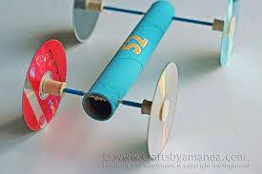
Example
4 | Testing and optimising a soap box car – class discussion/group work  - When most of the groups have a first prototype of their soap box car, the cars can be tested and discussed:  - What do we see? What happens?  - Why doesn’t the car move (smoothly)?  - What is the problem? What should we do better?  - How can we make the car go farther/faster/etc.?  - How can we measure the speed of the car? (= shortest time from start to finish)  After testing, students can optimise their car.  REMARK: Several attempts will be necessary, and an average of the different attempts can be made.  - Then, they can test again, optimise, etc. and finally, they should have created a car that meets the criteria as well as possible.  REMARKS:  - It’s important to explicitly link to the criteria:  First, they will have to find a way to get their car moving. The car should reach at least the finish line. Secondly, they can look for ways to make their car move faster. They should also think about: carrying the puppet, looking fancy/funny/etc.  - Students will have to come up with ideas of how to identify if their car is moving farther/faster than during earlier attempts.  Mathematics: measuring, making a table of the results Science: carrying out an investigation, fair testing  Engineering: Optimising the car making use of insights into scientific  concepts. | 40’
5 | Soap box race … the movie!  When every group is satisfied with their soap box car, the race can take place. Different prizes can be awarded based on the criteria, e.g. one award for the fastest car, one for the car that went the farthest, one for the most original soap box car, etc.  - Students think about ways to decide who wins the race (e.g. measuring distances/time, allowing multiple attempts, jury, etc.)  - Every group makes a movie about the race. They present their car, the specifics of their car, the problems they have tackled, etc. and finally, they film their car when it moves downhill towards the finish line. They  collect all the information in a short attractive movie. | 20’

Printables:
- Template for students (worksheet)

Organisation

Materials:

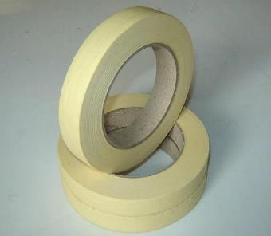
 | 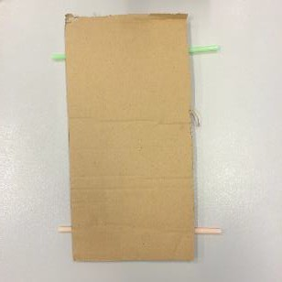
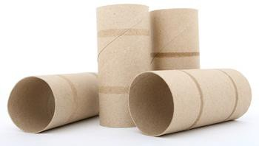 | 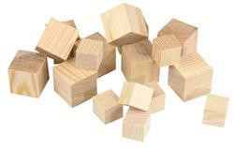 | 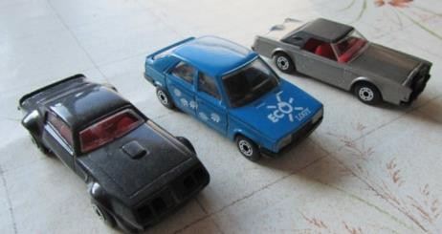
 | 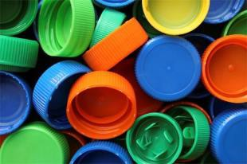 | 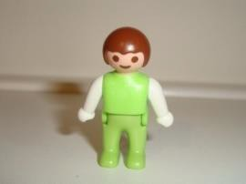
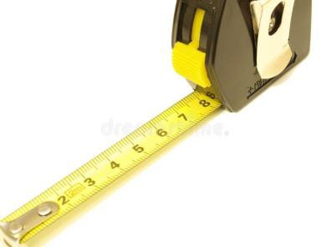 | 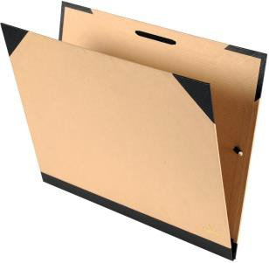 | Decoration material

Grouping:

- Groups consist of three or four students. These can be mixed groups of students with different talents who can help each other.

Coaching

Useful questions:

Context: Soap box car race is fun // Planning a soap box race/car
- Can we make a soap box car that goes as far as possible?
- What do you think the criteria are for a good soap box car?

Create the soap box racing circuit // investigate the slope
- What elements do we need for the racing circuit?
- How can we be sure that we can build the most optimal racing circuit?
- How steep does the slope needs to be if we want to car to go as far as possible?
- Does the starting position affect the distance a car covers?

Investigate and create– how to build a soap box car based upon the criteria?
- Can you devise a plan of how the soap box car should look?
- What materials will you need?
- What parts does your car need to have?
- How will you attach the different parts to each other? E.g. how will you attach the wheels to the carbon?
- What kind of wheels are you going to use? How many wheels?

Optimise and test
- Why doesn’t the car run smoothly?
- How can we optimise?
- What went well during the test?
- What went wrong during the test?
- How can you make it go faster?
- What needs to be optimised?
- How can we measure it?
- How can we test it?
- How can you be sure which car will go the farthest?
- How can you be sure which car will go the fastest?

Adaptations (abilities of age-group, within the group, etc.):

Assessment

Teacher’s assessment:

Assessment will take place in a formative way, especially regarding:

- Problem solving (e.g. in order to find the right solution for building the most optimal racing circuit)
- Planning (e.g. how to build a soap box car based upon agreed criteria)
- Reflecting (e.g. reflecting on the process: how did we attempt to make a car that goes as far as possible/as fast as possible?)
- Collecting, analysing and interpreting data (e.g. during testing)

Student’s assessment:

- Cooperate and add value to group work
- Schedule tasks, time and resources
- Individual contribution to the work
- Reflect on process and results of the different stages of this activity
- Analysing and Interpreting data in order to optimise
- Designing and producing a real ‘model’ from a design they have made on paper
- Making and using a plan

Tips and tricks

Idea for measuring distance with the students:

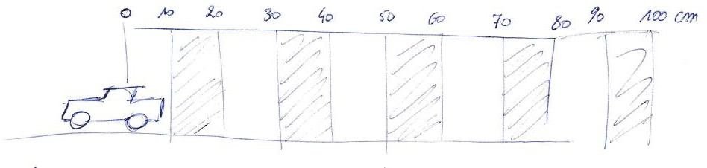

Where’s the STEM?

Science: observing, carrying out a fair investigation, experiencing scientific concepts such as 'friction', 'potential – kinetic energy'
Technology: making use of materials in order to construct a car
Engineering: Making a plan, designing, finding ways to optimise the car based on first testing Mathematics: measuring, calculating, making a graph in order to present results

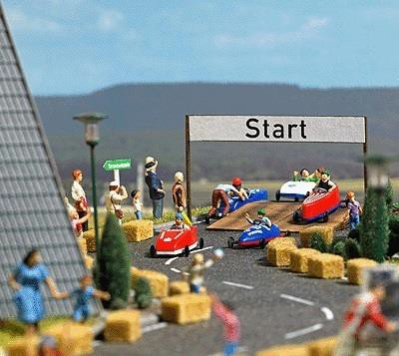

Soa
pbox race

……………………………………………………………
……………………………………………………………
……………………………………………………………
……………………………………………………………
……………………………………………………………
……………………………………………………………

Engage

The 'soap box race' …

Write down what you think will be important criteria for the soap box car.

…………………………………………………………………………………………………………………………………………………………………………………………………

…………………………………………………………………………………………………………………………………………………………………………………………………

…………………………………………………………………………………………………………………………………………………………………………………………………

…………………………………………………………………………………………………………………………………………………………………………………………………

…………………………………………………………………………………………………………………………………………………………………………………………………

Investigate

Before we start thinking about making a soap box car, we need a racing circuit with a starting slope.
How do we create an optimal slope for the soap box car?

We investigate: ……………

Prediction:

…………………………………………………………………………………………………………………………………………………………………………………………………

…………………………………………………………………………………………………………………………………………………………………………………………………

…………………………………………………………………………………………………………………………………………………………………………………………………

? | How far did the car go?

We investigate: ……………

Prediction:

…………………………………………………………………………………………………………………………………………………………………………………………………

…………………………………………………………………………………………………………………………………………………………………………………………………

…………………………………………………………………………………………………………………………………………………………………………………………………

? | How far did the car go?

Conclude

…………………………………………………………………………………………………………………………………………………………………………………………………

…………………………………………………………………………………………………………………………………………………………………………………………………

…………………………………………………………………………………………………………………………………………………………………………………………………

…………………………………………………………………………………………………………………………………………………………………………………………………

…………………………………………………………………………………………………………………………………………………………………………………………………

Create

How to build a soap box car based upon the agreed criteria?

The challenge is to build a soap box car that can go as far as possible on its own. Discuss in your group how you will build the soap box car.
Of course, you first need a plan!
Make a plan of your car on a big piece of paper

  - Think of the criteria we agreed on!
  - What materials will you need? (Take a look at the materials we have in our class)

Draw the different parts of the car
  - Make clear on the plan how you will attach the different parts of the car

PLAN:

CREATE now the car according to the plan!

Investigate
What do you think? Will your car reach the finish line? (Prediction) YES // NO (Why do you think so?)

First test of your self-made soap box car!

Did your car reach the finish line? YES // NO

- How much time did it take to reach the finish line?
Hint! Do several attempts and make an average!
...................................................... (Measure!)
What went (not so) well
…………………………………
Why?
…………………………………

…………………………….….
…………………………….….
What will you optimise?
Point out on your plan how you will do it
(use a different colour!)

Change your car according to attempt 1.
How much time did it take to reach the finish line?
Hint! Do several attempts and make an average!
...................................................... (Measure!)
What went (not so) well
…………………………………
Why?
…………………………………

…………………………….….
What will you optimise?
Point out on your plan how you will do it
(use a different colour!)
…………………………….….
Change your car according to attempt 2.

3.

How much time did it take to reach the finish line?
Hint! Do several attempts and make an average!

...................................................... (Measure!)
What went (not so) well
…………………………………
Why?
…………………………………

…………………………….….
What will you optimise?
Point out on your plan how you will do it
(use a different colour!)
…………………………….….

Report

Make a movie about your soapbox car and your race!

