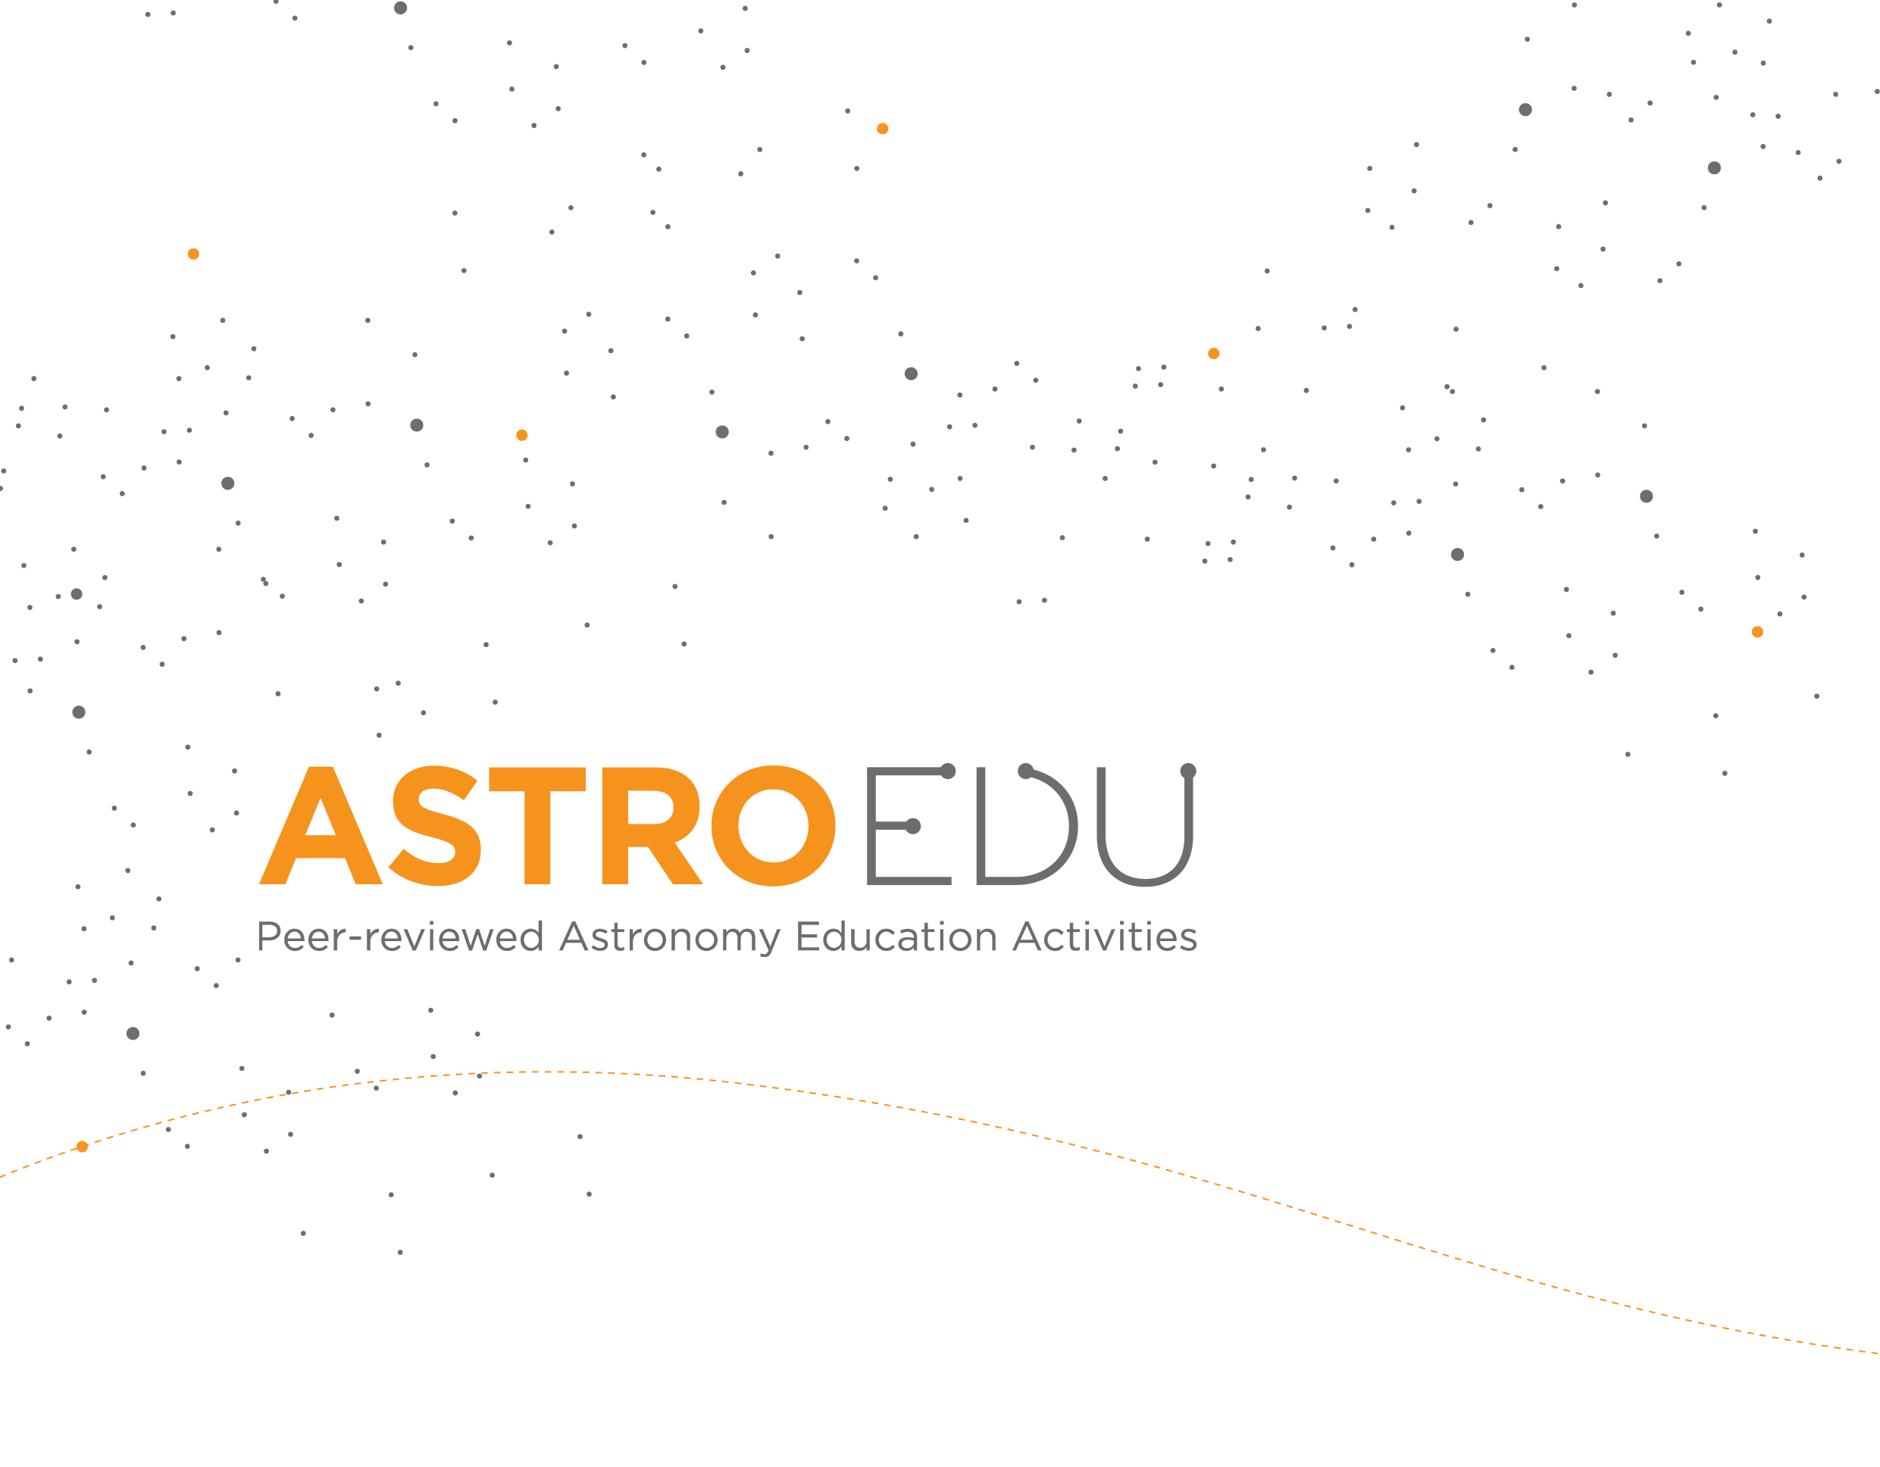Blue Marble in Empty Space

Students are taken on a virtual journey to outer space to experience that we live on a tiny planet that floats in a vast and empty space.

Erik Arends, UNAWE

Age
6 - 10
Level
Primary School
Time
30min

Group
Group

Supervised
Supervised

Cost
Low (< ~5 EUR)

Location
Indoors (small, e.g. classroom)

Core skills
Asking questions, Developing and using models, Communicating information

Type of learning activity
Demonstration / Illustration

Brief Description

Using photographs and models, students are taken on a virtual journey to outer space. They can look back at the Earth as they travel further away and see it growing increasingly smaller, giving the experience that we live on a tiny planet that floats in a vast and empty space.

Goals

- Experience the vastness of space and the relatively small size of Earth.
- Get a sense of scale for distances and sizes in the Solar System.

Learning Objectives

- Grasp the vastness of space by demonstrating models.
- Understand the Earth is just a tiny blue dot in the large emptiness of space and is very vulnerable indeed.
- Understand the importance of space explorations.

Evaluation

- Ask students to recall how many times Earth could fit in the distance between the Earth and the Moon.
- Ask students what size is Earth compared to the size of the solar system (Students should understand that as Earth appears only the size of a popcorn seed in the sky from Mars, which is relatively close by, Earth is very small compared to the size of the Solar System. Planets are very spread out with lots of empty space).
- Discuss with students whether it is important to look after the Earth, knowing that space is really big and a suitable alternative home is most likely very far away.
- Discuss with students whether their perspective of Earth has changed, and if so, how.

Materials

- Earth Ball (inflatable globe 40 cm in diameter)
- Tiny sphere of 0.25 cm in diameter (peppercorn or popcorn seed)
- Computer with internet connection
- Styrofoam sphere (10 cm in diameter), or orange

The Earth is the largest of four rocky planets (Mercury, Venus, Earth, Mars) in our Solar System, but smaller than the four gassy planets (Jupiter, Saturn, Uranus, Neptune). Distances in the Solar System are very large compared to the sizes of the planets. More than 10,000 Earths fit in the distance Earth-Sun. (The Earth’s diameter fits more than 100 times in the Sun’s, and more than
100 Suns fit in the distance Earth-Sun.) Astronomers call this distance an astronomical unit. In the distance to our neighbouring planets Venus and Mars fit respectively 3,300 and 6,100 Earths. And that is when the planets are closest to each other in their orbits. Usually our neighbours are much farther. Even to by far the closest celestial object, our Moon, you have to travel a distance of 30 Earths in a row. These large distances result in very small images of Earth when you look back from other planets.

The Earth is a finite sphere with finite resources that can be depleted by mankind. The Earth’s atmosphere is very thin compared to its diameter. If the Earth were an apple, than the atmosphere is thinner an apple’s skin. Humans can easily alter the composition of this thin atmosphere. If too much greenhouse gasses are put into the atmosphere, the Earth will warm because of a stronger greenhouse effect. This has dramatic consequences for our civilization, such as rising sea level, wider deserts, altering climates, and a runaway warming effect to increase the global temperature even more. With no known alien life to help us, or closeby habitable planets, we depent on the Earth.

Global citizenship

One of the primary goals of the educational project Universe Awareness (UNAWE) is to give children a sense of global citizenship. We all live on the same tiny blue planet floating around in the vast emptiness of space. When you are dealing with the extreme dimensions of planets, stars and the Universe in general, your perspective shifts from the local community you live in to the global community. Everyone on this planet sees the same Moon and the same Sun in the same sky. Dealing with astronomy is an identical experience for any human being. The realisation that we all share this one little sphere as our home bonds us as a species and makes us think about how we can work together to cherish the only safe haven in space that we have.

This video (http://goo.gl/t8l0R) exactly embodies the message Universe Awareness wants to promote. When astronauts went into space for the first time in the early 1960s and looked back upon Earth, they saw something that no human had ever seen before: the Earth floating around in empty space, a bright blue ball standing out against the dark, infinite background. These astronauts experienced the ultimate sense of global citizenship, termed the ‘overview effect’. They were able to communicate UNAWE’s message like no-one else could, using a video of the Earth from space.

International Space Station

With advances in camera technology, astronauts nowadays are able to make extremely high quality movies of the Earth viewed from the International Space Station (ISS) as they orbit the planet every 90 minutes. This footage (http://goo.gl/uF2nd) shows our planet in amazing detail and depicts a thriving world without any borders.

Cosmology

As a species, we do not only share one home planet, but also one history. Of course, every culture has its own background, but humanity as a whole has one, too—that is, a ‘cosmic history’. Cosmology tells the story of the Universe from its very beginning to the moment stars and planets formed. This story tells us that humans—despite their skin colour or culture—are all made of the same stuff: stardust. In fact, think of any person in the world, odds are that you carry some atoms in your body that were once in theirs!

Full Activity Description

Step 1:

Show the students the video filmed from the ISS as it orbits the Earth every 90 minutes, looking down on the planet’s surface from a height of 370 km.

Step 2:

Ask the students if they recognise Earth’s atmosphere. Emphasise how thin and vulnerable this actually is, in comparison to the size of the Earth. If the Earth were an apple, the atmosphere would be thinner than its skin. Ask them what else they see.

Step 3:

The students have now had a first overview of Earth, although they didn’t see it as just a sphere floating in space (for this, show them 'Earth from Space' image) Explain how the border between day and night shifts from east to west (right to left) across the surface of the Earth. The Earth rotates around its axis in the eastern direction—counter clockwise, if you look from space down on the North Pole—with the Sun as a fixed background light. If you look from space down on the South Pole, the Earth rotates clockwise (still in eastern direction).

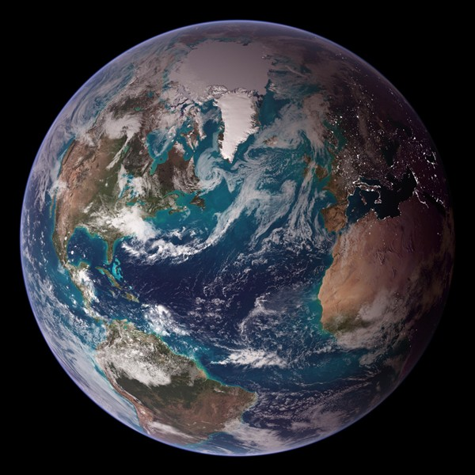

Step 4:

Now, we travel even further outwards, to the Moon. Show the students 'Earthrise' image (a photograph taken by the

astronauts from the Apollo 8 mission in 1968.) These astronauts were the first people to ever orbit a celestial body other than the Earth, and when they looked back at their home planet, they experienced the so-called overview effect: everything they had ever known and loved was on that tiny blue marble, hanging peacefully in space.

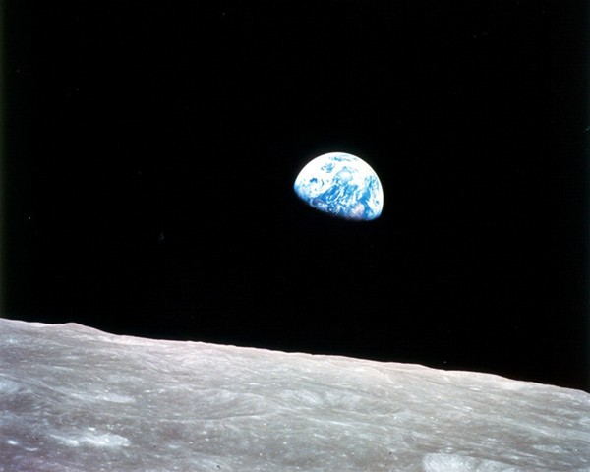

Step 5:

At this point, you can make the shift from photos to model objects. Take the earth ball and hand a Styrofoam sphere (10 cm in diameter) to one volunteer. If you don’t have a ball of that exact size, then use a sphere that approximately fits on Australia on the earth ball, for example an orange. If you use a globe instead of the earth ball, adjust the sizes of the objects accordingly. For example, of you use a globe that is 20 cm in diameter, use a 5 cm moon and also divide the next sizes and distances in this activity in half.

Step 6:

Ask the volunteer to hold this model of the Moon at a distance from the earth ball that he/she thinks is correct, according to this scale.

Step 7:

Ask the other students if they agree, and if not, let them stand at a distance they think is right. The correct answer is a distance of
30 earth balls (or whatever globe you use) in a row. For the earth ball this is 12 meters, meaning all the way to the back of the classroom, or even outside. Let the students look at the earth ball from there and tell them that this is the size of the Earth as it would appear if they were to stand on the Moon.

Step 8:

We proceed on our virtual journey, now, to the other planets. Ask the students to remain at the back of the classroom. Now hold up a sphere of about 0.25 cm in diameter, for example a peppercorn or popcorn seed. The students will be looking at the Earth as viewed from Mars at its closest distance to Earth!

Step 9:

Show the students 'Pale Blue Dot' image, which is a photograph taken by Voyager 1, a spacecraft that was sent out into space in 1977 and has now long since passed the orbit of Neptune—the outermost planet of our Solar System. Of course, Voyager 1 is unmanned. In fact, no human has ever travelled farther than the Moon. In the picture, you can see a teeny tiny ‘blue pale dot’. This is how small the Earth looks from 6 billion kilometres away, which is about the average distance to Pluto. Almost half a million Earths in a row fit in this distance. It takes an airplane more than 600 years to fly there! The stripes in the picture are just ‘noise’.

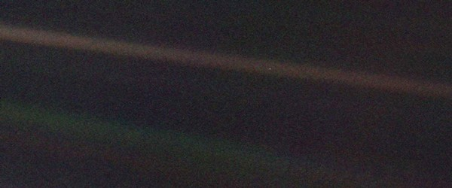

Step 10:

Ask the students if their perspective of Earth has changed. Do they think the Earth is big enough to provide is with inexhaustible resources? Explain that the Earth is a sphere with a finite atmosphere and finite resources. If we polute our planet, there is no-one in space that can help us. We have nowhere to go. The Earth is the only home we have.

Note: For students aged 9–10 years, you can extend this activity by getting into the subject of searching for life on exoplanets, which are planets outside our Solar System. So far, close to two thousand exoplanets have been discovered. For the current count, check out <http: planetquest.jpl.nasa.gov="">. From this activity, the students have learned that the Earth looks very small from outside the Solar System. This demonstrates that from Earth’s perspective, exoplanets must seem very small indeed and are very difficult to see. Therefore, it’s hard to determine whether life has developed on them. Even with very strong telescopes, astronomers can rarely see the planet, never mind zoom in far enough to look for living organisms!

However, methods are available to examine exoplanets.

Ask the students to think of ways to find out if a planet is hospitable to life, or even to check for actual life. The most important requirement for life is the presence of liquid water. The planet should be far enough from its host star so that water, if present, won’t evaporate. But it shouldn’t be too far, otherwise the water would freeze. Also, an atmosphere is probably necessary to protect life from harmful radiation and large temperature variations. In the future, astronomers might have developed such high-quality telescopes that they can see an exoplanet’s colour, from which they could deduce whether it has vegetation.

So far, however, we haven’t found a planet that is just like Earth. If we do, it will probably be very far away, meaning it will be difficult to study with our telescopes. Emphasise that lots of work still needs to be done in this area: if the students grow up to be astronomers, they might make a breakthrough discovery—they might even find life!

Curriculum

Country | Level | Subject | Exam Board | Section
UK | KS2: Year 5 | Science | - | Earth and Space
NL | Kerndoelen | - | - | 28, 33, 38, 39, 46

Additional Information

- The shift in awareness about the world the astronauts experience is also known as the overview effect: http://goo.gl/OuH9v
- Frank White's blog on The Overview Institute (author of "The Overview Effect: Space Exploration and Human Evolution"): http://www.overviewinstitute.org/blog/bloggers/frank-white
- "Overview" video by the Planetary Collective which documents astronauts’ life-changing stories of seeing the Earth from the outside –a perspective-altering experience often described as the Overview Effect: http://goo.gl/t8l0R
- "Further Up Yonder: A Message from ISS to All Humankind", a video by Italian videomaker, Giacomo Sardelli, about the International Space Station, its inhabitants, and its role in space exploration: http://goo.gl/uF2nd
- Frank White wrote a book about this topic: The Overview Effect
- Read more about the cosmic perspective we gain from cosmology: http://goo.gl/Fg62S

Conclusion

The activity should help students learn about scale and distance of the solar system and how important yet small the Earth is. It should give students a sense of global citizenship that we all live on the same tiny blue planet floating around in the vast emptiness of space.
Translated by:

Go to http://astroedu.iau.org/a/1412 for additional resources and download options of this activity.

