NATURE-BASED SOLUTIONS LEARNING SCENARIO
Deconstructing Climate Denial Speech and understanding the role of Nature-Based Solutions (NBS)

Deconstructing Climate Denial Speech and understanding the role of Nature-Based Solutions (NBS)
European Commission
Directorate-General for Research and Innovation
Healthy Planet – C3 - Climate and Planetary Boundaries
CDMA 03/154
Contact Josefina ENFEDAQUE
Email josefina.enfedaque@ec.europa.eu
RTD-PUBLICATIONS@ec.europa.eu
European Commission
B-1049 Brussels
Manuscript completed in October 2020.
1st edition.
This document has been prepared for the European Commission, however it reflects the views only of the authors, and the European Commission is not liable for any consequence stemming from the reuse of this publication.
More information on the European Union is available on the internet (http://europa.eu).
Luxembourg: Publications Office of the European Union, 2020
© European Union, 2020
The reuse policy of European Commission documents is implemented based on Commission Decision 2011/833/EU of 12 December 2011 on the reuse of Commission documents (OJ L 330, 14.12.2011, p. 39). Except otherwise noted, the reuse of this document is authorized under a Creative Commons Attribution 4.0 International (CC-BY 4.0) license (https://creativecommons.org/licenses/by/4.0/). This means that reuse is allowed provided appropriate credit is given and any changes are indicated.
For any use or reproduction of elements that are not owned by the European Union, permission may need to be sought directly from the respective right holders. The European Union does not own the copyright in relation to the following elements:
Cover page: © [Ping198 + 302210979]. Source: [stock.adobe.com]

EUROPEAN COMMISSION

NATURE-BASED SOLUTIONS LEARNING SCENARIO
Deconstructing Climate Denial Speech and understanding the role of Nature-Based Solutions (NBS)

Nicolas Duquenne

Directorate-General for Research and Innovation
2020 EN

Table of Contents
Keywords 3
1. Introduction 3
2. Overview 3
3. Integration into the curriculum 4
4. Aim of the lesson 4
5. Outcome of the lesson 4
6. Trends 5
7. 21st-century skills 5
8. Activities 5
9. Assessment 6
Annex 1: Initial survey 7
Annex 2: Climate deniers’ speeches 9
Annex 3: IPCC and IPBES introduction 11
Annex 4: IPCC and IBPES figures worksheet 13
Annex 5: Semantical Tools to Analyse a Speech 18
Annex 6: Compilation of NBS to fight Global Warming and Biodiversity Loss 19
Annex 7: Final survey 21

- Abstract
Scientists and experts recently released reports which should provide content to policymakers. IPCC (Intergovernmental Panel on Climate Change) and IPBES (Intergovernmental Science-Policy Platform on Biodiversity and Ecosystem Services) are probably the best-known structures that the public is aware of. In this Learning Scenario, we work from these documents to make the students able to appropriate them and giving them a tool – Nature-based solutions (NBS) – to solve the grave challenges presented in the reports. First, we assess the students' prior knowledge in the areas of biodiversity and climate change. An Online survey is set to easily gather this data. Secondly, the teacher goes through the scientific reports with the students by analysing several graphs, figures and short texts on climate change and nature-based solutions. The first step aims to give students the knowledge necessary to identify, expose and deconstruct disinformation while presenting positive narratives incorporating NBS as alternatives to combat fake and/or negative news and lack of action. In the next activity, students apply the knowledge by unbundling a climate denial speech through semantic analysis. There is in fact a bundle of elements that the students will learn to identify to critically evaluate the value of written or oral communication. Finally, one of the main goals of this activity is to raise awareness about the necessity for young people to actively take part in social and political life. NBS are highly diverse, and every student can apply their critical thinking skills and the nature surrounding them to tackle environmental issues.

Keywords
IPCC – IPBES – NBS – Mitigation and Adaptation – Citizenship – Expression – Disinformation

Introduction
“Nature-based solutions (NBS) are solutions that are inspired and supported by nature, which are cost-effective, simultaneously provide environmental, social and economic benefits and help build resilience. Such solutions bring more, and more diverse, nature and natural features and processes into cities, landscapes, and seascapes, through locally adapted, resource-efficient and systemic interventions. Nature-based solutions must therefore benefit biodiversity and support the delivery of a range of ecosystem services.” https://ec.europa.eu/info/research-and-innovation/research-area/environment/nature-based-solutions_en
To use this Learning Scenario more effectively, teachers are encouraged to:
- Check out the list of recent EU publications on Nature-Based solutions
- Read about Nature-based solutions: Transforming cities, enhancing well-being (also available as a PDF)
- Contact local NBS practitioners or scientists working in their area (they can be found through Oppla).
- Use the “Ask Oppla” service to request help in case of any technical/scientific question on NBS.

Overview
Overview
Subject | Biology – Ecology – Philosophy – Mathematics – Social Sciences – Communication – Information Technology
Topic | Climate mitigation and adaptation.
Age of students | 15–17 years old
Preparation time | 6 hours to handle the scientific data properly.
Teaching time | 3.25 hrs, 4 sessions recommended
Online teaching material | Any survey tool like Ahaslides– to create interactive presentations and survey for students: https://ahaslides.com/ or Google forms, or SurveyMonkey  Smartphones – to answer the surveys
Offline teaching material | Copy of scientific figures.  Copy of a climate denial speech.  Slideshow with complementary documentation  Paper  Pencils
NBS resources used | Reports for knowledge and information:  - IPCC report 1.5°C: https://www.ipcc.ch/sr15/;  - IPBES Summary for Policymakers report: https://ipbes.net/sites/default/files/2020-02/ipbes_global_assessment_report_summary_for_policymakers_en.pdf;  - Climate Adapt: https://climate-adapt.eea.europa.eu/knowledge/adaptation-information/adaptation-measures  - Biodiversity and nature-based solutions. Analysis of EU-funded projects https://op.europa.eu/s/onJG

Integration into the curriculum
For S6 students (Secondary School – one year before the baccalaureate) in biology lessons, human activities and its impact on the environment must be taught. During this last subject of the school year, students must write a report about one specific topic: loss of biodiversity, water resources, climate change and adaptation. The final work allows the students to mobilise knowledge acquired during the year. With that, they should have acquired critical thinking, scientific approach while looking at different subjects (problem, hypothesis, tests or observations and synthesis) and fundamental background about living systems.
This activity should provide a high level of scientific documentation to build a learning scenario. It can also offer a collaborative opportunity with stakeholders, scientists of climate change, or industries working on environmental solutions could be included to engage the students with companies that work in these areas and who live nearby.

Aim of the lesson
Students will work on figures and texts from expert reports. We demonstrate that they have enough knowledge to understand and to appropriate such documents. To handle scientific data, will provide confidence and ability to combat disinformation. This lesson will develop critical thinking and step up environmental awareness. Semantic tools will be provided to the students to allow them to easily recognise a fake-news speech. Finally, students are asked to sum up their knowledge and express their point of view about different already existing NBS to tackle global warming and biodiversity loss. At the end of the work, they will be able to draw a clear definition of NBS.
The scenario and teaching build on a process of (1) deconstructing the possible misinformation students might have about climate change and the loss of biodiversity and how it relates to human intervention and urbanisation, (2) learning to combat and respond to them, then (3) opening the routes to teach how our solutions – as a society and as individuals living in increasingly climate-change affected urban landscapes – should be based on Nature.

Outcome of the lesson
- Starting from an initial online survey, we will implement the LS and we will assess the progress with a final online survey. Students will have to decrypt a climate denial speech and bring valuable arguments through a short essay.
- Then, by showing that IPCC and IPBES are understandable and accessible online for free, we can expect students to develop competences to research and learn independently.
- Thinking about pertinence and efficiency learning about Nature-Based Solutions should promote innovative ideas amongst students.
- Students should comprehend that Climate Change, Global Warming, Biodiversity Loss are problems which need scientific knowledge and complex thinking (considering political, social, economic aspects) to be clearly understood and consequently to bring relevant responses.

Trends
- Ecojustice pedagogy: Learning to learn.
- Recognition of reliable documentation.
- Ability to decrypt disinformation and fake news.

21st-century skills
Citizenship Competence: Through a climate denier speech, students will have to develop critical thinking. They will learn and understand the functioning of communication media.
Digital Competence: with an online survey, students will use digital content, and learn to work collaboratively.
Competence in Science: Due to the study to expert’s report from IPCC and IPBES, students will enhance their ability to cope with technical graphs, figures, and maps. They will have the opportunity to develop an interest in environmental preservation. They will also be able to critically evaluate information and provide evidence to change someone’s position.
Literacy Competency: Students will be asked to read and write about climate denial. This will be a good opportunity to understand the impact of language. This includes becoming familiarised with the language used by international organisations in Assessments for Policymakers.

Activities
Name of activity | Procedure | Time
Initial Survey | With their smartphones, students answer the survey provided in Annex 1. Questions dealing with  - Knowledge about Expert Groups.  - Personal interest in Climate Change and Biodiversity  - General and Political Culture | 10 min
Documents 1 | Speeches from climate denier are given to the students without any information (see Annex 2). Their opinion is asked for.  This first contact with these 2 texts aims to raise controversy amongst student audience. Through a first short essay, they must express their feeling or understanding. | 20 min
Briefing  Document 2 | A short conclusion is made. IPCC and IPBES are introduced (suggested text in Annex 3)  Briefly, expert groups are introduced and both websites are shown to let the students aware that further information is accessible for free. | 25 min
Documents 3 | Documents with questions (from IPCC, 2 from IPBES – can be found in Annex 4, parts I and II) are studied  - A first figure is shown. This illustrates the Global Warming from 1850 until now. Work is done dealing with “reference period, meaning of 1.5°C rise scenario and anthropic impact.  - A second figure concerns Multi-Sector Risks for world Population. This can be used to reflect on the nature of the risks and the unfairness of the Climate Change consequences on the poorest part of the population.  - A third complex figure is studied to emphasise the biodiversity crisis occurring now. A background is reminded about the 5 latest mass extinction on Earth since 530 Ga.  - A last table summarises trends in the capacity of Nature to provide good quality of life for the last 50 years. Where areas with an improved contribution are rare. | 55 min
Slideshow | Other documents are used to correct and complete the information given by the 2 scientific reports.  This document provides all the figures and texts studied. More information can be found here to help teachers to complete the discussion with students. Download the full slides from here. | 10 min
Documents 1 | Return to the climate-denier speeches in order to analyse the structure of both texts. 4 D’s method is applied. A well-known pattern is commonly used to analyse semantically a text. Students will learn this technic (see more in Annex 5). | 30 min
Argumentation | Confrontation of scientific arguments extracted from the 3 IPCC/IPBES figures is asked to unbuild climate denial. Then they will be asked to identify untruths and oppose scientific evidence to them.  To master scientific notions is compulsory if a citizen wants to deconstruct a disinformation speech. | 25 min
Document 4 | 2 NBS projects are quickly presented: One in Italy, one in France (see Annex 6).  They are used to summarise information from the first phase of the current work.  Italian project permits to illustrate the importance of protection of a natural ecosystem to reduce CO2 emissions.  French project involved socio-economic aspects amongst new agricultural strategies which lead to an increase of regional biodiversity. | 15 min
Conclusions | The last document with NBS projects will provide support to ask the students to draw a clear definition of Nature-Based Solutions to tackle Climate Change and attacks towards biodiversity. | 15 min
Final Survey | With their smartphones, students answer the final survey that can be found in Annex 7.  This final survey allows the students to assess the relevance of each part of the activity. Students are asked to declare if the political involvement has grown or not with this work. | 10 min

Assessment
- The activity will be assessed by the students themselves with the final online survey.
- Two shorts essays are asked to describe how controversial speeches have been understood.
- If the teacher wants to assess the accuracy of analysis of the different figures, several questions are provided to help in this direction.
- Obviously, oral participation can be the main way to lead this work and it could be easily evaluated as well.

Annex 1: Initial survey
- Have you ever heard about the ipcc?

Yes
No

- Have you ever heard about ipbes?

Yes
No

- Did you hear about the ipcc?

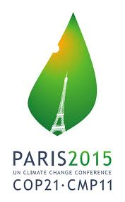

Yes
No

- Regarding Climate change, do you consider yourself:
- A well-informed person
- A not well-informed person
- An ignorant person
- You do not really care about the topic.

- Choose three words connected to Climate change.

- Regarding biodiversity, do you consider yourself:
- A well-informed person
- A not well-informed person
- An ignorant person
- You do not really care about the topic

- Choose three words connected to Biodiversity

- Who is she?

- What’s your opinion of what she is doing?

- Do you think that militancy and/or politicisation of youth is necessary and useful to flight climate change?
- Necessary
- Useful
- Both
- None

- Do you know this logo?

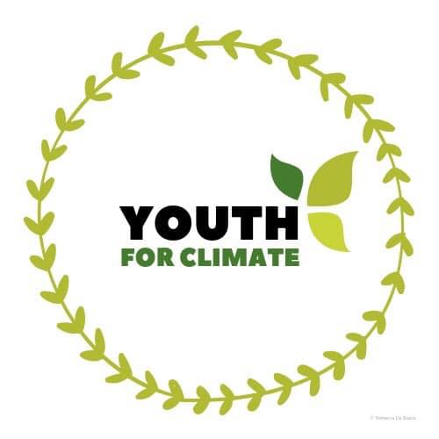
Yes
No

12) In the future, do you think you might/could get involved in a political or associative way to tackle climate change?
- Yes
- No
- Maybe

Annex 2: Climate deniers’ speeches
Note: The transcripts of the videos were done by the author of this Learning Scenario.

First Speech
Hello everyone, my name is Naomi Seibt. I’m a new member at the Heartland institute. And I have very good news for you: The world is not ending because of climate change. In fact, 12 years from now, we will still be around casually taking photos with our iPhone 18, tweeting about the current president on Twitter and ranting about the latest celebrity gossip.
However, we are currently being forced-fed with a dystopian agenda of climate alarmism that tells us that we, as humans, are destroying the planet and that the young people, especially, have no future, that the animals are dying, that we are ruining the Nature.
I truly believe the members of Antifa, Friday for Future, Extinction Rebellion have good intentions. But they are generally scared of the world’s ending. They are scared that parents and grandparents are ruining the planet. It’s breaking the relationship between families.
We, at the Heartland Institute, we want to spread the truth about the science behind climate realism which is essentially the opposite of Climate alarmism. Many people are now actually developing mental disorders, referring to Eco anxiety and Eco depression. I believe it is important we act now and change the entire mainstream narrative of fearmongering and climate alarmism. It is basically holding us in hostage in our own brains.
With all of that said, do not let their agenda depicting you as an energy sucking leech on the planet, don’t let then get into your brain and take away all of your passionate spirit.
I don’t want you to panic, I want you to think.

Second speech
Hello everyone.
It’s about time I speak up again and defend myself against the mainstream media misrepresentation of myself and the Heartland Institute. As some of you may know I am now a member of the Heartland Institute which is an American think tank. […] And I’m probably being instrumentalised as an Anti-Greta for the right-wing conservative opposition to the climate change mainstream to satisfy the financial desires of some big greedy American corporations. Apparently, that is the exact impression that the German News outlets ZDF and CORRECTIV got. Which is why they decided to spy on us under false identities. […]
But I won’t let that bring me down. I won’t let you take away my courage. No way. You know what? Now I am even more determined to fight back. My intention behind all of this is not to become famous or make a lot of money. I couldn’t care less about that kind of stuff. I live at home with my family in my tiny room and I am fully content. I don’t need or want anything else.
But what I do want is that this attack on our free speech ends. I want it to be possible to express scientific scepticism again. That’s all. When we do our research, we do it thoroughly! and we do not resort to […] news source just because it fits our agenda! We do not have an agenda! There is no ideology behind us, there is no “Friday for Future” backing us, we don’t have anything “cool” to offer like the Community Spirit of protesting teenagers. What we do have is science. And that is exactly what makes us stronger and authentic.
[…]
[I’d like to thank] the people who wake up slowly, who start to question their biases, the people who join climate realism or at least consider the sceptic opposition and question the way the media defames us as “climate deniers”. […] Thank you to everyone who challenges their brain just a little bit and is willing to listen to arguments from the other side. That is what I hope and advocate for. I don’t have to convince anyone that I’m right about everything. That would be nice, of course. Because I wish that there wasn’t this fearmongering going on about a climate catastrophe. I wish that young people weren’t being told to fear the future, that older generations are ruining the planet, that animals are going extinct, that nature is dying. I hope that we can live in an era of productive discussion again. Because discussion is what keeps the philosophical spirit of our society alive… it’s what keeps our freedom alive. Freedom of speech is the foundation for a society that can truly stick together. Because we don’t always have to agree on everything to show respect for one another. That is important to me. And so, I ask you to stay open-minded. Regardless of yours or your opponent’s opinion. And don’t trust everything that the mainstream media says – make sure to have many different sources of information!
And to the mainstream media, I have few last words for you “How dare You”
Naomi Seibt on YouTube – message to the Media

Annex 3: IPCC and IPBES introduction
(by author of this LS)

PRESENTATION OF THE IPCC
- The IPCC
The International Group of Experts on Climate Change is tasked by the United Nations with providing numerous scientific data capable of informing policymakers about the consequences of global warming and proposing solutions to limit or adapt to it.

- The notion of certainty and uncertainty

The IPCC now has 195 members and hundreds of "author" scientists whose function is to bring together the contributions of hundreds of other international experts. A review of this work by thousands of external reviewers ensures the completeness, objectivity and transparency of publications.
The IPCC is not intended to conduct its own research, its job is to analyse the published scientific literature. Because IPCC evaluations focus on areas where knowledge, already strong, are still constantly evolving, the authors' teams draw their conclusions with a "degree of certainty" or "confidence"
The probability that a conclusion is correct is then expressed in a degree of certainty (or confidence):
- very high confidence (9 chances at least out of 10) (HV)
- high confidence (about 8 out of 10 chances) (H)
- average confidence (about 5 out of 10 chances) (M)
- low confidence (about 2 out of 10 chances) (L)
- very low level of confidence (less than one in 10 chance). (VL)
Where statistical analysis is possible, probability ranges (confidence interval) are used:
- almost certain (probability greater than 99%)
- extremely likely (probability greater than 95%)
- very likely (probability greater than 90%)
- (probability greater than 66%)
- more likely than not (probability greater than 50%
- about as likely as it is unlikely (33% to 66%) probability
- unlikely (probability less than 33%)
- very unlikely (probability less than 10%)
- extremely unlikely (probability less than 5%)
- exceptionally unlikely (probability less than 1%)

- IPCC working groups and the aspects covered by the reports

There are three working groups (WGs):
- The "physical science databases" WG I
- The "consequences, adaptation and vulnerability" WG II
- The "Climate Change Mitigation" WG III
In addition to these working groups, a team coordinates data and scenarios for climate analysis and its impacts.

IPBES PRESENTATION
- THE IPBES
IPBES is the Intergovernmental Science-Policy Platform on Biodiversity and Ecosystem Services. It is therefore also a group of international experts mandated by 136 member states who have been tasked with coordinating government action with scientific expertise on biodiversity. This platform therefore seeks to preserve biodiversity and allow its use in the context of sustainable development.
- The functions of the IPBES
Four complementary areas of expertise can be identified:
- Evaluations and analyses: scientific methodologies implemented, local study levels, regional or global issues, specific or systemic themes.
- Policy support (and recommendation): identifying tools relevant to policy and facilitating policy action in the Biodiversity conservation realm.
- Strengthening knowledge and operational capabilities: finding donations reliable needs for member state-level implementation
- Communication and dissemination of work: awareness and impact as wide as possible of the IPBES work, knowledge produced and assessments.

Annex 4: IPCC and IBPES figures worksheet
(by author of this LS)

WORKSHEET FOR STUDENTS BASED ON IPCC AND IPBES REPORTS
- Evolution of global mean surface temperature (GMST) over the period of instrumental observations
Sample of document provided by WG 1
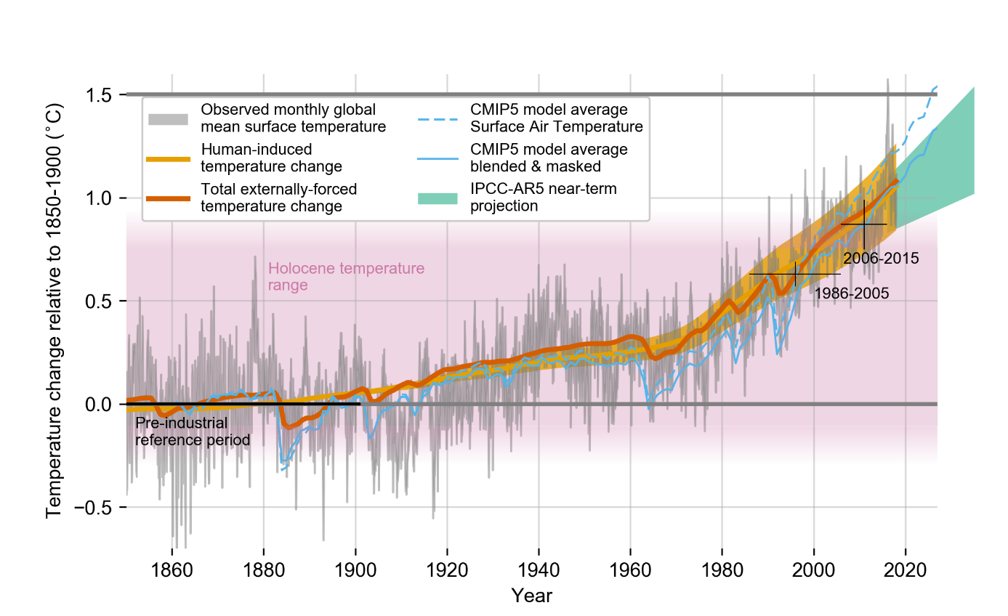
Source : IPCC, 2019 https://www.ipcc.ch/site/assets/uploads/sites/2/2019/01/figure-1.2.png

To do:
- Explain clearly from what reference we can state that in 2019, “global warming rises 1°C”.
- Justify that the pre-industrial period (1850-1900) is taken as the reference to set temperature comparisons/
- Find meteorological variations effects on this graph.
- Working on colour lines, state accurately the difference between weather variations and climate change.
- Write the statement you get by comparing yellow and orange curves.

- IMPACTS Of 1,5 °C OF GLOBAL WARMING on NATURAL and HUMAN SYSTEMS
Sample of document provided by WG 2
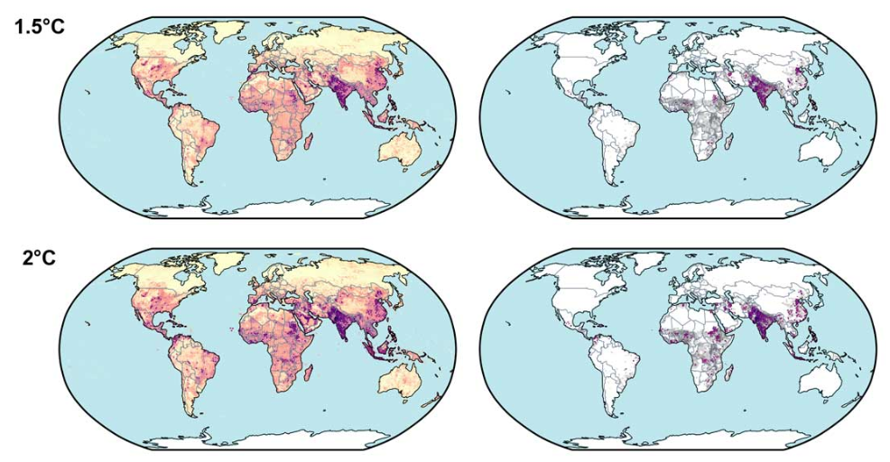
Source: IPCC, 2018

Notes:
- Left column shows overall Multi Sector Risks on a coloured range (MSR) from 0 to 9.
- A risk becomes multi sector (overall) if it scores up to 4 within the MSR range.
Right column overlaps poorest population map in 2050 (income < 10$ / day) with MSR map (where MSR > 4).

Modified from: https://www.ipcc.ch/site/assets/uploads/sites/2/2018/11/Figure_3.18.jpg

To do:
- List several risks generated by Global Warming which can be integrated into the MSR score.

- Justify that Global Warming is doubly unfair for one part of the human population

- A SUBSTANTIAL PROPORTION OF ASSESSED SPECIES ARE THREATENED WITH EXTINCTION
Sample of document provided by IPBES
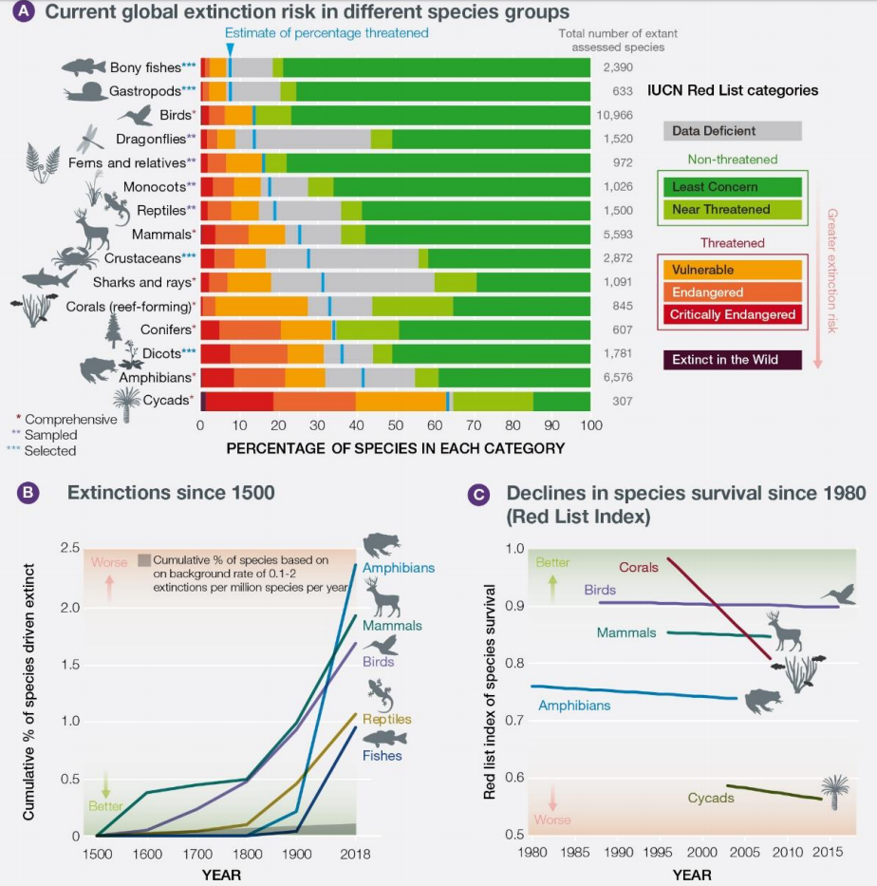
Source: IPBES, 2019
Notes:
- Percentage of species threatened with extinction in taxonomic groups that have been assessed comprehensively, or through a ‘sampled’ approach, by the International Union for Conservation of Nature (IUCN) Red List of Threatened Species.
- Extinctions since 1500 for vertebrate groups.
- Red List Index of species survival for taxonomic groups that have been assessed for the IUCN Red List at least twice. A value of 1 is equivalent to all species being categorised as Least Concern; a value of zero is equivalent to all species being classified as Extinct.
(Source: IUCN Red List)

To do:

  - Identify on document A the most threatened groups with extinction. Give some hypothesis to explain their current situation.
  - Based on document B, localise pre-industrial age and describe the curves from this period
  - Justify we could relevantly talk about the sixth mass extinction.
- GLOBAL TRENDS IN THE CAPACITY OF NATURE TO SUSTAIN CONTRIBUTIONS TO GOOD QUALITY OF LIFE FROM 1970 TO THE PRESENT
Sample of document provided by IPBES
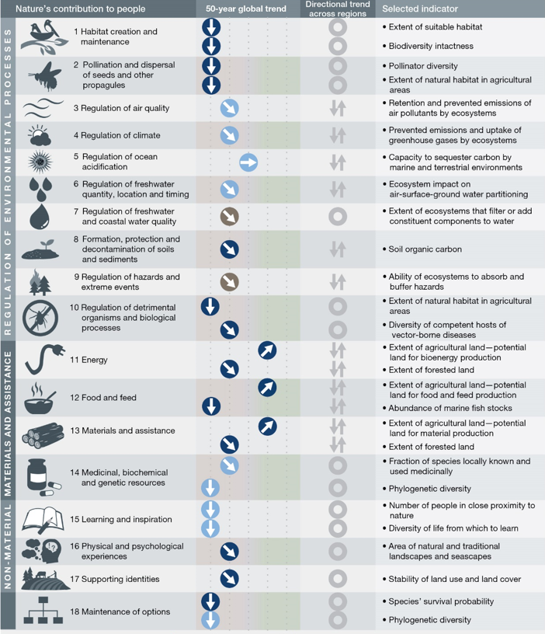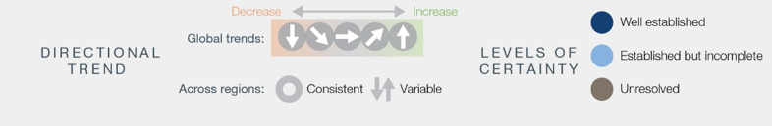

To do:
- Look at the table and identify all 3 kinds of contributions Nature bring to humanity. Also identify co-benefits nature brings to economy and job creation
- A recent scientific article states: “There are various definitions of Nature-Based Solutions but, at their core, they cluster into the general theme of learning from and using nature to create sustainable socio-ecological systems, which enhance human wellbeing locally, regionally or globally” (Dick, J., Miller, J.D., Carruthers-Jones, J. et al). Select three Nature’s contributions from the document and provide further explanation to illustrate the 3 scales for which human wellbeing’ improvement is expected due to NBS.
- Qualify the global trend within the last 50 years about the regulation of environmental processes.
- Provide some explanation to points 11, 12 and 13 of the previous image where trends could appear as contradictory
- This document will be needed for the last part of our work to easily identify the positive impacts that some innovative projects aim. Make sure to remember the different indicators used in this table.

Annex 5: Semantical Tools to Analyse a Speech
(by author of this LS)
TO DECRYPT AND TO UNCONSTRUCT CLIMATE-DENIER SPEECH
Today more than ever, in a world where the dissemination of information has never been so easy and fast, it is necessary to develop skills for analysing speeches, publications and websites.
How do I identify misinformation? How do I recognise fake news?
Many specialists use the so-called 4D model:
- Dismiss the message: If you do not appreciate what your critics/opponents say, insult them, attack them, change, and exaggerate what they say.
- Distort the fact: If the facts are not favourable to you, change them.
- Distract the hearing: If you are accused of something, accuse the opposing party of the same thing. Change the angle of attack.
- Dismay the whole thing: If you do not like what your critics/opponents expect, scare them, overwhelm them, mock them.

Naomi Seibt, a young YouTuber close to the German far right, recently put forward by an American think-tank, posts archetypal disinformation speech!

- Search in both texts for the elements belonging to the 4D model and fill in the table.
Dismiss | Distort | Distract | Dismay

- Oppose factual arguments against that person's allegations. Use the information you get during the first part of the activity.
"climate alarmism claims that animals are dying":
"climate alarmism claims that nature is being destroyed":
- Based on the concluding sentence of each of the 2 texts, write a paragraph that expresses your personal point of view on how the media deal with climate crisis.

Annex 6: Compilation of NBS to fight Global Warming and Biodiversity Loss
(by author of this LS. Images from EC-funded projects.)
DISCOVER AND COMPARE EXISTING NBS
The projects below have all be funded by EU. By studying these examples students can figure out everywhere within Europa innovative initiatives are promoted.
- Seaforest: Posidonia Meadows in Italy
https://www.seaforestlife.eu/en/

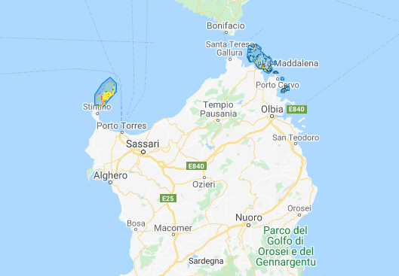 | 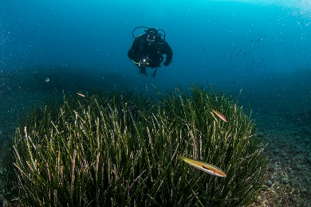 | 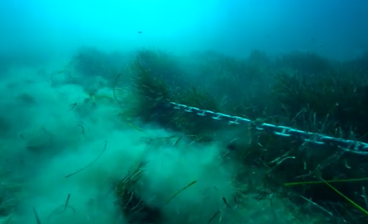

The SEAFOREST project has, as general objective, the increase of the capacity of the carbon reservoirs of Posidonia oceanica meadows through erosion reduction and subsequent consolidation of the habitat in some Italian protected areas. In particular, the protected areas identified are the National Park of Cilento, Vallo di Diano and Alburni (province of Salerno), the National Park of Asinara and the National Park of the La Maddalena archipelago (province of Sassari). These territories have a large extension of posidonia within their Marine Protected Areas, and part of this territory is threatened by degradation

- Agroforestry: Agriculture of the Future in France
https://oppla.eu/casestudy/18469

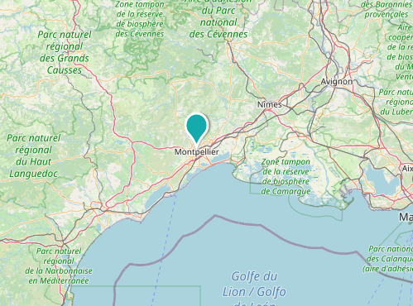 | 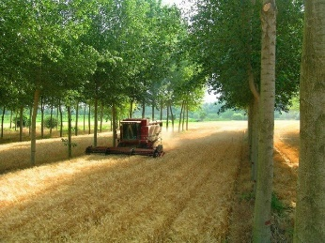 | 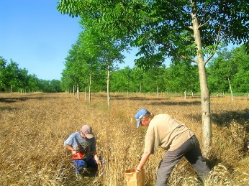

The agriculture sector in Montpellier is highly vulnerable to higher temperature and more frequent droughts associated with projected climate change. To prepare for the effects of climate change, it is important that agriculture in Montpellier takes appropriate adaptation measures. The current system, largely based on monoculture, is deemed to be more vulnerable compared to alternatives such as the cultivation of a mixture of crops and species, especially a mixture of trees and crops as in agroforestry. Such a practice has been adopted in Montpellier, as part of the SAFE project; a French national scheme for planting half a million hectares of agroforestry during the next 25 years based on results obtained by INRA at Montpellier.

    - According to the previous document from IPBES on Natures’ contributions set a list of positive expected impacts with the implementation of both projects.

Guidelines:

Regulation of Environmental Processes
Materials and Assistance
Non-material

    - Explain why the Italian project included Global Warming Mitigation as one of its potential benefit.

    - Both projects illustrate nature-based solutions. Create a definition of this concept as a conclusion to the work.
Guidelines:
Solutions to what problem?
Why Natured-based denomination?
Positive expectancies for whom?

Annex 7: Final survey
- How did you like this activity?
- Interesting
- Boring
- Useful
- Not useful
- Other

- Choose the part you preferred
- Text analysis
- Scientific figures analysis
- NBS samples
- All
- None

- Regarding the talks, how would you describe your feeling/understanding after the first reading?
  - I mainly agreed
  - I mainly disagreed
  - Astonished
  - Happy
  - Upset

- Which describes best the scientific figures you have studied
  - Easy to understand
  - Not so easy to understand, but you get the main point
  - Difficult to understand
  - Impossible to understand
  - Without any interest

- From the NBS samples provided, do you think such initiatives could help address climate change and biodiversity loss?
  - Yes, I do
  - No, I do not
  - Maybe

- Do you think Climate change and environmental issues are taught enough in school?
  - Yes
  - No
  - I do not think they are important

- After this activity, are you more interested in addressing the climate and biodiversity crisis by joining an associative or political movement?
  - Yes, but I am already involved
  - Yes
  - No, but maybe some day
  - No

Getting in touch with the EU
IN PERSON
All over the European Union there are hundreds of Europe Direct information centres.
You can find the address of the centre nearest you at: https://europa.eu/european-union/contact_en

ON THE PHONE OR BY EMAIL
Europe Direct is a service that answers your questions about the European Union.
You can contact this service:
– by freephone: 00 800 6 7 8 9 10 11 (certain operators may charge for these calls),
– at the following standard number: +32 22999696, or
– by email via: https://europa.eu/european-union/contact_en
Finding information about the EU
ONLINE
Information about the European Union in all the official languages of the EU is available on the Europa website at: https://europa.eu/european-union/index_en

EU PUBLICATIONS
You can download or order free and priced EU publications from:
https://op.europa.eu/en/publications. Multiple copies of free publications may be obtained by contacting Europe Direct or your local information centre (see https://europa.eu/european-union/contact_en)

EU LAW AND RELATED DOCUMENTS
For access to legal information from the EU, including all EU law since 1952 in all the official language versions, go to EUR-Lex at: http://eur-lex.europa.eu

OPEN DATA FROM THE EU
The EU Open Data Portal (http://data.europa.eu/euodp/en) provides access to datasets from the EU. Data can be downloaded and reused for free, for both commercial and non-commercial purposes.

About the NBS project

The NBS project is initiated and funded by the European Commission Directorate-General for Research and Innovation and coordinated by PPMI, in collaboration with European Schoolnet (EUN). PPMI (www.ppmi.lt/en) is a leading European research and policy analysis centre, aiming to help public sector and civil society leaders from around the world, presenting evidence in a way that is simple, clear and ready to use. European Schoolnet (www.eun.org) is the network of 34 European Ministries of Education, based in Brussels. EUN aims to bring innovation in teaching and learning to its key stakeholders: Ministries of Education, schools, teachers, researchers, and industry partners. Find out more about nature-based solutions: https://ec.europa.eu/research/environment/index.cfm?pg=nbs and all the NBS Learning Scenarios created in this project as well as the overall reports can be found at http://www.scientix.eu/pilots/nbs-project

The NBS project pilot has also been supported by the STE(A)M Partnerships programme of Scientix, funded from the European Union’s H2020 research and innovation programme – project Scientix 4 (Grant Agreement N. 101000063), coordinated by European Schoolnet (EUN). The content of the document is the sole responsibility of the organizer and it does not represent the opinion of the European Commission (EC), and the EC is not responsible for any use that might be made of information contained.
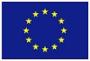

[Catalogue number]

Scientists and experts recently released reports which should provide content to policymakers. IPCC (Intergovernmental Panel on Climate Change) and IPBES (Intergovernmental Science-Policy Platform on Biodiversity and Ecosystem Services) are probably the best-known structures that the public is aware of. In this Learning Scenario, we work from these documents to make the students able to appropriate them and giving them a tool – Nature-based solutions (NBS) – to solve the grave challenges presented in the reports. First, we assess the students' prior knowledge in the areas of biodiversity and climate change. An Online survey is set to easily gather this data. Secondly, the teacher goes through the scientific reports with the students by analysing several graphs, figures and short texts on climate change and nature-based solutions. The first step aims to give students the knowledge necessary to identify, expose and deconstruct disinformation while presenting positive narratives incorporating NBS as alternatives to combat fake and/or negative news and lack of action. In the next activity, students apply the knowledge by unbundling a climate denial speech through semantic analysis. There is in fact a bundle of elements that the students will learn to identify to critically evaluate the value of written or oral communication. Finally, one of the main goals of this activity is to raise awareness about the necessity for young people to actively take part in social and political life. NBS are highly diverse, and every student can apply their critical thinking skills and the nature surrounding them to tackle environmental issues.

Studies and reports

If students are interested and want further activities, teachers can develop laboratory practices to determine which plant species absorb the most carbon dioxide (stopping climate change), building houses for pollinators in the High School (stopping the loss of biodiversity) and inviting an member of the IPCC or the IPBES to talk about the importance of NBS. However, we understand that these potential activities are outside the scope of this LS, and would require further planning by the teacher implementing the LS to adapt and expand the LS.

