Star in a Box: Advanced

Explore the life-cycle of stars with Star in a Box activity.

Edward Gomez, LCOGT

Brief Description

Have you ever wondered what happens to the different stars in the night sky as they get older? The Star in a Box application lets you explore the life cycle of stars. It animates stars with different starting masses as they change during their lives. Some stars live fast-paced, dramatic lives; others change very little for billions of years. The app visualises the changes in mass, size, brightness and temperature for all these different stages.

Goals
- To understand the differences in the lifecycle of stars with different starting masses.
- To demonstrate the use of graphing as a tool for exploring different physical aspects of a complex system.

Learning Objectives
- Describe the relationship between a star's mass and its life span.
- State that stars above a certain mass end their lives in a supernova.
- Name the major stages of a star's life cycle, in order, for several masses of star.
- Describe the relationship between a star's mass, its age, and its position on the Hertzsprung-Russell diagram.

Evaluation
The accuracy of their answers to the question can form the basis of the evaluation of students’ understanding. However, more detailed feedback can be obtained by talking to individual students about their understanding. - Ask students to talk through what is happening to a 1 solar mass star as the star marker moves around the graph. - Ask students why different

initial masses of star lead different life cycles; what are the main differences and happens at the end of these stars lives?

Materials
- Computer with internet
- Star in a Box worksheets

Background Information
- Students should understand what a star is in broad terms before starting this activity.
- Students should be familiar with the concept of hydrogen burning/fusion.
- Students should be familiar with using graphs to display and discern information.
- Teachers can use the Powerpoint presentation provided to give students a full lesson about the life cycle of stars before attempting the activity (available at http://lcogt.net/education/starinabox).

Full Activity Description
Star in a Box app is available at http://lcogt.net/starinabox

Advance Level

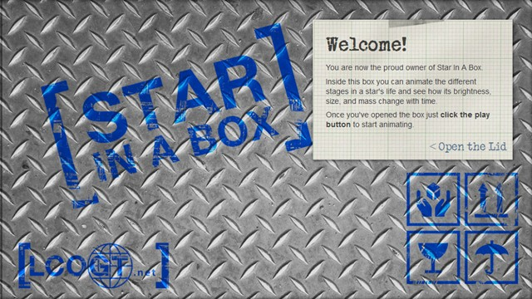
- Open the lid of your ‘Star in a Box’.
- The graph is a Hertzsprung-Russell diagram, where a star’s luminosity is plotted against its temperature.
- The information panels allow you to compare the Sun with your star. It compares the relative radius, surface temperature, brightness (luminosity) and mass of the star to the Sun.

A. The Sun’s Evolution during its lifetime.

Click the play button below the Hertzsprung-Russell diagram to show the Sun’s evolution.

- Name the three stages of the Sun’s life shown on the Hertzsprung-Russell diagram.

Stage 1: Stage 2: Stage 3:

Use the table below to describe the changes the Sun will go through between stages.

- Label ‘Increase’, ‘Decrease’ or ‘Stay the same’ for each of the quantities in the table along with the values they change from and to.
- Look at the light bulb tab: - At which stage in its life cycle will the Sun be at its brightest? - How old will the Sun be at this point? Myr
- Look at the thermometer tab: - At which stage in its lifecycle will the Sun be at its hottest? What is its maximum temperature? K
- Look at the pie chart tab: - In which stage of its life will the Sun spend most of its time? - How long will it spend in this stage? Myr
- Look at the mass tab: - What happens to the mass of the Sun as it gets older?
- What type of star will the Sun be at the end of its life?
- What is the total lifetime of the Sun?

Using the ‘Star Properties’ banner, explore the evolution of stars with different starting masses.

- Select a different starting mass for your star in the ‘Star Properties’ banner.
- Using the Hertzsprung-Russell diagram tab, click play to watch your new stars evolution.
- Try out a few different masses then answer the following questions.
- Using the Hertzsprung-Russell diagram:
- Where on the main sequence do the lower mass stars start?
- Where on the main sequence do the higher mass stars start?
- There are three possible outcomes for the final stage of a stars life depending on its initial mass. Name these 3 possible final stages.

Follow the evolution of five stars of different masses.

Complete the table below, filling in a row for each of the different masses. Hint: You may find it easier to use the data table on the ‘Star in a Box’ to find the exact values.

Study the data for the different stars in your table above.

- Comparing the temperatures: - Which mass star reaches the highest temperature? - At what stage in its life does the star reach this temperature?
- Comparing the luminosities: - Which mass star gets the most luminous (brightest)? - Is this the same mass of star that reaches the highest temperature?

Multiple choice questions Choose the correct answer.

- What type of star will the Sun become after it leaves the Main Sequence? Neutron Star | Red Dwarf | Red Giant | Red Supergiant
- What main factor determines the stages a star will follow after the main sequence? Mass | Luminosity | Temperature | Radius
- The mass of the star Betelgeuse is much greater than the mass of the Sun; therefore, its total lifetime will be: Greater than the Sun | The same as the Sun | Less than the Sun
- Compared to when it joins the Main Sequence, a star’s mass at the end of its life will: Be greater | Be the same | Be less | Depend on the type of star
- The Sun will spend most of its life in what stage? Main Sequence | Red Giant | Red Dwarf | White Dwarf

(solutions at: http://goo.gl/oLBg2N)

Curriculum

  - GCSE Science (UK)
  - A-Level Physics (UK)

Additional Information
  - If you would like to know more about how stars evolve, take a look at our SpaceBook pages about the life cycle of stars. http://lcogt.net/book/life-cycle-stars
  - You can also learn more about Hertzsprung-Russell diagram on SpaceBook http://lcogt.net/book/h-r-diagram

Conclusion
The activity finishes when the students have completed the worksheets. The teacher should discuss the range of answers the students had for some of the later questions on each worksheet.

Translated by:

